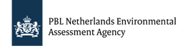

**Decarbonisation of the Dutch   
Container Glass Industry by 2050**

A Model-based Analysis of

Technology Options

**Ioannis**

**Papadogeorgos**

MSc Thesis

Photo by Owens-Illinois Inc. © 2019

**Decarbonisation of the Dutch   
Container Glass Industry by 2050**:   
A Model-based Analysis of   
Technology Options

Master thesis submitted to Delft University of Technology

in partial fulfilment of the requirements for the degree of

**Master of Science**

in Engineering and Policy Analysis

Faculty of Technology, Policy and Management

by

Ioannis Papadogeorgos

To be defended in public on 23rd September 2019

**Information:**

Student number: 4737296

Project duration: 2 April 2019 – 23 September 2019

**Graduation Committee**:

Chair / 1st supervisor: Prof. Dr. Andrea Ramirez Ramirez (TU Delft)

2nd supervisor: Assoc. Prof. Jan H. Kwakkel (TU Delft)

External supervisor: Dr. Klara M. Schure (PBL/TNO)

An electronic version of this thesis is available at <http://repository.tudelft.nl/>.

Preface

This study presents the results of a six-month research which was carried out at TU Delft in partial fulfilment of a Master’s degree in Engineering and Policy Analysis. It is intended to be used by researchers, glass companies and policy makers as well as people who have an interest in the container glass production and industry stakeholders who seek for an alternative methodology that supports decision making. The proposed methodology can also be used as a handbook for coupling exploratory modeling techniques with Excel models, which has a particular value for policy analysis, as well as system and industrial engineering students.

Elements from the fields of Policy Analysis, Electrical and Industrial Engineering have been necessary for the delivery of this research. An open source model was developed in MS Excel that replicates a benchmarking configuration of a container glass plant. A series of shortlisted best available and emerging technologies have been tested in the model with the prospects of achieving deep carbon emissions reduction in the container industry by 2050. A decision support method developed was leveraged for identifying robust decarbonisation options that account for the conflicting objectives. This method was developed in the Python programming language and the resulting set of robust options consist of the policy advice of this study. The model incorporates input from industry experts, among which the representatives of Dutch container glass companies as well as researchers and consultants from TNO and PBL Netherlands Environmental Assessment Agency. The thesis, as well as the Excel model and code are available through the TU Delft repository and GitHub, respectively.

Πρόλογος

Η παρούσα μελέτη παρουσιάζει τα αποτελέσματα μιας εξαμηνιαίας έρευνας που διεξήχθη στο Τεχνολογικό Πανεπιστήμιο του Ντελφτ για την ολοκλήρωση μεταπτυχιακού τίτλου σπουδών στη Μηχανική και Ανάλυση Πολιτικής. Προορίζεται για χρήση από ερευνητές, εταιρείες παρασκευής γυαλιού και σχεδιαστές πολιτικής, καθώς και από ενδιαφερόμενους στον ευρύτερο τομέα της βιομηχανικής παραγωγής που επιδιώκουν μια εναλλακτική μεθοδολογία για την υποστήριξη λήψης αποφάσεων. Η προτεινόμενη μεθοδολογία μπορεί επίσης να χρησιμοποιηθεί ως εγχειρίδιο για τη σύζευξη τεχνικών ερευνητικής μοντελοποίησης με μοντέλα κατασκευασμένα στο Excel, έχοντας ιδιαίτερη αξία για σπουδαστές τόσο στον τομέα ανάλυσης στρατηγικών, όσο και συστημάτων και βιομηχανικής μηχανικής.

Στοιχεία από τα πεδία της Ανάλυσης Πολιτικής, της Ηλεκτρικής και Βιομηχανικής Μηχανικής κρίθηκαν απαραίτητα για την εκπόνηση αυτής της έρευνας. Η λειτουργία ενός εργοστασίου παραγωγής γυαλιού αναπαραστάθηκε και τέθηκε ως βάση αναφοράς μέσω ενός μοντέλου κατασκευασμένο στο MS Excel. Βέλτιστες και αναδυόμενες τεχνολογίες υποβλήθηκαν σε δοκιμή, με την προοπτική επίτευξης δραστικών μειώσεων των εκπομπών άνθρακα στη βιομηχανία παραγωγής γυαλιού έως το 2050. Βέλτιστες εναλλακτικές επιλογές μείωσης ρίπων που ικανοποιούν αντικρουόμενους στόχους εντοπίστηκαν μέσω μιας μεθόδου υποστήριξης λήψης αποφάσεων. Η μέθοδος αναπτύχθηκε σε γλώσσα προγραμματισμού Python, και οι προκύπτουσες λύσεις αποτελούν τη συμβουλευτική πρόταση αυτής της ερευνητικής μελέτης. Εμπειρογνώμονες στον τομέα της βιομηχανίας συνέβαλαν στη διαμόρφωση αυτού του μοντέλου, μεταξύ των οποίων εκπρόσωποι ολλανδικών εταιρειών παραγωγής γυαλιού, ερευνητές και σύμβουλοι του ερευνητικού κέντρου TNO και της Εθνικής Περιβαλλοντικής Υπηρεσίας της Ολλανδίας. Η διπλωματική εργασία, καθώς και το μοντέλο και ο κωδικός είναι διαθέσιμα μέσω των σελίδων του πανεπιστημίου του Ντελφτ και GitHub, αντίστοιχα.

Summary

The Dutch container glass industry is an energy- and capital-intensive industry which accounts for about 350 kton of carbon dioxide (CO2) emissions on an annual basis. The fluctuating energy prices during the past decades as well as the implementation of the European Emission trading scheme (ETS) are pushing towards the deep decarbonisation of container glass-making activities. However the uncertainty which surrounds the transition strategies hinders the decarbonisation efforts, leading investment decisions in CO2-reducing technologies to postponement. In this study, a set of optimally robust performing policy options is identified for the effective decarbonisation of the container glass industry by 2050. By conducting techno-economic analysis on the processes of Dutch production sites, alternative technology options and their combinations are compared on the basis of their technical and financial feasibility. The robustness of decarbonisation strategies is determined on the basis of carbon emissions, energy consumption, product cost and return of investment and assessed under a wide spectrum of potential future events using a many-objective robust decision making technique. The study concludes on the importance of using alternative fuels (i.e. biomethane, electricity and syngas) as well as the coupling of waste heat recovery options with innovative furnaces for improving the melting activity. Further development of breakthrough technologies is necessary to achieve greater carbon emissions reduction, which will be supported by a sound regulatory framework for technology deployment. The study can be leveraged by industry stakeholders and policymakers on the future of the container glass sector and the industry in a broader sense in a competitive low-carbon economy.

Acknowledgements

Conducting this study would not be possible without the contribution and invaluable assistance of some special people I had the pleasure to collaborate with. The academic supervisors Prof. Andrea Ramirez Ramirez and Assoc. Prof. Jan H. Kwakkel from TU Delft offered me their support and their constructive feedback for delivering a sound scientific research as well as freedom to explore and make crucial decisions. Many thanks to my external supervisor Dr. Klara Schure from the PBL & TNO side for assessing closely my progress and helping me develop skills in analytical reasoning. Special thanks to Dr. Hans Eerens from PBL for teaching me the fundamentals of industry and chemistry, as well as sharing his ideas with me on building a strong basis for my final model. Key research studies that helped me gain understanding on both the industry and model-based decision support methods have been “The energy transition in the Dutch chemical industry: Worth its salt?” by Edzard Scherpbier and “Robust decision support methods: A comparative analysis”byErin Bartholomew.

Apart from the immediate collaborators to this study, I would like to thank the members of the “Leonidas Charalampous-Kolikithas” foundation from my hometown Nafpaktos in Greece for believing in me on the verge of making this career decision and awarding me with a bequest for the first year of my studies. I would also like to thank my colleagues Andreas Yunus and Mikhail Sirenko for spending some of their precious time for helping me working in Python, as well as Connor McMullen, Shajeeshan Lingeswaran and Assoc. Prof. Erik Pruyt who urged me to work on some creative projects. Also, my colleagues Andrew, Carina, Marco, Vincent and Yasmine for both their insight and for the beautiful moments we shared in between the working hours. You all have a bright future ahead of you and I wish you the best.

No words are enough for expressing my gratitude to my family members and closest friends, whose impact on my personality and way of thinking has always been and will be catalytic.

As for the quote that kept me motivated along this process:

*“Without commitment you will never start.   
But most importantly, without consistency you will never finish”.*

Yannis Papadogeorgos  
The Hague, 23/09/2019

Table of Contents

I INTRODUCTION 2

1 Foundation 3

1.1 Problem Definition 4

1.2 Research Relevance 5

1.3 Thesis Structure 5

2 Research Definition 6

2.1 Research Question 6

2.2 Supporting Questions 7

2.3 Research Approach 7

2.4 Research Methods 9

2.5 Expert Elicitation 10

2.6 Research Focus 10

2.7 Research Flow 11

3 Review of Concepts 12

3.1 The Dutch container glass industry 12

3.2 Container glass process activities 13

3.3 Transition to carbon neutral industry 19

3.4 Decision making under deep uncertainty 20

II METHODS 23

4 Techno-economic Analysis 24

4.1 Material Flow Analysis 24

4.2 Energy Flow Analysis 25

4.3 Economic analysis 33

5 Decarbonisation options 36

5.1 Fuel substitution 38

5.2 Feedstock substitution 41

5.3 Process design 42

5.4 Recycling and re-use 53

5.5 Product design 54

5.6 Residual energy use 54

5.7 Carbon Capture, Storage and Utilisation (CCS/CCU) 55

6 The MORDM method 57

6.1 Model specification 58

6.2 Policy determination 62

6.3 Uncertainty analysis 63

6.4 Scenario discovery 65

7 Verification & Validation 67

7.1 Verification 67

7.2 Validation 69

III RESULTS 71

8 Research Findings 72

8.1 Material and Energy flow Analysis 72

8.2 Economic Analysis 80

8.3 Policy Determination 83

8.4 Uncertainty Analysis 86

8.5 Scenario Discovery 90

8.6 Second iteration of MORDM method 93

IV DISCUSSION 95

9 Conclusions and Recommendations 96

9.1 Process and Developments 96

9.2 Answering the Primary research question 103

9.3 Future avenues for the Container glass industry 103

10 Reflection 108

10.1 Response to Identified gaps 108

10.2 Reflection on the delivered methodology 109

10.3 Using the Results 110

11 Limitations and Future work 111

11.1 Limitations of Techno-economic analysis 111

11.2 Model-related limitations 112

11.3 Limitations of the MORDM approach 114

REFERENCES 116

APPENDIX A – Research flow diagram 130

APPENDIX B – The Dutch glass manufacturing industry 131

APPENDIX C – Conventional technologies 135

APPENDIX D – Emerging technologies 136

APPENDIX E – Alternative glass compositions 138

APPENDIX F – Commodity prices 139

APPENDIX G – Maximum regret of policies 140

APPENDIX H – Common issues when replicating MORDM results 141

# I Introduction

*This section establishes the core ideas and characteristics of the study for developing a sound scientific research. The research problem is introduced, followed by a preface of the key areas of interest: the industrial process of container glass production and the model-based decision support for decarbonising the glass industry. Research gaps are identified on the basis of the state-of-art scientific literature, leading to the formation of primary and supporting research questions. An emphasis on research design is given afterwards by introducing the approaches, methods and focus of this study. A review of the concepts is provided in the end for establishing the preferred characteristics of the decarbonisation options.*

# 1 Foundation

The Dutch industrial sector accounts for about 40% of the total national energy consumption and a quarter of the national carbon dioxide (CO2) emissions (HCSS, 2018; Reuters, 2018). Cutting down industrial emissions by 19.4 Mton in a medium-term horizon of 2030 comprises one of the ambitious goals laid out in the Dutch Climate agreement in June 28th, 2019 (ISPT, 2019). The glass manufacturing industry which is part of the non-metallic sector is directly affected by this agreement. It is an energy- and capital-intensive industry with one of the highest production volumes per capita worldwide, and is responsible for the production of glass formats for heterogeneous applications such as beverage, food, pharmaceuticals and personal care (Eurostat, 2011). In particular, the container glass industry exceeded 75% of nationwide glass production in 2015 (i.e. 1.3 Mtons of glass-container products), emitting 0.6 tn CO2 per tonne of glass produced (FEVE, 2016). The developments are mostly driven by the demand for glass as packaging material and are associated with improvements in manufacturing process efficiency (FEVE, 2016).

Over the period 1992-2010, the container glass industry improved energy efficiency by 22%, while mitigating 10% of its CO2 and 65-75% of its SO2-, dust- and NOx-related emissions (VNG, 2012; FEVE, 2015; 2016). About 80-90% of the process heat was produced by means of natural gas which is interlinked to emitted CO2 of the industry (Fiehl et al. 2017). From that period and on, the specific energy consumption per mass unit of produced container glass is gradually reaching the thermodynamic minimum which does not guarantee deep emissions reductions in the longer term (Fiehl et al. 2017). On top of that, an increasing pressure is placed upon container glass companies under the Emissions Trading Scheme (ETS) to minimise their pollutant emissions which results in a number of competitiveness challenges (IETS, 2017).

The ambitious goals associated with the deep decarbonisation of the container glass industry imply that a shift to innovative low-carbon technologies, product substitutions, and circular production routes must be introduced in an unprecedented size- and time-scale (JRC Report, 2013; CAT, 2017; ECN, 2018). Advancements, however, are now adopted in a slow pace and investments came to a near standstill (ECN, 2018; MINEZ, 2017; Shah, 2017). Apart from the environmental regulations, major contributors to these phenomena have been the sluggish turnover of capital stock, the insufficient return of investments for capital-intensive technologies, as well as the fluctuations in raw material availability, market demand, and fuel prices.

In this context, this study reflects on the current position of the container glass industry and explores decarbonization options from an industry perspective in the most accurate way possible. It consolidates available information on best available and emerging technologies with the goal of modeling how these technologies implicate to the overall process of glass production. The model is then stress-tested using exploratory modelling techniques to identify decarbonisation strategies which are maximally robust against many possible futures. This gives engineers, researchers, glass companies, policy makers, and other interested parties a well-structured database on this topic, as well as a methodology for decision support within the container glass and other industries.

## 1.1 Problem Definition

1.1.1 Manufacturing Process

Heavy industry emissions are often intrinsically linked to the production process due to energy-intensive activities (CAT, 2017). The chemical reactions which take place during the conversion of raw materials into finished products, as well as the combustion of traditional energy carriers such as natural gas are the main drivers of the plants’ total direct emissions. The glass manufacturing process is generally considered to be among the most sensitive industrial production processes, where even small deviations in the melting activity can result in problems related to product quality, efficiency or pollutant emissions. This explains why process enhancements are necessary to achieve controlled changes in the properties of materials, as well as help improving the manufacturing efficiency (Berntsson, 2017; NAP, 1995).

On the other hand, process activities are not always standardised for optimal efficiency, while opportunities for leveraging their decarbonisation potential remain under-exploited (IEA, 2012; Schmitz et al. 2011). Both technology characteristics and location-specific information in a process level are required for analysing this energy efficiency and decarbonisation potential (see Chapter 3.3.1) which are currently unavailable to a large extent. Such missing public information, as well as outdated process designs prohibit further research on implications of technology deployment on the overall industrial performance (TASIO; 2015; ECC, 1993). Past research on decarbonisation potential was conducted on the basis of industry averages which result in considerable deviations from the accurate representation of the system under study (JRC Report, 2013).

**Knowledge Gap 1:** Lack of publicly available empirical evidence and coherent mapping of the container glass industry, which are needed to examine the implications of current and future decarbonisation technologies on its manufacturing process.

1.1.2 Model-based decision support

When numerical simulations of engineered systems account for uncertainty, they typically do so by sampling from probability distributions without considering the multiple plausible futures (Herman & Kasprzyk, 2013; Maier et al. 2016). Traditional processes have been employed in the past for handling uncertainty, but they are vulnerable to bias and gridlock, lack transparency and perform poorly when the future diverges from determined projections (Kalra et al. 2014; Hamarat, Kwakkel & Pruyt, 2013). Most importantly, these methods do not account for deep uncertainty (see Chapter 3.4.1), where in combination with competing beliefs they can impede much-needed mitigation efforts (Agusdinata, 2008; Kalra et al. 2014; IETS, 2017).

Decision support methods that use the concept of robustness (see Chapter 3.4.2) would help in addressing these challenges (Lempert, 2002; Brown, 2010; Brown et al. 2011; IEA, 2017). The quantitatively analysed robust alternatives would allow industry stakeholders to make informed decisions about the size and timing of investments in process improvements (PB & DNV GL, 2015a; Svensson et al. 2009). Such alternatives perform well across a wide range of contingencies and have the potential to help industries attain their decarbonisation goals (Andrews et al. 2017; Pruyt et al. 2011; Elliott, 2007). Despite these evident benefits, model-based decision support methods have been overlooked within the context of technology deployment in the glass industry.

**Knowledge Gap 2**: Limited use of robust decision support methods for carbon emissions reduction in the container glass industry, which address deep uncertainty when making strategic decisions in technology adoption.

## 1.2 Research Relevance

The present study is related to the decarbonisation efforts for achieving a transition to a carbon-neutral industry. Apart from the energy carriers used and the activities followed, the container glass industry is characterised by a direct dependence of the composition of final products to the material inputs. Despite this peculiarity, the sector has many similarities with other energy-intensive industries in terms of the technologies used and the prioritisation of objectives made by the stakeholders. This implies that the inventorisation of process activities, the exploration of mitigation options, as well as the investigation of trade-offs when considering conflicting objectives are integral part of the research. For these reason, the proposed methodology would allow for later generalisations and can be used as an explorative inventory of the enablers and barriers for decarbonising an industrial sector (see Chapter 10.2). The outcomes can be leveraged by analysts and glass technologists for broadening their perspective on the future of container glass industry in a competitive low-carbon economy (see Chapter 10.3). They will also be valuable for entrants in the manufacturing industry for better understanding the impact that design choices can make on policy alternatives.

## 1.3 Thesis Structure

The study follows the “Introduction, Methods, Results, and Discussion” (IMRAD) format for its organisement, which provides a comprehensive structure in a plain and explicit language (Sollaci & Pereira, 2004). In the introductory part, Chapter 1 delineated the policy problem and identified the research knowledge gaps. Chapter 2 establishes the objectives, approaches and methods of this study, and Chapter 3 elaborates on the current status of the Dutch container glass industry, as well as concepts which are fundamental to answering the primary research question.

Part II takes a closer look to the employed research methods. In particular, Chapter 4 presents the methods for performing techno-economic analysis as well as the criteria for inventorying and assessing decarbonisation options. Chapters 5 elaborates on these options which helps identify promising business cases and conditions for decarbonising the industry. This allows for the organisement of the robust decision-support method in Chapter 6, a stepwise approach for determining robust solutions for the policy problem. Chapter 7 describes the actions followed for verifying and validating the methodology, the model and the shortlisted options. Lastly, Parts III and IV are devoted to the results and conclusions of the analysis. The findings of the techno-economic analysis and the model-based decision support method are presented in Chapter 8. Chapter 9 provides the conclusions of the study, revisiting the research questions to provide a thorough elaboration of the findings. Reflections about this study are provided in Chapter 10, and the limitations as well as the future avenues of research are discussed in Chapter 11.

# 2 Research Definition

This chapter presents the core characteristics of the research. A research question is provided on the basis of the remarks presented in Chapter 1 and is further disaggregated into supporting questions. It also discusses the approaches and the subsequent methods which are applied for identifying solutions for CO2 emissions reduction within the framework of the container glass industry. A research flow diagram is then provided to guide the reader through the steps followed.

## 2.1 Research Question

The previously neglected scientific knowledge gaps provide the foundation for this study. The core idea is that solutions that have the potential to enable forward-looking investments in CO2-reducing technologies in the container glass industry need to perform well under many possible futures. The absence of publicly available information dictate the generation of empirical evidence, which will be handled through a model-based approach that enables decision support. In this context, the study will address the following research question:

*How can a model-based approach help prioritise the deployment of CO2-reducing   
technologies for decarbonising the Dutch container glass industry by 2050?*

The deliverables of this study will be a portfolio of options which can be deployed by glass producers with attention to the limitations they face[1]. Conflicting objectives characterise planning (Kasprzyk et al, 2013), hence the leveraged approach will require to identify and assess CO2-reducing options which are cost-effective, maintain the glass production levels, reduce the melting energy requirements, and minimise total CO2 emissions. This will lead to a policy advice to help prioritising the best suited decarbonisation strategies to be taken up from an industry perspective. This policy advice can be potentially used for building decarbonisation pathways according to the timeline set within the Climate agreement. Information regarding the focus and the conditionality of the research is provided in Chapter 2.6.

## 2.2 Supporting Questions

Research sub-questions (SQ) are developed with the underlying purpose to narrow down the focus of the overarching question (Agee, 2009). In practice, they allow for discovery and give direction to the particular actions to be taken, in an attempt better articulate what is under research. The sub-questions are formulated as follows:

* **SQ1**: How can a techno-economic analysis of best available and emerging technologies and their combinations help the container glass industry achieve deep CO2 reductions?
* **SQ2**: Which robust options enable a balance of reduced carbon emissions, energy consumption and cost effective container glass production?

The first sub-question indicates a demonstration of which steps should be followed to help the industry achieve the decarbonisation goal. It requires a reflection on the pros and cons of the underlying methodology, elaboration on the benefits and weaknesses of the performed work, as well as a discussion on how the deliverables can be generalised.

The second sub-question refers to the determination of a portfolio of robust solutions. These solutions will firstly need to comply with the criteria determined within the first sub-question and then account for the conflicting objectives which have been identified. The leveraged approach will require to account for the effects of deep uncertainty of the future of technology deployment.

## 2.3 Research Approach

This section presents the most appropriate approaches for answering the research questions. The selected approaches will help establishing the framework based on which the research design will be further developed. Two approaches are followed: a techno-economic analysis of CO2-reducing technology options (see Chapters 4 and 5), and a model-based approach for identifying the best performing technology options (see Chapter 6). The application as well as the connection between these approaches will be enabled using research methods (Chapter 2.4).

2.3.1 Techno-economic Analysis

For addressing the first supporting question, a detailed techno-economic evaluation of technology options is performed which is a common practice for guiding research within the context of the industry (Frey & Zhu, 2012; Rao et al. 2019; Andersson et al. 2016). A methodology is proposed that starts with a Material and Energy flow analysis in order to thermodynamically analyse the system under study. This offers a first image of the system, allowing to gain understanding on the implications of technologies in the glass-making process and identify their actual decarbonisation potential. The findings consist of a benchmarking plant configuration which is shared with glass experts for verification and validation. New insight are sought in the literature regarding future decarbonisation pathways for the glass industry and suitable options are long-listed. These options consist of CO2-reducing technologies or combination of measures (e.g. preheating options downstream the melting) which can forward improvements within the full production chain.

Economic analysis is then performed for short-listing these options which are evaluated based on their technical and financial feasibility. This distinction is crucial when looking at transitions in a plant scale, since it reveals the boundary conditions from the producer’s point of view. A set of candidate options which qualify in terms of the estimated energy and CO2 reductions and their cost effectiveness consist of the short-listed options. The findings are verified by company representatives, minimising model assumptions and providing the analyst with more concrete results. The findings are then used as input for the model-based decision aid approach.

2.3.2 Many-Objective Robust Decision Making (MORDM)

A literature is emerging which adopts model-based approaches for decision support (Bryant & Lempert, 2010; Moallemi, de Haan & Köhler, 2018; Kasprzyk et al. 2013; Hamarat et al. 2014; Maier et al. 2016). Among the developed frameworks, Robust Decision Making (RDM) is the one which minimises the need for a priori assumptions of deeply uncertain factors (Kwakkel, Haasnoot & Walker, 2016). RDM provides a structure for comparing previously identified policy alternatives and assessing the implications of their performance on the model properties (Lempert et al. 2003). That information enables the development of strategies, which can be tailored to the conditions formed by deep uncertainty (Sayers, Galloway & Hall, 2012). As an extension of the RDM structure, the Many-Objective Robust Decision Making (MORDM) is the technique leveraged in this study, which attempts to incorporate robustness directly into the many-objective search for policy alternatives (Kwakkel, Haasnoot & Walker, 2016)

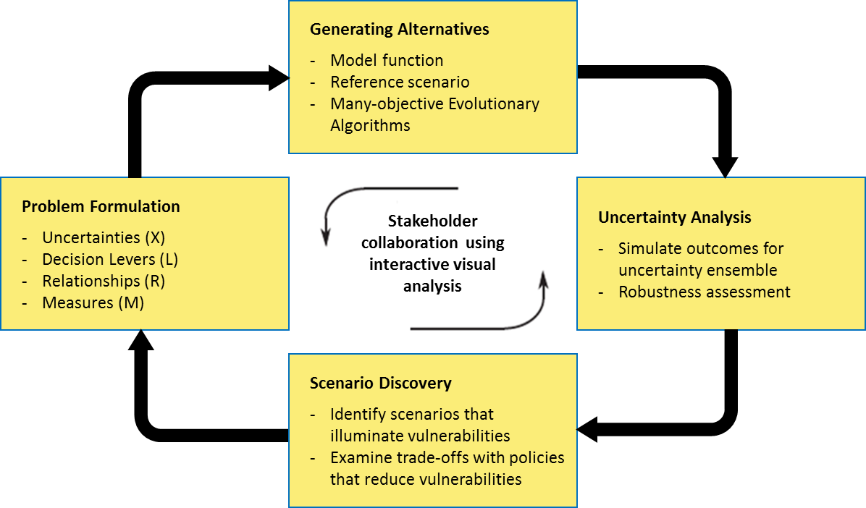

Figure 1 | Steps of the MORDM framework. Each step facilitates stakeholder involvement using interactive visual analytics (Kasprzyk et al. 2013).

Model development requires an XLRM-based specification structure, defined by exogenous uncertainties (X), decision levers (L), system relationships (R), and performance metrics (M) (Herman, 2013). The process of running computational experiments is conceptualised in terms of the XLRM notation by handling the model as a running function. Once a set of XLRM values is defined, MORDM uses a single reference scenario to compare the performance of potential policy alternatives, which is generally established with input from decision makers (Kasprzyk et al. 2013). Finding a good candidate strategy becomes feasible through searching over the range of decision levers (i.e. technology and policy levers). In the third step, the behaviour of these alternatives are tested across the set of uncertainty parameters and their robustness is defined using Uncertainty analysis (Kasprzyk et al. 2013). Scenario discovery reveals afterwards the conditions under which the candidate strategies perform poorly (Kwakkel, Haasnoot & Walker, 2016). The number of process repetitions is mostly interwoven to decision maker goals, but it is also a matter of finding solutions that retain their robustness after re-evaluation.

## 2.4 Research Methods

The research methods are the particular strategies which are used for the collection and the analysis of data in order to answer properly the respective research questions (Hammarberg, Kirkman & de Lacey, 2016). Insight on both the theory and the concepts related to the glassmaking process, as well as the perceived bottlenecks for the transition to a low-carbon industry and the role of robust decision making in policy analysis research will be sought from past dissertations, open-source code repositories, and through discussions with experts in the field of container glass production. Qualitative findings will be supplemented with quantitative results, based on which the main conclusions will be drawn. Interpretation is associated with the process of meaning-making, therefore both the results and the visuals will be critically discussed at every step of the methodology (Lukianova & Fell, 2015). In that final part of this study, the emerging trade-offs of the policy problem will be reflected from an industry standpoint. The following methods receive more detailed attention further on (see Chapters 4, 5 and 6).

2.4.1 Inventory of technologies and glass-making activities

The cornerstone of this study is the inventorisation of plant- and process-specific information on an industry aggregate level. A database is created which is composed of plant and commodity data, technology characteristics, and current plant configuration. It prerequisites the collection of up-to-date information with regards to capacities, equipment, energy usage and emissions per industrial location. The description of a technology option is also documented, which includes a general description of the concept, applications/experiences, technological development level, as well as specifications of any deviation from the benchmarking plant configuration described in Chapter 2.3.1. The information is mainly retrieved from scientific papers, company reports, and interviews with company representatives, which helped obtaining a clearer picture of location-specific manufacturing processes.

2.4.2 Mass/energy balance and financial metrics

The estimation of the mass transfer effects and reactions is essential when studying any industrial process (Moran, 2019; Madivate, 1998; Ruuska et al. 2017). For this purpose, mass and energy balancing is performed in MS Excel to extract quantitative information from the system under study (see Chapter 2.6), but also to examine any substantial changes on the energy and material flows caused by the candidate technologies (see Chapters 4.1; 4.2). Options that permit the continuation of the majority of the benchmarking operational capabilities are deemed technically feasible which, subsequently, enables the investigation of whether an option is financially feasible.

The financial metrics of Product cost, Return of investment (ROI) and Payback period are leveraged in an effort to take the cash flows into account (see Chapter 4.3). Their calculation requires information regarding market prices of fuel, materials and other feedstock, as well as the investment (CAPEX) and other economic implications (OPEX) of candidate technologies. Any uncertainties on the above specifications will be provided in bandwidths. The infrastructure assumptions or requirements will be documented depending on the availability of sources. Overall, the combination of these methods provide the reader with information regarding the energy use and pollutant emissions in every process activity, but also an assessment on feasibility of technology adoption within the plant’s commercial operations.

2.4.3 MORDM method

Based on the structure of the system model (i.e. elements, links, flows, and relationships among these elements), a many-objective optimisation is performed and candidate strategies are discovered which are Pareto optimal conditional on a reference scenario (see Chapter 6.2). The resulting set of options is re-evaluated over a sampling of deep uncertainty in order to assess its robustness (see Chapter 6.3). The conditions for which solutions are not robust are then discovered (see Chapter 6.4) which further enables optimisation for a different reference scenario (see Chapter 8.5). It is common the latter scenario is extracted from the subspace identified by the Scenario discovery where the solutions perform poorly (Watson & Kasprzyk, 2017). In the end, these two Pareto approximate sets from different scenarios can be combined and re-evaluated under deep uncertainty which increases the chances of finding decarbonisation solutions that retain their robustness.

## 2.5 Expert Elicitation

Glass experts and researchers have contributed to this study through sharing their insight and feedback. People from the research centres PBL and TNO in the Netherlands offered their support in a span of six months for structuring a methodology and building a solid model which replicates the industrial activities of a container glass plant. Interviews were conducted with company representatives from Ardagh Glass, Celsian and O-I, who shared their views and perspective on both the current status and the expectations on the Dutch container glass industry. Those immediate contributors have been the following:

* Sven-Roger Kahl - Furnace Operations and Innovations Group Manager, Ardagh Glass B.V
* Oscar Verheijen - Project leader on Process Optimization and Furnace Support, Celsian B.V
* Joost Lavèn - Environmental Health and Safety Manager NL, O-I Netherlands Schiedam B.V
* Hans Eerens - Senior Policy Researcher, PBL Netherlands Environmental Assessment Agency
* Marc Marsidi - Senior Researcher, PBL Netherlands Environmental Assessment Agency
* Ton van Dril - Senior Specialist at NL Organisation for Applied Scientific Research (TNO)
* Wouter Wetzels, Researcher at NL Organisation for Applied Scientific Research (TNO)
* Marco van Valburg - VP Engineering EMEA, Libbey Inc.

## 2.6 Research Focus

The specific energy consumption for the melting activity “explains” about three-fourths of the total energy use of the container glass plant (Tapasa et al. 2012). For this reason, the system boundaries of this study consist of the amount of industrial activities that take place in a glass facility with an emphasis on reducing the energy used in and the CO2 emitted from the melting process. The research is also conducted under the assumption that enough sustainable fuels (e.g. synthetic methane and hydrogen) will have been available for the container glass industry in the period of 2030-2050, and that the grid will have been gradually decarbonised through the generation of electricity using renewable sources.

The determination of topics under investigation enables the narrowing of candidate technology options (Table 1). The options are then categorised according to a framework laid out in Figure 10, and long-listed (Table 9) based on both their energy and emissions reduction potential. For example, heat integration techniques which reintroduce the wasted heat back to the melting furnace will be thoroughly examined, while options for external heat delivery are taken into account but not explicitly investigated.

Table 1 | Main and secondary focus of the research.

|  |  |
| --- | --- |
| **Focus** | **Details** |
| **Main focus**  (i.e. topics which are actively investigated within the context of the glass sector) | * Energy efficient heat integration (see Chapter 5.3) * Emerging technologies * Air/oxygen analysis * Batch and glass composition analysis * CO2 emissions and their reduction |
| **Secondary focus**  (i.e. topics which are not actively search for, but relevant points are drawn out of the selected literature) | * Feedstock substitution * Post-combustion carbon capture * Steam and electricity generation * Treatment of exhaust gases * Non-CO2 emissions (e.g. NOx, SOx) * Drivers, barriers, governmental policy |
| **Excluded topics**  (i.e. topics which are not explored due the defined system boundaries and time constraints) | * Building heating and heat recovery options outside   the boundaries of the glass plant (i.e. District heating)   * Energy efficiency in electrically driven equipment   (e.g. compressors, pumps, motors)   * Product switching (i.e. from glass to other materials) |

The main decarbonisation options are then short-listed based on the techno-economic criteria discussed in Chapter 2.3. The feasibility and the requirements of the shortlisted options will be discussed in terms of enablers and barriers for their implementation within the longer-term horizon of 2050 (see Chapter 5). The shortlisted technology options may go hand in hand with supporting options such as alternative energy carriers, batch reformulation or other innovative activities (see also Appendices C and D).

## 2.7 Research Flow

An overview of the structure of this study is provided in Figure A1 (see Appendix A), which illustrates how research phases and methods are interlinked. The thesis is submitted and made available to the TU Delft repository. Both the Excel model as well as the Python code which was developed for performing the decision support method are made available through GitHub.

# 3 Review of Concepts

This chapter provides an in-depth description of the concepts which are related to this study. Starting from an introduction on the current state of the container glass sector and the most common process activities, the chapter distinguishes and elaborates on concepts such as energy efficiency, decarbonisation, deep uncertainty, and robustness. The selected decision support method, as well as its relation to policy analysis will be further discussed. In the end, a solid base will have been established for designing a methodology in subsequent chapters.

## 3.1 The Dutch container glass industry

The developments in the Dutch container glass industry are driven by advancements in the food and beverage industry together with the demand for glass as packaging material. Such developments are associated with improvements in manufacturing process efficiency, with an emphasis on curtailing energy use and carbon emissions (FEVE, 2016). Over the period 1992-2010, the sector achieved an energy efficiency improvement of 22%, mitigated CO2 emissions by 10% and reduced SO2-, dust- and NOx-related emissions by 65-75% (VNG, 2012; FEVE, 2016). This trend of reduced energy consumption of container glass furnaces was primarily driven by factors such as furnace size, pull rates, selected raw materials, recycled glass content, efficiency of residual heat recovery systems, furnace insulation and sealing, and share of electric boosting. However the average energy use has begun to plateau, showing that the practical limits for energy efficiency have been reached (Figure 2).

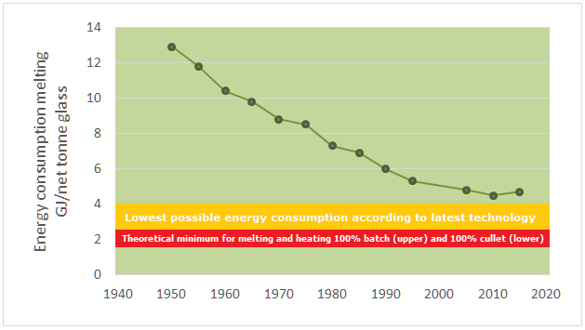

**Figure 2 | Average melting energy consumption in the Dutch container glass industry. Orange bar: best practical limits between 3.0-3.55 GJ using 50% cullet (excl. wall losses and preheating systems); Red bar: theoretical requirement for melting 100% recycled glass (Beerkens, 2012; Fraunhofer, 2019a)**.

Recycled glass in the form of cullet (i.e. broken pieces of glass) is used predominantly by the container glass industry to substitute virgin raw material (Schmitz et al. 2011). Groningen natural gas is the dominant energy source which is used for melting, refining and annealing (see Chapter 3.2). Non-melting processes typically account for 20-25% of the total energy demand, where a substantial share of this amount refers to electricity consumption. Current targets of the industry include a 25-40% energy efficiency improvement and deep emissions reduction by 2030 compared to 2009 levels, which will demonstrate net energy savings downstream the process, maximised economical returns and high quality glass products (JRC Report, 2013; PB & DNV GL, 2015a). An overview of the Dutch companies which participate in the [Emissions Trading System](https://ec.europa.eu/clima/policies/ets_en) (ETS), as well as their activities with regards to glass production can be found in Appendix A.

3.1.1 Role of recycled glass in the container glass industry

The container glass sector draws the vast majority of recycled glass, which comes from post-consumer glass or glass processing plants (Drummond, 2011). The recycled glass content of the total heterogeneous glass mix varies between 50-80% for external recycled cullet and 10% for internally recycled glass and depends on the requested glass quality and operating constraints (e.g. product changes per year).

By partly replacing a batch of mineral raw materials with recycled glass, the plant reduces:

1. the use of heat for the endothermic chemical reactions between batch components during the glass formation by the same rate (De Jong et al. 2011);
2. the fuel consumption by 2.5-3.3% for every 10% addition of cullet, purely calculated as melting energy saved (Madivate, 1998; Drummond, 2011; Butler & Hooper, 2011);
3. the demand for raw materials, among which the most significant are carbonates such as soda ash, limestone and dolomite that decompose in the furnace releasing CO2. In principle, the addition of 1tn of recycled glass leads to a reduction of 1.2tn of primary raw materials, along with consequent cuts in process emissions (JRC Report, 2013).

## 3.2 Container glass process activities

Glass manufacturing involves the conversion of raw materials into finished products that fulfil certain requirements (Chang, 1995). This conversion is accomplished using a great variety of activities that apply energy (i.e. mechanical, thermal, electrical, or chemical) to produce controlled changes in the configuration properties of materials (JRC Report, 2013; NAP, 1995). However, industrial emissions are intrinsically linked to the production process due to those activities (CAT, 2017). Energy efficiency and CO2 reduction need to be assessed in light of the melting techniques which are applied, as well as the existing infrastructure, fuel input, and glass characteristics.

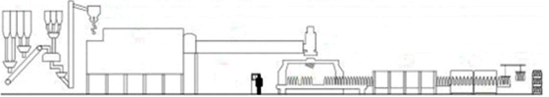

Figure 3 | Process activities for container glass production (Emhart Glass, 2012).

The production of container glass can be roughly subdivided into seven process steps: batch preparation, melting & fining, refining & conditioning, forming & moulding, annealing, surface treatment and inspection which are further described in the following chapters. Most of the energy is consumed in the melting of the heterogeneous mix up to the conditioning step. This part is assumed to be responsible for about 88% of the total energy consumption of the plant.

3.2.1 Batch preparation

The glass melting process starts from a granular mixture of natural and/or synthetic raw materials (i.e. batch). [Soda-lime-silica glass](https://en.wikipedia.org/wiki/Soda-lime_glass) is usually made by melting batches of silica sand (SiO2), soda ash (Na2CO3), limestone (CaCO3) and dolomite (CaMg(CO3)2). Alumina carriers (Al2O3) are added as stabilisers to enhance the chemical durability, while fining agents such as sodium sulphate are added to promote the removal of bubbles from the melt (Hujova et al. 2017). Small quantities of other additives are included to give desired characteristics to individual glasses (Ecofys, 2009). Recycled glass is used in variable quantities and can be found in proportions as high as 60–90% for external and 5-25% for internal cullet which originates from defective products. The materials are fed into the weighing area, carefully sorted and mixed according to a precise formula to form to a homogenous composition.

**Table 2 | Batch preparation energy and material requirements; own calculations.**

|  |  |  |  |
| --- | --- | --- | --- |
| **Parameter** | **Value** | **Unit** | **Comments** |
| **Input values** | | | |
| Electricity | 0.06 | GJ/tn packed glass | Assumed to be 1% of  total energy use |
| Silica sand | 190 - 195 | kg/tn packed glass | Table 4; Average of  three glass types |
| Soda ash | 50 - 58 | kg/tn packed glass | Table 4; Average of  three glass types |
| Limestone | 25 - 35 | kg/tn packed glass | Table 4; Average of  three glass types |
| Dolomite | 20 - 35 | kg/tn packed glass | Table 4; Average of  three glass types |
| Sodium sulphate | 1 - 2 | kg/tn packed glass | Table 4; Average of  three glass types |
| External cullet | 733 | kg/tn packed glass | Assumed 66% external cullet |
| Domestic cullet | 111 | kg/tn packed glass | Assumed 10% internal cullet |
| **Output values** | | | |
| Indirect CO2 | 8 | kg/tn packed glass | Emission factor 0.5 kg CO2  per kWh (WEC Report, 2018) |
| Batch mix | 1152 | kg/tn packed glass | Heterogeneous glass mix |

Variations batch formulas are used among glass-making companies which ultimately define the colour (i.e. flint, dark/light amber, and emerald green; see Chapter 4.1) and other desired characteristics of the produced container glass (see Chapter 3). Depending on the demand for glass and location-specific type of production, the plant may switches to other products for about 5-9 times per week[2]. The efficiency of the melting operation and the uniformity and quality of the glass are often determined by the conveyance of raw materials (i.e. carbonated or calcined) and the quality of mixing (De Jong et al. 2011). The operation requires electricity as primary energy source and accounts for 1.0-1.5% of total energy demand (IETD, 2018). Depending on the mixers used, a longer treatment than 3-8 minutes may result in segregation (De Jong et al. 2011). The batch is taken by a conveyor belt to the batch charger which supplies the glass furnace.

3.2.2 Melting & Fining

For transforming the batch and cullet mixture into molten glass, furnaces employ combustion heating (e.g. air/oxy-fuel burners), direct electrical heating or their combinations (e.g. electric boosting; see Appendix A). The melting activity normally reaches a 15-year uninterrupted operation period and accounts for about 75-80% of total energy use (i.e. 4.6 GJ/tn packed glass). Almost a third of this energy is dispersed in the exhaust gases and about 35% of it is structural losses depending on the degree of insulation, sealing and heat recovery options (Tapasa et al. 2012; see Chapter 5.3). The majority of total heat is absorbed by the mixture during the first 0.75‐1 hour, while the molten glass resides in the furnace between 8-32 hours depending on the melting technique, furnace capacity and glass quality standards. Process emissions originate from carbonate decomposition and account for 10-15% of total direct emissions (Ecofys, 2009).

Melting of raw materials, homogenisation and fining takes place in the melting end of the tank. After the glass went through a narrow channel called throat, the refining, final homogenization and conditioning of the glass takes place in a refiner and forehearth. The cold batch is heated by electrical heating and mainly by fuel-burning systems until batch-to-melt conversion takes place between 850-1200°C. The resulting glass melt contains bubbles and is further heated to temperatures of maximum 1550°C depending on glass specifications (i.e. colour, recycled glass content etc.) and until 1650ºC for fining. The mixture is continuously charged into the furnace to compensate for the glass withdrawn and keep the glass level in the furnace constant (IETD, 2018).

Depending on location-specific strategies by container glass companies, synthetic–ordered dolomite may be used in the batch mixture. The decomposition of calcium carbonate occurs in a two-stage process (Olszak-Humienik et al. 2015):

**CaMg(CO3)2(s) + Heat** ⇨ **CaCO3(s) + MgO(s) + CO2(g),** ΔΗf= - 1780 kJ/(kg CaCO3)(1)

**CaCO3(s) + Heat** ⇨ **CaO(s) + CO2(g),** ΔΗf= - 3303 kJ/(kg CaO)  (2)

Sodium carbonate serves as a flux for silica, enabling a decrease of the melting point of the mixture hence decreasing the residence time of the melt in the furnace (Hubert, 2015). Sodium carbonate requires lot of heat to completely decompose:

**Na2CO3(s) + Heat** ⇨ **Na2O(s) + CO2(g),** ΔΗf= - 3576 kJ/(kg Na2O) (3)

Decomposition of carbonates occurs between 600-900°C or even lower when dolomite is used while the addition of cullet can accelerate the melting of the mixture (Deng et al. 2018). The mix starts exhibiting liquid characteristics in temperatures around 800-850°C. Gases are released from fining agents across all temperature trajectories of the glass melt. Chemical homogenization is achieved in the bulk of the glass melt in the glass melting tank and further downstream[3].

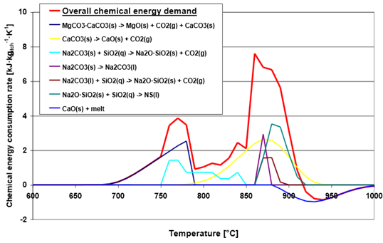

**Figure 4 | Chemical energy demand for the production of SLS glass (Hubert, 2015).**

Due to organic contamination in high cullet-containing batches as well as the sulphur originating from fining agents, the exhaust gases are often cleaned in an electrostatic filter when exiting the furnace and before entering a regenerator (i.e. technology for air preheating; see Chapter 5.3.4). Desulphurisation and normal operation of the filter takes place in temperatures between 250-380°C. Pollutant-abatement systems may be installed after the regenerator for cleaning this stream of process and combustion emissions (e.g. de-SOx and de-NOx).

Furnace can be sealed using a bag house filter, an air pollution control device and dust collector which is attached to the furnace. As a consequence, if a regenerative furnace is connected to a bag house filter it is mandatory to cool the flue gasses, because filter bags only withstand 220°C (TNO, 2010). Waste gas cooling takes place in a quench chamber that is operated either with air or water, or a combination of both (Sorg, 2011). If the flue gases are cooled down a lot, the cleaning system of flue gases may not work properly (HREII, 2018). For sulphur removal a temperature between 180-200°C is ideal, while the absorbent filter has 2 working temperature ranges: below 200°C and above 350°C[4]. When the remaining temperature is insufficient for flue gas cleaning after preheating, supplementary natural gas may be needed.

3.2.3 Refining & Conditioning

The other separated section of the tank is the refiner (i.e. refining end) in which the melt starts to cool and to condition toward its uniform working viscosity. An initially bubble-rich melt is produced by CO2 from carbonate-containing batch ingredients, together with water and air trapped in the interstices of the fill (De Jong et al. 2011). The refining takes place under controlled temperatures, starting from 1650oC and dropping down to 1400oC where the solubility of the gases in the melt increases with decreasing temperature (Hubert, 2015; Butler & Hooper. 2011). The refining time typically lasts 60-90 minutes and can influenced by a number of factors such as viscosity, batch composition, sulphate used and melting time (Watts, 2017).

The bubble-free molten glass is then distributed to a forehearth, a brick lined canal which delivers glass to the forming machine. The forehearth can be gas-fired or electrically heated, and its performance is determined by the range of pull rates (i.e. amount of molten glass produced), range of temperatures where the production maintains an acceptable degree of homogeneity, and its ability to maintain temperature stability (Beerkens, 2012). The outcome is a thermally and chemically homogeneous melt made available at the defined temperature level (Conradt, 2008). Energy required in both activities is 6-7% of the total consumption (JRC Report, 2013).

3.2.4 Forming & Moulding

The conditioned glass exits the melting tank and is transported to forming machines at a constant rate, where a plunger pushes it down through a narrow tube (Emhart Glass, 2012). As the stream of glass emerges from the tube, it is cut off using shears and turned into gobs of molten glass (i.e. even shapes which can be moulded). This takes place in 8-20 machines called Individual Sections (IS) which can be independently maintained. The forming machines give shape to the container glass through automated processes known as press-blow (mainly for jars) and blow-blow (mainly for bottles). By pressing the sheared gob into a blank mould using compressed air, the gob gets its intermediate shape (i.e. parison) which is then moved from the blank side to the blow side for final blowing and shaping (Figure 5). The energy used in forming containers is about 5-6% of the total energy use, and depends largely on the electricity for compressed air and the weight of the 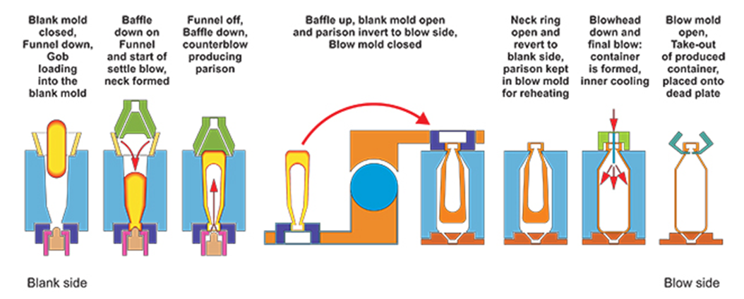container.

**Figure 5 | Blow-blowing process for container glass forming (Qorpak, 2019).**

3.2.5 Annealing

Once the blown containers are formed, they are loaded through a conveyor belt into a lehr for thermal treatment (i.e. annealing). Their temperature is rapidly brought back up to approx. 580°C, then reduced gradually and uniformly until no further strain can be induced (IETD, 2018). The product is cooled afterwards by fan air to room temperature. Without this activity, which accounts for approx. 4-5% of the total energy consumption, the glass would be low-resistant to cracks under small thermal or mechanical shocks (Hubert, 2015). The duration of the activity is important, both for the successful relieving of the glass from its internal stresses and for the reduction of the costs associated with the energy requirement. Depending on the product type (i.e. size and wall thickness), a 15-minute residence is required close to the annealing heating point, followed by a 30-60 minute residence close to a higher, strain point. Emerging from the lehr, the container glass is fully cooled and conveyed to further steps.

3.2.6 Surface Treatment

The coating of glass surfaces gives to the glass new physical and optical properties. Glass containers are coated with organic compounds to give the surfaces a degree of lubricity, thus preventing abrasion in handling (IETD, 2018). The two main types are stearate- and polyethylene-based coating, which add strength to the container, facilitates the application of labels and enables glass manufacturers to make lightweight products (Worrell et al. 2008). In contrast, the Internal Fluorination Treatment (IFT) is the process that makes soda-lime glass to treated soda-lime glass and is applied to prevent blooming (Qorpak, 2019). The energy required for post treatment is about 0.3-0.8% of the total energy use (Beerkens, 2012).

3.2.7 Inspection

Before the shipping of the final product, further activities include the Inspection, which uses fully automated devices to eliminate defective containers, and the Packaging of glass for transportation to the client’s factory (Meuleman, 2017). It includes measurements in terms of height, diameter, verticality, choke and thickness of containers. Critical defects are discarded as dangerous, while main-faults defects make the container unusable. Secondary defects represent a lowering of the quality of the container but do not affect the functionality of the container. As a result, the inspection contributes to the plant’s domestic cullet, sending rejected glass for re-melting.

Table 3 | Post-melting energy and material requirements.

|  |  |  |  |
| --- | --- | --- | --- |
| **Parameter** | **Value[5]** | **Units** | **Comments** |
| **Input values** | | | |
| Natural gas | 0.6 | GJ/tn packed glass | Needed for annealing |
| Electricity | 0.54 | GJ/tn packed glass | Needed for forming, annealing, surface treatment & inspection |
| Molten glass | 1152 | kg/tn packed glass | Glass melt exiting the furnace |
| **Output values** | | | |
| Direct CO2 | 37 | kg/tn packed glass | Emitted from annealing lehr |
| Indirect CO2 | 74 | kg/tn packed glass | Emission factor 0.5 kg CO2  per kWh (WEC Report, 2018) |
| Glass product | 1000 | kg/tn packed glass | Packed glass |
| Heat of Flue gases | 0.13 | GJ/tn packed glass | Exhaust gases leaving  the annealing lehr |

## 3.3 Transition to carbon neutral industry

3.3.1 Energy efficiency and decarbonisation

Energy efficiency is perceived as an area of competitive advantage for glass companies. Measures for improving energy efficiency have a direct financial benefit in terms of energy cost, helping to reduce companies’ operational costs (e.g. through increasing the lifespan of the furnace), reduce exposure to fluctuating energy prices and achieve subsequent cuts in CO2 emissions. The melting process have been the most important area for efficiency improvement, followed by refining and conditioning. Reducing energy intensity and capturing the full potential from energy efficiency improvements is inherently challenging (WEF Report, 2018). The trend of energy consumption over recent years has shown that improvements will remain limited without a major technological breakthrough (AGC, 2015). New directions are formed as a consequence, which put the industry in the spotlight to accelerate progress in low-carbon technology deployment (Fraunhofer, 2019a).

In an effort to make more decisive steps towards a low-carbon economy with inclusion of the most energy-intensive sectors, the Dutch Government presented its decarbonisation plans in the Climate Agreement[6] on June 28th, 2019 (ISPT, 2019). The objective of 49% reduction in CO2 emissions by 2030 compared to 1990 has been set, with an effort to balance the burdens evenly between individuals and businesses (Pieters, 2019). Prior to that, the proposal for the Climate Act in June 10th, 2018 laid out goals to achieve further reductions of GHG by 80-95% in the longer term horizon of 2050[7]. An added pressure is put upon the polluting industries through the carbon tax for achieving these ambitious targets (Pieters, 2019). The emission permits[8] which set an enforceable limit on the amount of pollution allowed to emit become stricter over time (Masselink, 2008; Evans, 2018; Nijpels, 2018). Under this carbon pricing regime, the contributions of the stakeholder parties will determine the extent to which the industry, and the container glass sector as a consequence, will be able to fulfil these ambitions in 2030 and ultimately in 2050.

3.3.2 Best Available Technologies (BATs)

Best Available Technologies (BATs) or “best practices” has been defined by Directive 96/61/EC on Integrated Pollution Prevention and Control (IPPC) as favourable techniques to apply for limiting pollutant discharges with regard to an abatement strategy (Griffin, 2016). In the past years, the improved energy efficiency and the deployment of BATs have been the key levers for achieving cumulative emissions reduction in the industrial sector (JRC Report, 2013; West, 2017; Masselink, 2008). A reference document (BREF) was prepared to facilitate the development of a productive and competitive industry, which provides descriptions of a range of industrial processes, as well as their respective operating conditions and emission rates (Tobler-Rohr, 2011).

The container glass industry employs BATs which target energy efficiency and deliver verifiable operational cost savings, while cutting CO2 emissions. Air/fuel fired furnaces are equipped with regenerators for primary heat recovery which preheat the combustion air (see Chapter 5.3). Secondary heat recovery can be installed in both air/fuel and oxy/fuel furnaces to generate electricity, preheat batch and/or cullet, or generate steam in waste-heat recovery boilers (Wallenberger, 2010). Oxy-fuel combustion for making the furnaces more thermally efficient and full-electric furnaces have been some of the major energy saving efficiency opportunities for the glass sector (IETD, 2018; Karellas et al. 2018; Hatzilau et al. 2016; Harmsen et al. 2018; GFE, 2011). BATs are not independent from product quality and must therefore be adapted in each case.

3.3.3 Emerging technologies

Having reached the efficiency limits of the prevailing technologies or practices, future reductions in absolute energy use and process- or combustion-related CO2 emissions will require further innovation in this industry (Springer & Hasanbeigi, 2017). Innovations will likely include development of alternative processes and materials for glass production or technologies that can economically capture and store emissions (HRE, 2018; Meuleman, 2017). Carbon-reducing technologies can be either commercially available or gradually evolve and meet the “commercially viable” standards (i.e. innovations with TRL 4 or greater) (Shah, 2017; IEA, 2018). The development of these emerging technologies and their deployment in the market will be a key factor in the glass industry’s mid- and long-term climate change mitigation strategies (Hasanbeigi, 2018).

The decarbonisation potential of synthetic methane and renewable hydrogen, post-combustion CCS, direct use of electricity or radical process innovations are examples of technologies or processes which are currently under research within the container glass industry (Fiehl et al. 2017; Fraunhofer, 2019a; Springer et al. 2017; Stormont, 2017). Their deployment as well as a balanced mix of these options must be able to compete with existing technologies. The investment decision on these technologies is interlinked to the companies’ sustainability goals, provided that the requested glass quality is maintained, the production is not disrupted, further cuts in production costs are enabled, and CO2 emissions reduction are achieved in both the current and future energy systems. Novel technologies which are expected to be introduced in the market by 2030-2050 but information on their technical characteristics are scarce will be presented in Appendix D.

## 3.4 Decision making under deep uncertainty

3.4.1 Deep uncertainty

Policy problems are often subject to uncertainties which cannot be addressed by incorporating probabilities and statistics into the analysis. These sources of uncertainty can be cognitive, strategic, or institutional which are characterised by partial or complete lack of information (van Bueren, Klijn, & Koppenjan, 2003). Such deeply uncertain factors are known as “deep uncertainties”, the presence of which prevents the accurate prediction and determination of an optimal solution (Walker, Lempert, & Kwakkel, 2013). Within the context of model‐based decision support, deep uncertainty is defined as the situation where the analyst is able to enumerate a variety of possibilities (e.g. futures and model formulations) without being able or willing to order these possibilities in terms of their perceived likelihood (Kwakkel, Walker & Marchau, 2010).

Both energy transition and decarbonisation strategies are deeply uncertain, and yet the impact of deep uncertainty on energy transition endeavours had been largely undermined (Pruyt et al. 2011; Köhler et al. 2018). Deep uncertainties exist about the availability of future technologies, the effectiveness and economic impact of the energy policies, as well as the balancing of a multitude of industrial objectives (Rosen & Guenther, 2015; Kalra et al. 2014; Bowen, 2011). Such factors have a direct impact on technology innovation and ultimately impede investment decisions (IEA, 2008; Lempert, Popper & Bankes, 2003). It is likely that the effects of deep uncertainty of the future of technology deployment will continue to hinder multilateral and informed decision-making (Moallemi, de Haan & Köhler, 2018; Lempert, Popper & Bankes, 2003).

3.4.2 Robustness vs. Optimality

The traditional way of approaching policy problems denotes a “predict-then-act” structure, in which a single computational model incorporates all known information to approximate a real-world system (Bankes, 1993). An optimal solution can then be extracted, as dictated by the ideal course of action of that known future. Contrary to the traditional methods of analysis and decision support for policy problems, methods that incorporate deep uncertainty have been developed by minimizing the need for a priori assumptions of deeply uncertain factors (Lempert, 2002). The focus is shifted to extracting a set of robust solutions that perform well under many possible futures, rather than seeking the single optimal solution (Bryant & Lempert, 2010).

Robust strategies factor in uncertainty, and their expected performance is only weakly affected by a wide variety of future events (Kwakkel, 2017a). Whether a decision is “robust” depends on whether it has adequately represented possible uncertainties. Therefore, “robustness” can be thought of as a measure of the insensitivity of the performance of a given strategy to future conditions. In the context of this study, the uncertain future of fuel prices, the increasing permit pressure, as well as the volatile availability of recycled glass indicate that successful scenarios are examples that exhibit robustness than optimality when deploying CO2-reducing technologies. This enables performing search for finding promising optimum rather than optimise outcomes.

3.4.3 Decision support methods and Policy analysis

Analysts often undertake the translation of necessities into parameters within the context of a policy problem. This primarily happens by looking at the numbers through the model, which is by definition an approximate representation of the system under study (Giere, 2004). Two main issues arise from this: (a) not all aspects of the policy problem are incorporated in the model, and (b) the complete alignment with reality is not always sensible. On top of that, the models themselves cannot calculate consequences, as well as interpret how the uncertain factors of a policy problem impact decision making. They are the means for translating data into meaningful information, showing the intelligence of data by revealing the story behind them.

Decision-making support methods under deep uncertainty (i.e. DMDU methods) can help addressing uncertain conditions of a policy problem, broadening up perspective instead of minimising objectives. Babovic, Mijic & Madani (2018) argue that DMDU frameworks offer an improved ability to design reliable systems regardless of highly uncertain future conditions.

DMDU methods build around:

1. the consideration of multiple futures in the planning instead of a single future, and choose these futures to stress test the mappings from decision to outcome space;
2. the search of robust plans that perform well over many futures, instead of optimal one which are designed for a single, best-estimate future;
3. the construction of flexible and adaptive plans, which often makes them more robust.

From an industry perspective where it is necessary to balance between production costs and emitted greenhouse gases, the MORDM method is the DMDU method which is used to determine a posteriori how likely these outcomes might be (Herman & Kasprzyk, 2013; Hong, 2013). For that purpose, MORDM is used to generate multiple policy alternatives and assess their robustness a posteriori across multiple states of the world (SOWs) (Kasprzyk et al. 2013). MORDM has been used for integrating long-term infrastructure investments, medium-term financial instruments, and short-term operational strategies (Lempert, 2018). Other DMDU methods that build on the work of MORDM are Multi-scenario RDM and Many-Objective Robust Optimization. The former provides a more diverse mechanism to evaluate performance of a policy alternative (Watson & Kasprzyk, 2017). The latter determines robustness by examining how each solution responds to changes in key model variables (Deb & Gupta, 2006). For each outcome of interest, the robustness over this set is calculated. The limitations of these DMDU methods are discussed in Chapter 11.3.

3.4.4 EMA Workbench

Complex optimization problems often require hybridizations of techniques to obtain high-quality solutions in reasonable time (de la Banda et al. 2014). Building hybrid solutions becomes feasible through the Exploratory Modelling and Analysis (EMA) Workbench, a Python-based toolkit which provides a highly customization interface for performing analysis, visualisation and optimization. The optimization can be used in three ways: over levers for a scenario (MORDM), over uncertainties for a policy (worst-case), and over levers for set of scenarios (robust search). The workbench supports many-objective optimization, uncertainty analysis, scenario discovery and interactive visualizations (Kwakkel, 2017b; Kasprzyk et al. 2013), which are techniques for supporting the making of decisions under deep uncertainty while helping the analyst expand what he/she can do with a model (Kwakkel, 2018).

The basic idea of EMA is to develop an ensemble of models that capture different sets of assumptions about the world and to explore the behaviour of this ensemble through computational experiments. A single model run drawn from this set of plausible models provides a computational experiment that reveals how the world would behave if the assumptions encapsulated in this specific model were correct (Watson & Kasprzyk, 2017). The connectors’ package of the workbench contains connectors to modelling environments among which MS Excel, and the analysis package contains a wide range of techniques for visualization and analysis of the results from series of computational experiments. For more information, the reader can also refer to the Water Programming research blog[9].

*.*

# II Methods

*This section elaborates on the methodology which is employed for addressing the research questions of this study. This includes the development of a benchmarking configuration of a container glass plant which will allow testing the performance of best available and emerging technologies. A method for performing techno-economic analysis will be presented and empirical evidence will be acquired with regards to the industrial process activities. The impact of candidate technologies on the energy and material flows will also be portrayed. Later on, a series of techniques is selected to complement the decision aid approach. This involves finding robust decarbonisation options which account for conflicting objectives. The section closes with the mechanisms employed for model verification and validation.*

# 4 Techno-economic Analysis

In response to the first sub-question, a methodology is proposed for performing techno-economic analysis within the context of the container glass industry. Benchmarking conditions for the current process activities are identified in terms of energy requirements and CO2 emissions which helps understanding the implications of technologies into the process. This empirical evidence will enable the investigation of the energy performance and decarbonisation potential of process technologies. The technical and economic feasibility of technologies are evaluated afterwards, which leads to the formation of technology combinations for deployment consideration.

**SQ1**: How can a techno-economic analysis of best available and emerging technologies and their combinations help the container glass sector achieve deep CO2 reductions?

Within the analysis of physical systems in MS Excel, mass and energy balance assists the estimation of material and energy requirements of units or equipment, total emitted CO2, as well as waste heat and material cycles. Particular emphasis is given to the melting activity which accounts for about 80% of a plant’s energy use and emissions. The empirical evidence consist of the baseline for evaluating the energy and CO2 savings from introducing a novel technology.

## 4.1 Material Flow Analysis

Material flow analysis helps minimising the assumptions about the primary energy needed to deliver energy to the system and the chemical composition of batches and final products. For this purpose, mass balance is performed for estimating the material requirements and cycles which are directly connected to the material and emissions streams. The batch weight is the aggregate of virgin materials and recycled cullet (i.e. heterogeneous mixture) and equals to the amount of molten glass added by the process emissions (Eq. 1, 2). Approximately 10% of glass is lost in activities downstream of the melting (i.e. pack-to-melt ratio) which is re-introduced back to the batch mixing. The reactions taken place can be expressed as:

((1 + b) kg of batch) (Troom) ⇨ (1 kg of glass mix) (Troom) + (b kg of gas) (Troom), *ΔHR* (1)

(1 kg of glass mix) (Troom) ⇨ (1 kg of glass melt) (T), *ΔHglass* (2)

(b kg of gas) (Troom) ⇨ (b kg of gas) (T), *bΔHgas* (3)

where *T*: melting temperature, *b*: gas emitted during reaction, *ΔHR*: sum of energy necessary to decompose raw materials to oxides and energy involved in the formation of vitreous phases of glass (approx. 0.3 GJ/tn glass), *ΔHglass*: enthalpy of glass (approx. 0.6 GJ/tn glass depending on the glass type), and *ΔHgas*: enthalpy of gases (approx. 0.28 GJ/tn glass). The enthalpies used originate from standard thermochemical tables and they are presented in Chapter 4.2.

The batch and glass compositions per glass colour are presented in Table 4, which are normalised by the sum of the most abundant contents to 100%. The end-product contains 70-74% silica, 12-15% sodium oxide, and 10-15% calcium oxide by weight. The heat capacities under constant pressure[10] (cp) for raw materials and natural gas compounds were calculated using formulas of Moore et al. (1951; 1958) and Engineering Toolbox[11], respectively.

**Table 4 | Chemical composition Batch and glass product (Madivate, 1998).**

|  |  |  |  |  |  |  |
| --- | --- | --- | --- | --- | --- | --- |
| **Compound** | **Flint** | **Amber** | **Green** | **Molar mass**  **(kg/mol)** | **Heat capac.**  **(kJ/mol*K)** | **Density**  **(kg/m3)** |
| **Batch composition (wt %)** | | | | | | |
| SiO2 | 62.28 | 61.98 | 62.96 | 0.060 | 0.111 | 0.265 |
| Na2CO3 | 18.42 | 16.79 | 18.89 | 0.106 | 0.115 | 0.254 |
| CaCO3 | 7.78 | 9.81 | 11.33 | 0.101 | 0.098 | 0.271 |
| CaMg(CO3)2 | 10.90 | 11.11 | 6.31 | 0.184 | 0.225 | 0.286 |
| Na2SO4 | 0.62 | 0.31 | 0.51 | 0.142 | 0.199 | 0.266 |
| **Glass composition (wt %)** | | | | | | |
| SiO2 | 73.07 | 73.39 | 73.31 | 0.060 | 0.283 | 0.265 |
| Na2O | 12.72 | 12.36 | 12.74 | 0.062 | 0.483 | 0.227 |
| CaO | 9.86 | 9.91 | 10.00 | 0.056 | 0.254 | 0.334 |
| MgO | 2.84 | 2.77 | 2.03 | 0.040 | 0.318 | 0.358 |
| Al2O3 | 1.53 | 1.58 | 1.92 | 0.102 | 0.278 | 0.395 |
| **Process emissions (vol %)** | | | | | | |
| CO2 | 98.18 | 99.14 | 98.44 | 0.044 | 1.097 | 1.977 |
| SO2 | 1.22 | 0.57 | 1.04 | 0.064 | 2.109 | 2.630 |
| O2 | 0.60 | 0.28 | 0.52 | 0.032 | 1.037 | 1.331 |

## 4.2 Energy Flow Analysis

The estimation of melting heat starts from determining the energy requirement for the fusion of input materials in quantities which are retrieved from publicly available reports. That way, the heat released in the combustion space can be obtained by subtracting the melting heat, the enthalpy exchange of input materials and the heat losses through combustion space and glass tank refractory from the enthalpies of fuel and flue gases (Khoshmanesh et al. 2007). Any unknown values are initially filled with industry averages, which will be calibrated based on location-specific information when a complete image of the plant functioning is obtained.

Depending on energy recovery options applied in the process as well as the oxidant used for the combustion of fuel, the respective temperature windows of flame, furnace and flue gases are extracted and a first impression about the energy use is obtained. The iterative application of this method helps for the assessment of the specific energy consumption of the furnace by imitating the continuous process of glass melting (Figure 6). Values are expressed in tonnes of molten glass when extracting the heat values related to the furnace, and expressed in tonnes of packed glass when referring to the glassmaking process as whole[12]. These more detailed calculations for specific plant types and glass types were performed and are presented in Chapters 4.2.1 and 4.2.2.

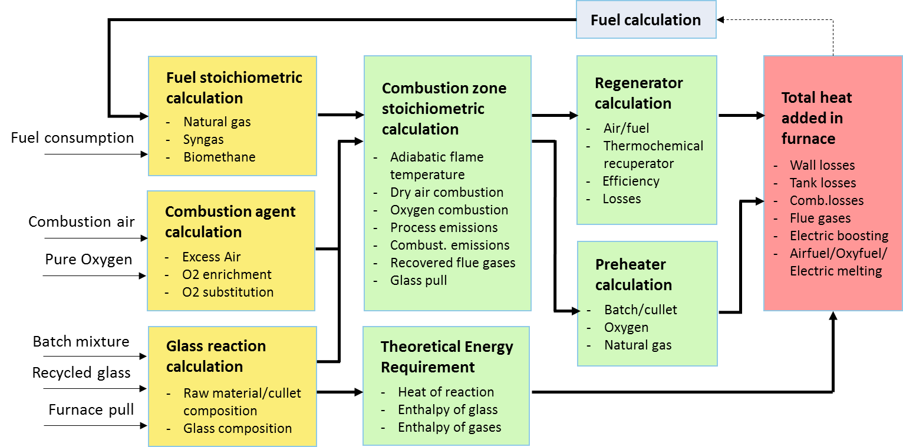

**Figure 6 | Method followed for estimating specific energy consumption of furnaces.**

4.2.1 Theoretical Energy Requirement

The estimation of the material and emissions streams enables the application of the laws of thermodynamics for calculating the energy requirements of the melting activity (Figure 6). Integral to the calculation of the specific energy consumption of the melting activity is the estimation of the temperature windows of the batch melting point and furnace operation. Within these boundary conditions, the simplified methodology proposed by Madivate (1998) is used for calculating the theoretical energy requirement for silicate glasses. This includes the heat involved in the transformation of a certain amount of batch material at room temperature to molten glass and flue gas at temperature *T* in the glass-melting region.

The estimation of the temperature windows of both the furnace operation and batch melting point are necessary for setting realistic boundaries for the calculation of the specific energy use of the furnace. With the assumption that the trajectories of both the furnace temperature (Eq. 4) and the batch melting point (Eq. 5) have the same slope and are proportional to the cullet added to the batch[13], these temperatures can be approximated using the following formulas:

**Furnace Temperature** = Tf *(1 + E*(1-C/100)) / (2*10) (4)

**Batch melting point** = Tm*(1 + E*(1-C/100)) / (2*10) (5)

where *Tf*: furnace temperature for 100% cullet, *Tm*: melting temperature for 100% cullet, *E*: energy savings per cullet (approx. 33% for 100% cullet), *C*: cullet percentage, *C/10*: amount of times that a 10% increase is added in the batch. The melting point moves within the temperature window for sand dissolution and increases after the melting for homogenising the molten glass (i.e. maximum furnace temperature; see Chapter 3.2). In regenerative furnaces, furnace temperatures lower than 1485oC would endanger the integrity of the crown (i.e. furnace roof).

This study leverages the methodology proposed by Madivate (1998) for calculating the theoretical energy requirement (TER) for the fusion of glass. The energy consumption of the furnace is considered constant in the modelling. In reality it is dependent on the production level of the equipment which should be taken into account when calculating emissions. But in that case, a full bottom-up model would be needed which is beyond the scope of this work. The results generally have a deviation of <2% from results of more-complex approaches (Madivate, 1998, pp. 3305). The theoretical energy requirement (TER) for the fusion of glass is expressed as follows:

**TER** = ΔHglass(T) + ΔHgas(T) + ΔHR(Troom), [kJ/(kg of glass mix)] (6)

where *ΔHglass* is the heat required to raise the temperature of the raw materials from 25oC (*Troom*) to the highest melting point and then raise the temperature of the melt until the maximum furnace temperature, *ΔHR* is the latent heat required to enable the reactions between the batch components to form the glass as a function of *Troom*, and *ΔHgas* is the heat content of the gases released from the batch during melting, all expressed in kJ per kg of the heterogeneous glass mix. The mixing enthalpy which is involved in the transformation of the batch and cullet mixture into homogeneous molten glass was neglected (see Chapter 3.2.2).

The mass fraction of oxides Na2O, CaO, and SiO2 which are found in abundance in the glasses under study are normalised by their sum to 100%. By leveraging the glass compositions of Table 4 for the respective type, the elements of Eq. (6) are obtained from the following relations (Madivate, 1998):

**ΔHglass(T)** = Σ(%oxide)i*xi + [Σ(%oxide)i*yi]*T (7)

**ΔHgas(T)** = b * [Σmiai*(T-296) + (0.5/10-3)*Σmibi*(T2-2962) - …

… - (1/106)* Σmici*(T-1-296-1) + (0.33/106)*Σmidi*(T3-2963)] (8)

**ΔHR** = (1+b)*(ΣΔΗd,i*mi) + ΔHf,1*(%CaO/100) + …

… + ΔHf,2*(rest-Na2O/100) + ΔHf,3*(rest-SiO2/100) (9)

where: rest-Na2O = %Na2O - %CaO*(MNa2O/3*MCaO) (10)

rest-SiO2 = %SiO2 - %CaO*(6*MSiO2/3*MCaO) - rest-Na2O*(2*MSiO2/MNa2O) (11)

and *%oxide*: percentage of glass content extracted from Table 4, *xi* and *yi*: factors which have been derived from measured heat contents of glass samples using standard linear regression (see Table 5a), *T*: batch melting point (Eq. 5), *b*: gas emitted during reaction, *mi*: mass fraction of a given component of process emissions, *ai, bi, ci,* and *di*: coefficients of heat capacity (see Table 6), *ΔHd,i*: enthalpies of dissociation of raw materials to their respective oxides for the production of the silicate glasses under study (see Table 5b), ΔHf,1= -3303 kJ/(kg CaO), ΔHf,2= -3576 kJ/(kg Na2O), and ΔHf,3= 152 kJ/(kg SiO2), and *MNa2O, MCaO, Msio2*: molar mass of the respective oxide.

The parameters *rest-Na2O* and *rest-SiO2* in Eq. (10) and (11) denote the respective amounts of Na2O and SiO2 which are not consumed in the following reactions:

**Na2O + 3CaO + 6SiO2** ⇨ **Na2O.3CaO.6SiO2**,ΔΗf1= - 3303 kJ/(kg CaO) (12)

**Na2O + 2SiO2** ⇨ **Na2O.2SiO2**,ΔΗf2= - 3576 kJ/(kg Na2O)  (13)

**Table 5 | (a) Factors for calculating ΔHglass; (b) Enthalpies of dissociation of raw materials (Madivate, 1998).**

|  |  |  |
| --- | --- | --- |
| **Oxides** | **xi** | **yi** |
| SiO2 | 67.67 | −0.014 |
| Na2O | −133.30 | −0.027 |
| CaO | −264.00 | 0.148 |
| MgO | −224.40 | 0.124 |
| Al2O3 | −365.10 | 0.250 |

|  |  |
| --- | --- |
| **Compounds** | **ΔΗd,i**  **(kg/kg raw)** |
| Na2CO3 | 3040 |
| CaCO3 | 1796 |
| CaMg(CO3)2 | 1649 |
| Na2SO4++ | 4063 |
| Al(OH)3 | 1188 |

**Table 6 | Coefficients of the heat capacity equation for calculating ΔHgas.**

|  |  |  |  |  |
| --- | --- | --- | --- | --- |
| **Gases** | **ai** | **bi** | **ci** | **di** |
| CO2 | 1.162 | 0.099 | 0.033 | - |
| SO2 | 0.780 | 0.074 | 0.016 | - |
| NO2 | 0.750 | 0.536 | 0.009 | 0.149 |
| O2 | 0.911 | 0.202 | 0.006 | 0.032 |
| H2O | 1.910 | 0.436 | 0.024 | - |

Assuming that the cullet does not undergo any transformation during melting, the Eq. (6) can be expanded for including the impact of cullet in TER. Therefore the TER value for cullet-containing batches becomes:

TER’ = ((1-c)*TER + c*(1+b)*ΔHglass) / (1+c*b), [kJ/kg of glass melt] (14)

4.2.2 Fuel combustion

Glass melting furnaces make use of either air or oxygen for generating flames that bring the heat for transforming raw materials into molten glass. Combustion emissions per unit of energy are attributed to the fuel input, the most common of which is methane processed from natural gas (Butler & Hooper, 2011). The CO2 and water vapour (H2O) released by the combustion of natural gas with atmospheric air will participate to the heat transfer to the glass while the nitrogen (N2) will only be “a heated load” then lost by the fumes at the furnace outlet. The heat capacities of the natural gas, the air compounds and the combustion emissions correspond to the temperature window between the ambient and the furnace temperatures (Table 7). By contrast, the estimation of indirect CO2 emissions uses country-specific CO2 emission factors related to the electricity generation (approx. 0.5kg/kWh) (VNPI, 2018; WEC Report, 2018).

Table 7 | Composition of Natural gas and atmospheric air (Gasunie, 1980).

|  |  |  |  |  |  |
| --- | --- | --- | --- | --- | --- |
| Compound | Composition  **(vol %)** | Gross C.V.  (MJ/m3) | Molar mass  (kg/mol) | Heat capacity  (kJ/K*mol) | Density  (kg/m3) |
| **Groningen Natural gas** | | | | | |
| CH4 | 81.30 | 39.82 | 0.016 | 4.099 | 0.668 |
| C2H6 | 2.88 | 70.31 | 0.030 | 3.398 | 1.264 |
| C3H8 | 0.39 | 101.23 | 0.044 | 3.172 | 1.882 |
| C4H10 | 0.16 | 133.69 | 0.058 | 3.148 | 2.489 |
| C5H12 | 0.04 | 169.27 | 0.072 | 3.128 | 3.390 |
| N2 | 14.33 | - | 0.028 | 1.150 | 1.165 |
| O2 | 0.01 | - | 0.032 | 1.037 | 1.331 |
| CO2 | 0.90 | - | 0.044 | 1.097 | 1.977 |
| **Atmospheric air** | | | | | |
| N2 | 78.10 | - | 0.028 | 1.150 | 1.165 |
| O2 | 20.94 | - | 0.032 | 1.037 | 1.331 |
| Ar | 0.93 | - | 0.040 | 0.907 | 1.661 |
| CO2 | 0.03 | - | 0.044 | 1.097 | 1.977 |
| **Exhaust gases from Natural gas combustion** | | | | | |
| N2 | 67.25 | - | 0.028 | 1.150 | 1.165 |
| O2 | 0.001 | - | 0.032 | 1.037 | 1.331 |
| Ar | 0.78 | - | 0.040 | 0.907 | 1.661 |
| CO2 | 8.39 | - | 0.044 | 1.097 | 1.977 |
| H2O | 23.57 | - | 0.018 | 2.288 | 0.554 |

4.2.3 Heat balance

Heat balance is considered as a guideline for determining energy conservation in a glass-melting furnace since it can monitor heat losses and furnace efficiency (Tapasa et al. 2012). Factors that have a major influence on energy consumption and emissions are fuel used, furnace age and capacity utilisation, cullet percentage, mixed batch recipe and degree of residual heat recovery. By recovering minimum losses from flue gases, energy savings is obtained regarding a system with process recovery, combustion recovery, and recovery of both. In regenerative furnaces, the heat effects are balanced in the following manner:

Qfuel - Qflue + Qpreheat air = QU + Qloss - Qpreheat batch (15)

where *Qfuel*: primary energy, *Qflue*: heat carried by exhaust gases, *Qpreheat air*: energy re-introduced from the regenerator, *QU*: theoretical energy requirement, *Qloss*: sum of combustion space and tank losses, *Qpreheat batch*: heat carried by batch mix. The left-hand side of Eq. (15) expresses the heat released in the combustion space and the right part denotes the heat consumption in the furnace (Khoshmanesh et al. 2007).

To maintain a constant temperature in the furnace, a certain rate of heat transfer from the combustion gas is required. Assuming that combustion takes place under adiabatic conditions, the energy balance for the flow through the furnace becomes:

CV + HR = HP + Qu+ Qloss mNG*LHV + mR*CpR*(Tpreh - To) = mP* CpP*(Tflame - To) (16)

where *CV*: net calorific value[14], *HR*: sensible heat of reactants (i.e. fuel and oxidant), *HP*: heat of products (i.e. flue gas), *To*: ambient temperature, and *Tflame*: theoretical flame temperature. More specifically, *Tflame* represents the practical upper limit of flame tem­perature when fuel and oxidant is mixed rapidly and ignited (Baukal, 2013). Preheating the reactants (e.g. atmospheric air) leads to higher flame temperatures, hence increased heat transfer in the system and better effectiveness of the regenerative heat exchanger.

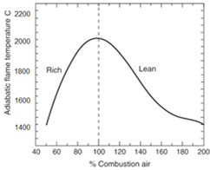If combustion takes place with an oxygen rich gas, high flame temperatures can be reached as the mass of flue gas is considerably reduced. This causes the enthalpy difference between the flame-temperature gas and the exhaust to become higher (Ming et al. 2003). For the same heat transfer, this would lead to a lower required mass flow rate which is proportional to fuel consumption. Therefore, fewer carbon dioxide is formed as a result of burning less fuel.

**Figure 7 | (a) Flame temperature versus air-fuel ratio (Boateng, 2016); (b) Effect of the increased O2 concentration on the flame temperature (Hendershot, 2010).**

The calculation of energy requirements is iterative, and depends on the assumptions made for both the combustion agent and the heat recovery options. When the modelling paradigm prevents from having a variable energy input, then the exploited wasted heat *Qpreheat.Air* and *Qpreheat.Batch* can be subtracted from the primary *Qfuel* with a deviation < 3.5% from the actual situation. More information in combustion with oxygen is provided in Chapter 5.3.2.

Total energy consumption of a container glass plant is between 5.8 – 6.5 GJ per tonne of packed glass[15] and depends on the glass colour and amount of furnaces and articles produced[16]. Energy is coming from both gas and electrical boosting, where electricity is normally used in rates 8-15% of the total melting energy (Figure 8; see also Appendix C). Furnace designs are bound to the plant’s space, while the investment decision on selecting a furnace type is mostly affected by the quality of the product, stability and lifetime. The frequency of maintenance is also dependent on the company’s strategy, in an effort to avoid the shut-down of the production line (i.e. downtime lasts 35-40 days) and technically achieve extended lifetimes (Ecofys, 2009). An indication for the latter would be a steep increase of energy consumption or the considerable wear of refractories which increases the risk of unexpected leaks[17].

4.2.4 Waste heat recovery

The otherwise lost residual heat is taken as heating medium from the waste gas channel of the melting end. Waste heat recovery options are interlinked to the furnace type (i.e. air/fuel, oxy/fuel) as well as the temperature and purity of the flue gases exiting the furnace or the regenerator (see Appendix A; Chapter 5.3.4). The recovered heat from flue gas is about 60-68% depending on the heat recovery system, which helps to maintain the primary energy input for melting at the levels of 4.5-4.8 GJ per tonne of packed glass. A heat recovery system of high efficiency results in residual gases of low heat content which prevents a further use of the exiting gases. Options that do not use the residual heat directly back to the meting process may be more preferable for process control reasons (see Chapter 5.6), but may also require the cleaning of flue gases and also stay above 180oC to avoid sulphuric acid (e.g. preheating natural gas for annealing).

4.2.5 Process flowchart

Process flow diagrams are an integral part of plant- and process-specific information which depict the individual process steps within product manufacturing (Wynn & Clarkson, 2018; van Berchum et al. 2018). The generic process flow chart shown in Figure 8 is deemed representative for the average Dutch container glass manufacturing process, neglecting specifics of the different production locations. Its development facilitated the embedding, the communication and the validation of the empirical evidence with the assistance of glass experts. After conducting material and energy flow analysis, the process flowchart is then finalised. Unnecessary steps, bottlenecks and other inefficiencies can be identified, allowing the interaction between equipment and process streams to be further explored (Bhattacharyya et al. 2012).

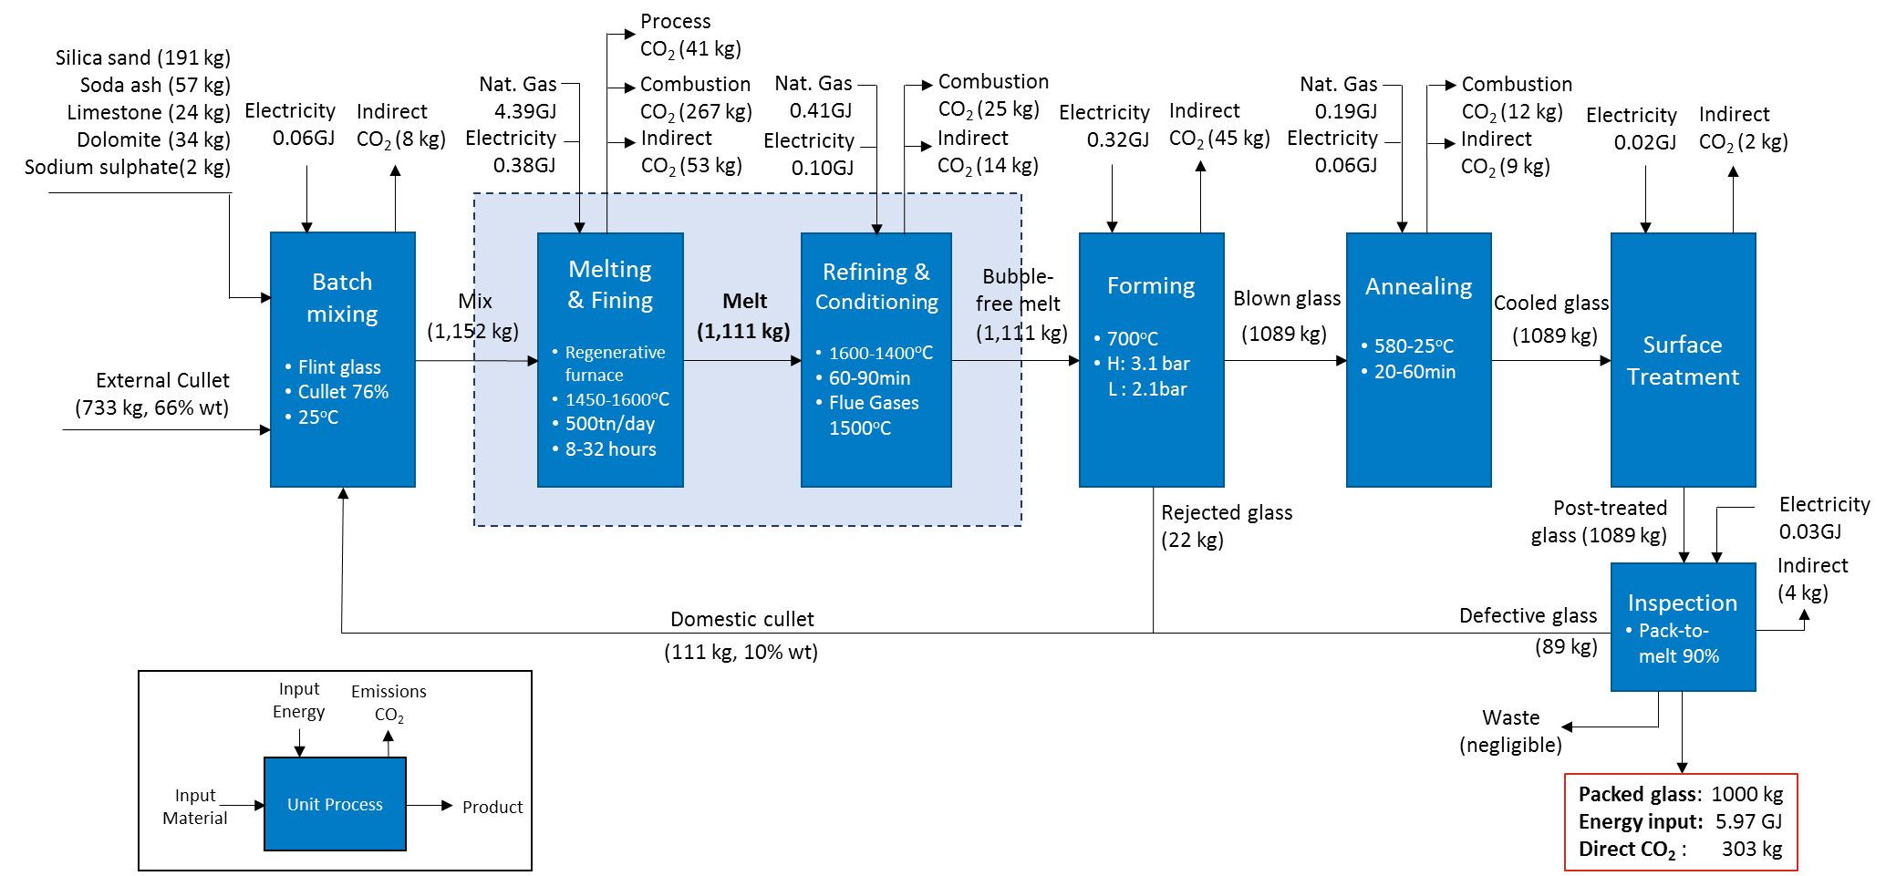

**Figure 8 | Process flowchart of a typical Container glass plant[18].**

## 4.3 Economic analysis

Apart from the reduction potential of CO2 emissions, decarbonisation options must also be technically and financially feasible to qualify for further investigation. For the purposes of this study, the adoption of a novel technology is deemed technically feasible if the technology can leverage the majority of the current operational capabilities. By contrast, an option would be financially feasible if its adoption results in a profitable process. Both criteria will be summarised in terms of adoption enablers and barriers of the shortlisted technologies in Chapter 5. The methodology for performing Economic analysis is presented in Figure 9.

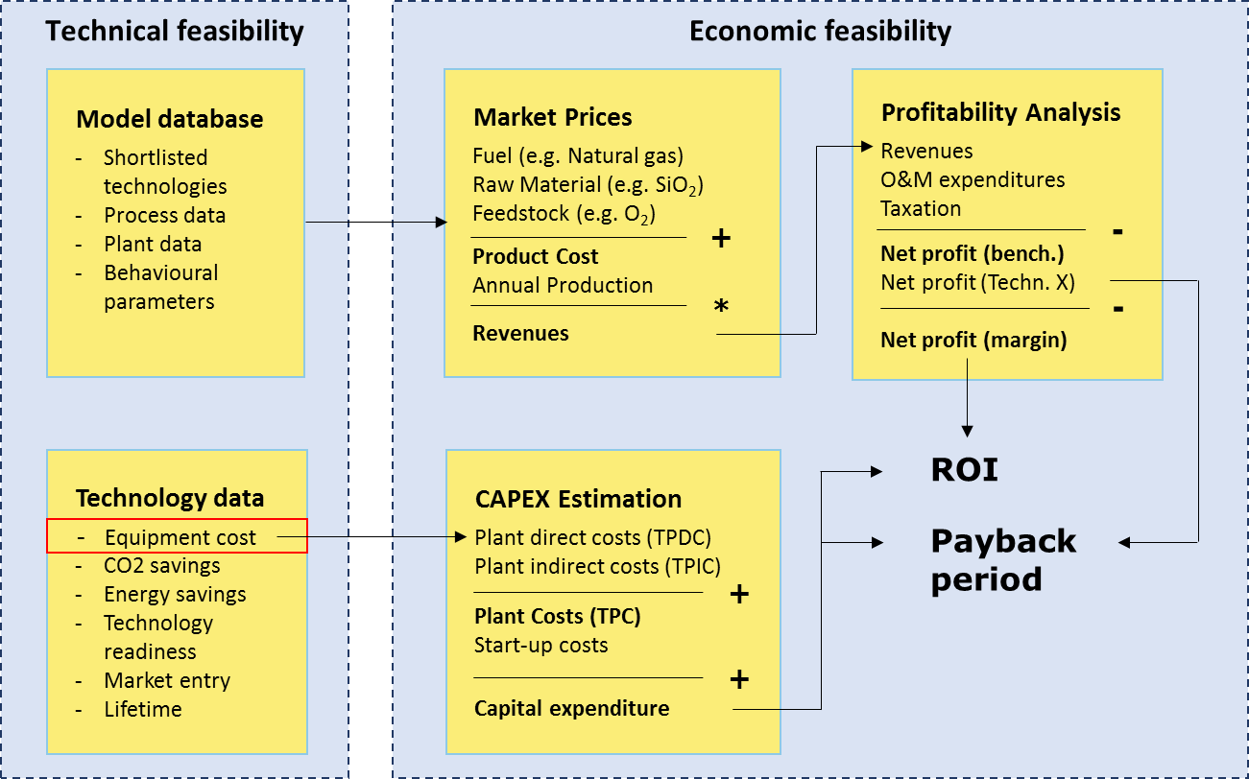

**Figure 9 | Method followed for performing estimating ROI and Payback period.**

4.3.1 Technical feasibility

The input of glass experts has been the first indication on whether a technology satisfies thefirst criterion. The material and energy flow analysis has been used afterwards to verify their quotes by looking at the modified process conditions. Each option implicates differently in the industrial process in terms of energy demand and cost effectiveness. Therefore a hypothetical energy balance is re-calculated based on modified process settings which enables comparisons among multiple configurations. Such configurations can be furnaces with adjusted input parameters (e.g. reduced natural gas or increased use of pure oxygen) or aggregates of furnaces and preheating options.

This comparison takes place under the assumption that more flexible operating conditions apply than in reality. Firstly, this is because the initial calculations have shaped a structurally constrained model for replicating the function of a regenerative furnace, while the shortlisted options require new configurations which include different assumptions (e.g. oxyfuel furnaces, Optimelt TCR concept, electric furnaces). Secondly, this creates room for discussion on the broader impact of an alternative solution to the energy usage and carbon emissions, followed by the refection on the technical constraints of adopting a new technology in the aftermath of the analysis. In the end, the technical feasibility of a technology is determined which enables the investigation of its economic feasibility.

4.3.2 Economic feasibility

The potential adoption of a shortlisted option must create an added value and ensure maximum return on investment. In order to evaluate the profitability of the process for every configuration, the study leverages the metrics of Product costs, Return of investment (ROI) and Payback time. A benchmarking technology is set for that purpose (i.e. an “as-is” regenerative furnace) and the Product costs of every process configuration will be compared to this value.

The estimation of Product costs for both the benchmarking and an examining technology requires the process data (e.g. energy use, carbon emissions etc.), as well as the market prices of the respective parameters (e.g. m3 of pure oxygen, kWh of electricity etc.). The former were extracted from Material (Chapters 4.1) and Energy (Chapter 4.2) flow analyses, and the latter were extracted from publicly available sources (Eurostat, 2018; Statista, 2017). With the assumption that the annual production of packed glass in a typical container glass plant is 1 bil. bottles on average, the annual revenues and net profits can be extracted as follows:

**Product cost** = $Σ$ (Price* Amount), [€-cent/packed glass] (17)

**Revenues** = Product cost * Annual production of packed glass, [€/yr] (18)

**Net profit** = Revenues – O&M expenditures – Taxation, [€/yr] (19)

where the *Price* denotes fuel, feedstock, material price, *Amount* denotes the respective unit of measurement, *Annual production of packed glass* is taken as the average production in Dutch container glass plants, *O&M expenditures* is assumed as 35% of the Revenues (i.e. initial, not ongoing costs) and *Taxation* is assumed as 40% of the Revenues. The same procedure is followed for every shortlisted technology other than the as-is regenerative furnace which is an indication of the benefits gained from switching to another technology (i.e. Net profit margin). As a result:

**Net profit (margin)** = Product cost (Bench. Technology) - Product cost (Short. Technology) (20)

In an effort to take the cash flows into account, the financial metric of ROI tries to compare the amount of return on a particular investment to investment costs. This happens by making a ratio of cash inflows to outflows that follow from the investment, allowing the measurement of a variety of investment types compared to one another. Thus, the ROI ratio is by definition "net investment gains over total investment costs (Business Encyclopaedia, 2019).

**ROI** = Net profit (margin) * 100% / Total investment cost (21)

where the *Product cost* has been calculated using Eq. (17) for both the benchmarking and an examining technology, and the *Total investment cost* is expressed in terms of capital expenditure (CAPEX). It is argued that using CAPEX to support long-term growth is a central component of successful corporate strategy (Pidun, 2017). The capital is exchanged for an asset, which can be amortised and depreciated over its lifespan, and can add value to the business. Optimizing a company’s CAPEX means making the most of every investment, regardless of size. OPEX is used for ongoing expenses and estimates are based on a working knowledge of the industry. Some technologies are very CAPEX intensive with low OPEX and vice versa, which entails different investment risks.

For the calculation of CAPEX, this study leverages the methodology proposed by Osseweijer & Straathof (2018). It involves the calculation of the plant’s total direct and indirect costs with assumptions on the various costs on process technologies (Table 8).

**Total Plant Cost (TPC)** = Total Plant Direct Costs (TPDC) + Total Plant Indirect Costs (TPIC) (22)

**Total Investment Cost** = Capital Expenditure = Total Plant Cost + Start-up Costs (23)

A requisite for using the above equations if retrieving the Purchase equipment costs (PEC) for each shortlisted option. These PEC’s have been retrieved from reports and databases of research centres (Fraunhofer, 2019a; Ecofys, 2018; IETD, 2018; VNPI, 2018), as well as the cooperating parties of PBL and TNO and quotes from interviewed glass experts. When information is scarce, these costs can be approximated based on commercially available technologies with similar characteristics or estimated within price ranges which originate from several sources.

**Table 8 | Potential costs which contribute to the total investment on process technologies (Osseweijer & Straathof, 2018).**

|  |  |  |  |  |  |
| --- | --- | --- | --- | --- | --- |
| **Total Plant Direct Costs**  **(TPDC)** | | **Total Plant Indirect Costs**  **(TPIC)** | | **Total Plant Cost**  **(TPC =TPDC+TPIC)** | |
| Installation | 0.30 x PEC | Engineering | 0.25 x TPDC | Contractor fee | 0.05 x TPC |
| Process piping | 0.35 x PEC | Construction | 0.35 x TPDC | Contingency | 0.10 x TPC |
| Instrumentation | 0.40 x PEC | Other | 0.05 x TPDC | Start-up costs | 0.07 x TPC |
| Insulation | 0.03 x PEC |  |  | Other | 0.05 x TPC |
| Buildings | 1.00 x PEC |  |  |  |  |
| Space improvem. | 0.15 x PEC |  |  |  |  |
| Auxiliary facilities | 0.40 x PEC |  |  |  |  |

The last financial metric which is used for analysing cash flows is the Payback period. This metric is determined by dividing the cost of the capital investment by the projected annual cash inflows resulting from the investment, therefore it refers to the amount of time it takes to recover the cost of investment (Maverick, 2019). When multiple projects with similar cumulative benefits are examined but the timing of these benefits varies (e.g. due to the volatility of demand and fuel prices), the payback method helps to show that earlier benefits are more attractive than latter benefits. It is calculated as follows:

**Payback period** = Total investment cost / Net profit (24)

Besides the inherit limitations of the above metrics (see Chapter 11.1), they are valuable tools for determining whether a particular investment should be undertaken. These methods are also applied for the emerging technologies with Technology Readiness Level (TRL) greater than 4, whose deployment is expected during the period 2030–2050 (see Chapter 5). Notably that the current cost burden does not place a technology out of range of consideration, since the economic conditions are country’s trends at a point in time and change over the years (Chen, 2019).

# 5 Decarbonisation options

Developments associated with increased recycled cullet, improved furnace design, enhanced insulation and more effective regenerators have led to significant energy efficiency and emission improvements in the container glass industry over the years (Hatzilau et al. 2016). In the aftermath of improving energy efficiency, a transition to innovative methods is needed to unlock new possibilities for reducing combustion- and process-related CO2 emissions (HRE, 2018; Meuleman, 2017). After industry consultation and literature review, the main decarbonisation options which are investigated revolve around air/fuel, oxy/fuel and electric furnaces. This minimally suggests that innovative technologies with regards to the melting activity may contribute to the decarbonisation endeavours of the industry towards 2050. The long-listed options are categorised according to a framework laid out in Figure 10, in which seven categories are distinguished.

. 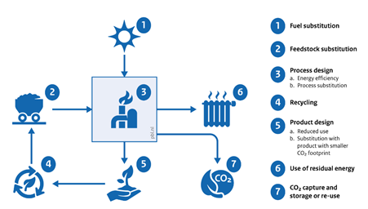

Figure 10 | Clusters of mitigation options in the full production chain.

An overview of long-listed potential options and processes is provided in Table 9. The CO2-reduction potential refers to combustion emissions compared to an “as-is” regenerative furnace[19] and fuel savings are expressed in terms of primary energy used[20]. These options will be further shortlisted on the basis of the feasibility[21] of their actual implementation within their commercial operations. Their level of development is indicated by the “Technology readiness level” (TRL) which ranges from 1 for Basic technology research to 9 for Successful end-use operation. The costs of CO2-recuding technologies are related to annual production capacities (or emissions in the case of CCS) and ranges may be provided for the purchase equipment cost (PEC) when data are partly over- or underestimated. The Tables 10 to 27 contain values from own calculations.

Table 9 | Best available and innovative technology options for CO2 and energy reductions with regards to the Dutch container glass industry.

|  |  |  |  |  |  |
| --- | --- | --- | --- | --- | --- |
| **Option** | **TRL** | **Market**  **Entry** | **PEC**  **(€ mil.)**[22] | **CO2 (C) -**  **Energy (E)**  **Reduction** | **Data Source** |
| **Fuel Substitution :**  Substitution of the currently used fossil fuels | | | | | |
| **Full electrification** | 6-7 | 2030 | 0.1 – 0.5  /ktn glass | 75-100% (C)  35-56% (E) | Fraunhofer (2019a) |
| **Biogas combustion** | 8 | 2020 | - | 75-84% (C)  - (E) | PB & DNV GL (2015b)  Fraunhofer (2019a) |
| **Green Hydrogen combustion** | 4 | - | €1.5/kg H2[23] | - (C)  - (E) | WEC report (2018) |
| **Feedstock Substitution :**  Feedstock substitution, recycled flows, other upstream material substitution | | | | | |
| **Batch reformulation** | 7 | 2020 | - | 5% (C)  20-33% (E) | PB & DNV GL (2015b)  Springer et al. (2017) |
| **Process Design :**  Energy efficiency improvements and/or substitution of production processes | | | | | |
| **Electric furnace** | 7 | 2030 | 56.3  (3.5-5 * MW) | 100% (C)  30-35% (E) | Reynolds (2019)  PB & DNV GL (2015b)  VNPI (2018)  Meuleman (2017)  Navigant (2019) |
| **Air–Oxy/fuel burner** | 7 | Present | 0.4 | 15%- (C)  20-30% (E) | PB & DNV GL (2015a) |
| **Cryogenic system** | 9 | Present | 0.05  *ktn glass | 46%[24] (C)  20% (E) | Fraunhofer (2019a) |
| **Oxy-fuel furnace** | 9 | Present | 0.9-1.1 | 8-10% (C)  25-35% (E) | Sundaram (2016)  Baukal (2013) |
| **Batch/cullet preheating** | 9 | Present | 1.5-2.1 | 15% (C)  10-20%[25] (E) | Ricardo AEA (2013)  Wallenberger (2010)  PB & DNV GL (2015b) |
| 2020 | 4.5 | 33% (C)  15-20% (E) | Fraunhofer (2019b)  HRE (2018) |
| **Electricity generation** | 8 | 2020 | 1.7-4.9[26] | 23% (C)  40% (E) | Forni et al. (2014)  Ricardo AEA (2013)  PB & DNV GL (2015b) |
| **Optimelt TCR** | 7 | 2025 | 3.5-4.5 | 45-60% (C)  20-30%[27] (E) | de Diego (2016) |
| **Natural/ Oxygen preheating** | 6 | 2030 | 1.66 | 10-15%[28] (C)  28-38% (E) | Zerbinatti et al. (2017)  Laux et al. (2017) |
| **Improved furnace construction** | 5 | 2030 | 56.3 | 10-25% (C)  12.5% (E) | PB & DNV GL (2015b) |
| **Recycling and reuse :**  Methods for recycling and reusing glass | | | | | |
| **Increased cullet rate** | 9 | Present | - | 20% (C)  15% (E) | PB & DNV GL (2015b)  Fraunhofer (2019a)  HRE (2018) |
| **Product Design :**  Alternative applications of end-product for replacing products of larger CO2 footprint | | | | | |
| **Alternative glass compositions** | 9 | Present | - | 20-60% (C)  15-50% (E) | see Appendix E |
| **Residual Energy use :**  Ways of heat exploitation such as steam and/or electricity generation | | | | | |
| **Building heating** | 8 | 2020 | 1.0-2.1 | 15% (C)  10% (E) | PB & DNV GL (2015b)  IETD (2018) |
| **District heating** | 7 | - | 1.0 | - (C)  - (E) | Forni et al. (2014)  Ricardo AEA (2013) |
| **Carbon Capture and Utilisation and/or Storage :**  Process of capturing and storing CO2 or alternative uses of the potentially emitted gases | | | | | |
| **Post-combustion Carbon Capture[29]** | 6-7 | 2025 | 56.3 | 65-75% (C)  - (E) | PB & DNV GL (2015b)  Fraunhofer (2019a)  VNPI (2018) |
| 2030 | 0.400  *ktn CO2 |
| 2050 | 0.296  *ktn CO2 |
| **Carbon Transport & Storage** | 6 | 2030 | 0.140  *ktn CO2 | - (C)  - (E) | Fraunhofer (2019a) |
| 2050 | 0.113  *ktn CO2 |

## 5.1 Fuel substitution

The fuel predominantly used in the container glass industry is natural gas, which accounts for about 90% of the fuel mix. Fuel switching is challenging, as it may impose changes in operating permits and adjustment to installations such as new burners and control systems. The goal of fuel substitution is to rely on fuels with a lower carbon footprint but, at the same time, keep the same general manufacturing processes (Fraunhofer, 2019a). According to HRE (2018, Table 10), the diffusion level of the fuel switch option is estimated to be 88% by 2030 and approx. 99% in the horizon of 2050.

5.1.1 Full Electrification

The substitution of fossil fuel input with electricity typically refers to the use of all-electric melting using electric furnaces (see Chapter 5.3.3) or increased use of electric boosting (see Appendix C) in combination with the electrification of downstream activities (i.e. fining and annealing). This measure is interlinked to the glass quality specifications, as well as economic (i.e. electricity price, investment cost) and physical conditions (e.g. missing infrastructure, position of electrodes into the furnace) (Reynolds, 2018). All-electric solutions are applied in some niche glass manufacturing applications, however significant innovation is required for its adoption in high-scale container glass production, especially in the case of high cullet rates (Kahl, Personal communication). The process prerequisites a steady supply of great amounts of electricity which requires additional reinforcement for the local grid (Fraunhofer, 2019a). All-electric options can have emissions benefits provided that the electricity comes from renewable sources, where the complete greening of the electricity grid may occur post-2050 (PB & DNV GL, 2015a).

Table 10 | Technical and economic feasibility assessment of full electrification.

|  |  |
| --- | --- |
| **Technical feasibility** | |
| **Enablers** | **Barriers** |
| * Electrification of process activities * Up to 30% of total furnace energy may be covered using electricity without changing footprint and basic design | * Unknown effects on glass quality * Physical limitation (i.e. number and location of electrodes which can be placed) * Unstable electricity supply in industrial areas |
| **Economic feasibility** | |
| **Enablers** | **Barriers** |
| * Expected decrease in (green) electricity price * Elimination of combustion CO2 emissions which impacts the product cost | * High capital investment for site adjustment * Additional cost of missing infrastructure |

5.1.2 Biogas combustion

Switching from a fossil fuel such as natural gas to a fuel that can be considered CO2-neutral is an alternative approach for reducing CO2 emissions even further. Bioenergy can be potentially used for glassmaking purposes, given the similar energy content of biogas to natural gas. Biogas in this context refers to a de-sulphurised product gas produced by a fermentation process which typically has a methane content of about 50-70 vol. %, with the rest being mostly CO2 and some trace components. Biomethane can be either upgraded biogas from anaerobic digestion or cleaned syngas from gasification of biomass, being 100% renewable (EBA, 2013). Using this fuel as a replacement source of heat would bring carbon emissions to net zero, as biomethane lifecycle absorbs the emitted CO2 during production (Fraunhofer, 2019a).

The partial or complete conversion of such a sensitive industrial process to the utilisation of biogas is a controversial issue. Material testing indicated that there were no negative consequences of biogas firing for the material properties (Fiehl et al. 2017). However, the durability of the refractory of industrial furnaces as well as trace contaminations found in the biogas may pose additional challenges. Other concerns include the availability and sustainable production of biogas, as well as “the existence of a reliable and upgraded supply” (Fraunhofer, 2019a). The technology is already used in other sectors (incl. the gas grid itself) and is expected to be introduced in the medium term by the glass industry (Fraunhofer, 2019a).

Table 11 | Technical and economic feasibility assessment of biomethane as fuel input.

|  |  |
| --- | --- |
| **Technical feasibility** | |
| **Enablers** | **Barriers** |
| * Similar energy content to natural gas * No refurbishments required * Maximal adiabatic flame temperature at stoichiometric air-fuel ratios *λ* ≈ 1 | * Negative impact on equipment lifetime * Limited research on glass quality implications * Expecting a limited availability of biofuel for the glass industry * Requires upgraded supply of biogas |
| **Economic feasibility** | |
| **Enablers** | **Barriers** |
| * No capital costs; provided that the system runs on gas burners * Considered as a good option for staying within allowances | * Unknown intrinsic price of biofuel * Large uncertainty range of future prices |

5.1.3 Hydrogen combustion

Hydrogen is often produced on an industrial scale using a steam methane reformer (SMR), but also developed through electrolysis or through a non-catalytic reforming process (see Chapter 5.3.3.c). Despite the evident benefits of this carbon-free fuel (WEC Report, 2018), hydrogen does not have a proven applicability in the container glass industry. Water vapour which is released from a complete hydrogen combustion creates foam with an effect on the specific energy consumption, efficiency on the yield, and integrity of the furnace (PB & DNV GL, 2015). At the same time, hydrogen emits sub-optimally in the required wavelength compared to the heavy-fuel air flame of natural gas[30].

Current research examines whether pure hydrogen or a blend with fossil energy achieve better radiative properties of the flame (e.g. by spraying biodiesel in a hydrogen flame), hence qualify for container glass making. This would allow a stepwise increase of hydrogen and make the process more renewable, but would also impact on the process (e.g. different burners and control schemes). The future availability and price of hydrogen also guides investment decisions, while its on-site production requires energy which can originate from fossil fuels or renewable sources. For a discussion of the various production processes of hydrogen including energy requirements and related emissions can be found in Suleman (2014).

Table 12 | Technical and economic feasibility assessment of hydrogen as fuel input.

|  |  |
| --- | --- |
| **Technical feasibility** | |
| **Enablers** | **Barriers** |
| * The infrastructure of natural gas can be used for switching to hydrogen * Possibilities on mixed flames for high temperature processes (i.e. fuel blend with fossil energy) | * Unsuitable wavelength for container glass * Water vapour from combustion impacts furnace’s normal operation which impacts glass quality * Different environmental permit and safety system * Uncertainty on when green hydrogen will be available in large amount |
| **Economic feasibility** | |
| **Enablers** | **Barriers** |
| * Supply of CO2-neutral energy which potentially offset the fuel cost | * Requires advanced control schemes * High and volatile price of hydrogen * Unknown market availability |

## 5.2 Feedstock substitution

5.2.1 Batch reformulation

Decarbonising the existing batch can be achieved through the use of low-carbon materials for replacing currently used carbonates. A potential reduction of process emissions can be achieved by replacing limestone and soda ash with burnt lime and sodium-containing raw materials, respectively (VNG, 2012; Wallenberger, 2010). However, this alternative would transfer the challenge of emissions reduction to another sector rather than address it. As to the drawbacks of this option, the quality of final product remains uncertain under current furnace designs, accompanied with an increase in material costs, transportation and chemical preparation (PB & DNV GL, 2015b).

Alternatively, lower temperatures for mixing or melting may be achieved by adding small quantities of more innovative materials, hence reduce fuel consumption (PB & DNV GL, 2015b). Also known as “batch separation”, raw materials can be split into portions with different compositions, melting temperatures and reaction paths. That way, the desired reactions between the fluxes and quartz are promoted at correct timing, resulting in up to 50% shorter melting time and allowing more time for the refining process (Carty, 2013; PB & DNV GL, 2015b). Shorter melting times are also achieved through the production of pre-mixed pellets with the correct proportions of ingredients. The technology is expected by 2020 for low-cullet containing batches at a relatively small additional cost (i.e. €0.28 mil.), with the possibility to apply pelletised batch preheating with flue gas heat (VNG, 2012; Hatzilau et al. 2016).

Table 13 | Technical and economic feasibility assessment of batch reformulation.

|  |  |
| --- | --- |
| **Technical feasibility** | |
| **Enablers** | **Barriers** |
| * Potential reduction of process emissions * Lower residence times and subsequent reduction in combustion emissions | * Implications on glass quality and desired characteristics * Availability of alternative materials |
| **Economic feasibility** | |
| **Enablers** | **Barriers** |
| * Material cost is offset through fuel savings and emissions reduction | * Potentially requires an advanced  chemical preparation unit |

## 5.3 Process design

The industrial processes have already been substantially optimised, but process enhancements are required to further lower the demand of high-temperature processes (Berntsson, 2017; NPI, 1998). Such improvements implicate a more complex technology that results in additional maintenance and capital expenditure, the use of non-environmentally friendly chemicals, and limitations to equipment lifespan (Meuleman, 2017). The focus is on furnace energy reduction methods for improved energy intensity efficiency and subsequent cuts in carbon emissions.

5.3.1 End-port regenerative furnace

Air/fuel furnaces of this type are broadly used in the Netherlands along with oxy/fuel firing technology. 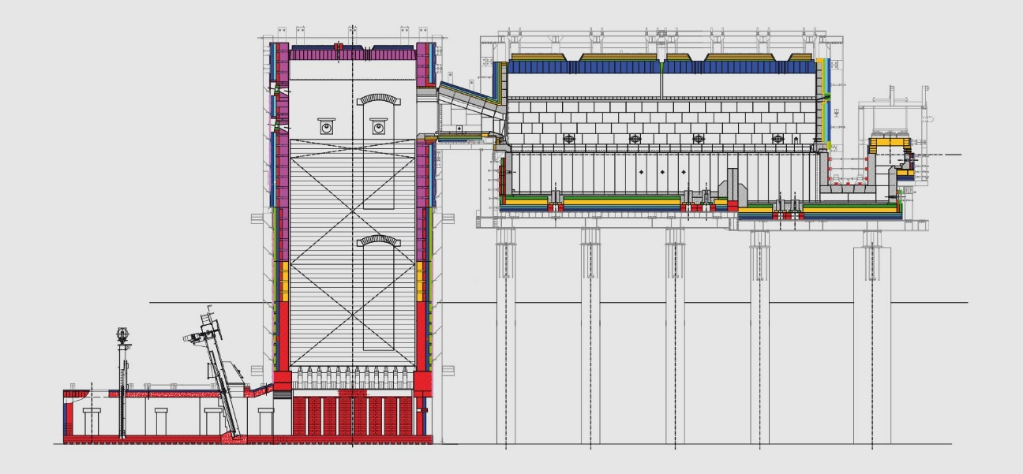In classical air-combustion melting technology, regenerators are used to recover energy losses by the hot fumes and transfer a part of the energy to the combustion air. A cyclic process is followed where exhaust gases pass over and heat up refractory blocks in one of two pre-heating chambers (Meuleman, 2017). Cold combustion air is introduced into the first chamber to be pre-heated by abstracting heat from the refractory while the exhaust gases are diverted to heat the second chamber. Continuous reversal of this process in 20-minute intervals provides a permanent flow of pre-heated combustion air. As a result, preheating the combustion intake air going into the burners can lead to more potential savings (Ming et al. 2003).

**Figure 11 | Schematic of an end-port regenerative furnace[31].**

Regenerative furnaces help providing higher capacities and producing high quality glass, operating with a typical energy efficiency of 70%. This results in an energy use of approx. 4GJ/tn for a container batch containing 76% cullet. It allows high thermal efficiencies and preheat temperatures at a theoretical maximum of 1480oC, and the hot flue gases exit the regenerator at 450-550oC (TNO, 2007). The capital cost for heat recovery in air/fuel furnaces reaches 1.5 million euros (Baukal, 2013). A technical barrier is that the implementation of a supporting option (e.g. preheating system) may be postponed until the next furnace rebuild will take place (see Chapter 4.2.3).

Table 14 | Technology characteristics of an end-port regenerative furnace.

|  |  |  |
| --- | --- | --- |
| **Performance and cost characteristics** | **Value** | **Units** |
| **Unit of main output** | 1 | tn molten glass |
| **Natural gas use per unit main output** | 3.947 | GJ |
| **Electricity use per unit main output (for 8% electr. boosting)** | 0.858 | GJ |
| **Air preheating per unit main output** | 3.990 | GJ |
| **Stack loss per unit main output** | 1.420 | GJ |
| **Direct CO2 per unit main output** | 240 | kg |
| **Purchase equipment cost (PEC)** | 1.3 – 1.5 | € mil. |
| **Operation and maintenance cost** | 0.2 | € mil. |
| **Technology lifetime** | 15-20 | Years |

5.3.2 Oxygen in Combustion

The use of oxygen for the combustion of natural gas decreases fuel usage, improves operational flexibility, increases specific melt rates, improves glass quality, decreases the use of expensive additives and improves furnace stability due to continuous firing (Lievre et al. 2008). The increase of O2 content in the combustion air creates a reasonably pure CO2 stream and reduces specific NOx emissions while helping increase the flame temperatures (TNO, 2007; see Chapter 4.2.3). The oxygen cost for gas combustion is estimated at €0.84 mil. for a 250tpd glass melter, which makes it a cost-efficient option when expensive alternatives to natural gas are used (Baukal, 2013).

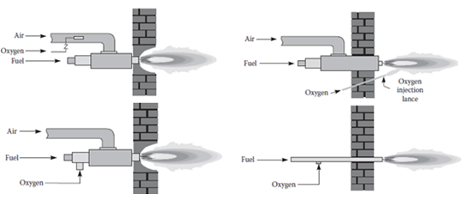

Figure 12 | (a) Premixing atmospheric air with oxygen; (b) Oxygen lancing; (c) Air-oxy/fuel firing; (d) Oxy/fuel firing (Baukal, 2013).

The development of lower-cost oxygen separation techniques allows the use of oxidiser with almost 100% content of oxygen, making the conversion to oxy/fuel even more economic (Baukal, 2013; Levine, 2001). Such techniques include vacuum pressure swing adsorption (VPSA) units, membrane separation, and cryogenic systems which produce grade of oxygen up to 99.5% (LexInnova, 2013; TNO, 2007; Ming et al. 2003). The main concern for the deployment of this technology is the energy and costs required to produce oxygen, as well as the corrosion of refractory silica bricks used to line the furnace roof. An optimal use of oxygen is required to offset this cost through fuel savings and emissions reduction.

**a) Oxygen-enriched air**

Oxygen enrichment uses a blower to deliver combustion air which mixes with oxygen and further mixes with the fuel inside the burner (Figure 12a). By supplying slightly more oxygen than the stoichiometric minimum, the unburned fuel is avoided and the efficiency penalty from excess air is minimised (see Appendix C). As a result, a mole fraction of oxygen in the oxidant stream between 21-30% is the range which compromises between energy savings and pollutant emissions such as NOx (Worrell et al. 2008). Beyond that range, flame temperatures decrease as the dissocia­tion reactions become appreciable (e.g. CO2 to CO and O2; H2O to O2 and OH) (Ming et al. 2003; Baukal, 2013). For this reason, oxygen enrichment and fuel injection are often linked in furnace operations for balancing the temperatures. This system can be retrofitted but requires a combustion system.

**b) Air/oxy/fuel firing**

This type of combustion technologies entails injecting air and O2 separately through a combined air/- and oxy/fuel burner (Figure 12c). The burner allows for higher concentrations of oxygen compared to oxygen enrichment, resulting in lower emission rates and greater melting capacities for responding to fluctuating demand. A conventional air/fuel burner can be retrofitted by inserting an oxy/fuel burner through it or by placing an O2 lance to fire natural gas in the combustion space above the glass melt. This method has also been used to con­trol the flame to produce a desired shape (Baukal, 2013). Overall, the operating costs of this technology are less than for oxy/fuel.

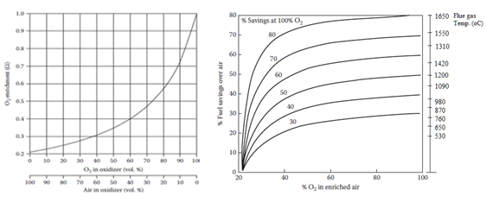

**Figure 13 | (a) Oxidizer compositions for blends of air and pure O2; (b) Natural gas savings vs. flue gas temperature (Baukal, 2013).**

**c) Oxy/fuel Combustion**

This technology involves increasing the percentage of oxygen in the furnace which makes the furnace more thermally efficient (PB & DNV GL, 2015b; LexInnova, 2013). The major differences in the operation of oxy/fuel compared to regenerative furnaces are in the way that fuel is burned and the amount of electricity and oxygen consumed for the oxidant delivery (O’Connor, 2015). There are typically 4-6 staggered burners per sidewall and a limited number of exhaust ports. Electric boosting accounts for 5-10% of the total melting energy (if applicable) and depends on the cost model and the specific load on the furnace. Attempts have been made to apply batch/cullet or cullet-only preheating with oxy/fuel furnaces which has been used as BAT for improving the efficiency of gas burning (Fraunhofer, 2019a; Dolianitis et al. 2016; AGC, 2015).

Table 15 | Technology characteristics of an oxy/fuel furnace.

|  |  |  |
| --- | --- | --- |
| **Performance and cost characteristics** | **Value** | **Units** |
| **Unit of main output** | 1 | tn molten glass |
| **Natural gas use per unit main output** | 3.561 | GJ |
| **Electricity use per unit main output (for 5% electr. boosting)** | 0.469 | GJ |
| **Oxygen required per unit main output** | 212.7 | m3 |
| **Stack loss per unit main output** | 0.983 | GJ |
| **Direct CO2 per unit main output** | 217 | kg |
| **Purchase equipment cost** | 0.9 – 1.1 | € mil. |
| **Operation and maintenance cost** | 0.15 – 0.3 | € mil. |
| **Technology lifetime** | 12-17 | Years |

Taking plant infrastructure, burner technology, gas and oxygen supply, furnace design, and air separation systems into account, the investment cost for this technology is higher than regenerative furnaces (PB & DNV GL, 2015a). A change from air/fuel to oxy/fuel usually is a total rebuild of an existing furnace and usually comes with a total change of footprint[32]. Oxy/fuel rebuilds (approx. €0.6 mil.; Baukal, 2013) often require reduced construction time than air/fuel (Lievre et al. 2008). Despite requiring an energy intensive production of high-purity oxygen, oxy-fuel firing is still beneficial as it reduces the volume of waste gases by about two thirds, increases the product throughput rate by 15-20% and yield improvements in excess of 5% (Ecofys, 2009; Lievre et al. 2008). Any pollutants such as nitrous oxides or sulphur dioxides are easier to remove in an oxy/fuel exhaust, since they are in much higher concentrations compared to air/fuel (LexInnova, 2013).

Table 16 | Technical and economic feasibility assessment of oxy/fuel furnaces.

|  |  |
| --- | --- |
| **Technical feasibility** | |
| **Enablers** | **Barriers** |
| * Efficient radiant heat transfer * Operational flexibility and flame temperature control * Flexible melting capacities | * Fast corrosion and erosion of refractory materials * Availability of an oxygen supply line nearby * Limited use of electric boosting, depending on the cost model |
| **Economic feasibility** | |
| **Enablers** | **Barriers** |
| * Oxygen cost is offset through fuel savings and emissions reduction * Low cost of equipment for the basic design (w/o cryogenic system) * Short Payback period of investment * Lower maintenance cost than air/fuel furnaces | * Perceived technical risk and additional cost associated with construction of oxygen generating plant (Ricardo AEA, 2013) * Cost of conversion from air/fuel to oxy/fuel * High maintenance cost (e.g. fast refractory ware) * High operational cost, but local conditions can make it worthwhile |

5.3.3 Electric furnaces

Electric melting is a key decarbonisation technology which is assumed to be available for commercial implementation post-2030 (PB & DNV GL, 2015a). This type of melter is based on the Joule’s Principle where the molten glass is used as the resistive element of the electrical circuit (Smothers, 2009). All-electric melting generally implies a cold-top vertical melting (CTVM), with the raw material being distributed evenly over the melting surface of the glass (Stormont, 2010). Most of the electrical power ends up in the melting process, and only relatively low energy losses come from transformers, busbar and control efficiency.

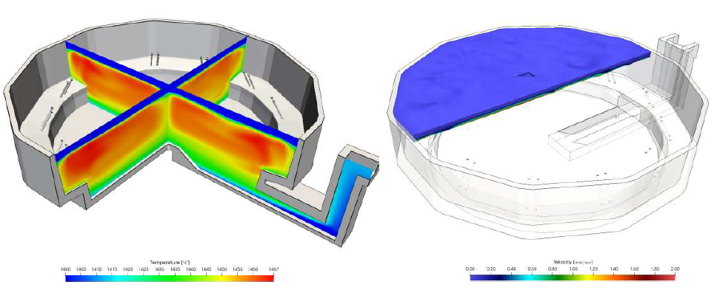

Figure 14 | CFD model of 100m2 design (250tpd) all-electric melting concept in container glass applications (Reynolds, 2019).

Electric furnaces are much more thermally efficient than gas-fired melters, using about 35% less energy compared to an as-is regenerative furnace (i.e. 3.2 GJ/tn; excluding losses in electricity generation) (Meuleman, 2017). Commercially available electric furnaces have a relatively small capacity (approx. 150tn). For some glass types the use of an all-electric furnace is difficult (e.g. conductivity issues in fibre glass). A 200tpd cold-top all-electric furnace can potentially achieve 2.75 GJ/tn for 50% cullet (Reynolds, 2019). When melting flint container glass, a 250tpd furnace by Electroglass requires 710kWh of electricity per tonne of glass, equivalent to a thermal efficiency of 85% (Stormont, 2010). Other pollutants are considerably less for an electric melter, where thermal NOx or SOx emissions are plunged and combustion related CO2 are avoided.

Table 17 | Technology characteristics of a cold-top vertical electric furnace.

|  |  |  |
| --- | --- | --- |
| **Performance and cost characteristics** | **Value** | **Units** |
| **Unit of main output** | 1 | tn molten glass |
| **Electricity use per unit main output** | 4.107 | GJ |
| **Direct CO2 per unit main output (i.e. process emissions)** | 36 | Kg |
| **Indirect CO2 per unit main output** | 570 | Kg |
| **Heat content of flue gases per unit main output** | 0.054 | GJ |
| **Purchase equipment cost** | 3.5 – 5.0 | € mil./MW |
| **Operation and maintenance cost** | 0.07 – 0.10 | € mil./MW |
| **Technology lifetime** | 6-8 | Years |

As to the challenges of a standard full-scale container glass electric furnace, a cold-top solution affects the stability of the batch blanket[33]. The mixture melts much faster for 80-90% cullet rates which prohibits the creation of a stable and controlled blanket that keeps the furnace sealed. Electric furnaces are currently not flexible when it comes to changing pull rates, which is important for meeting the fluctuating demand. It is also not easy to transform conventional furnaces into cold-top ones due to size, quality and lifetime. Like a burner system for a traditional furnace, the electrical system needs to be fully integrated. The large amount of power needed for this conversion often comes with additional investments to the electricity infrastructure. Electric melting would be only possible provided that sufficient renewable electricity is available and can also be delivered to a plant.

Table 18 | Technical and economic feasibility assessment of cold-top vertical electric furnaces.

|  |  |
| --- | --- |
| **Technical feasibility** | |
| **Enablers** | **Barriers** |
| * Easy and rapid turn-off * Many different ways for designing full-scale container glass furnaces * Temperature homogeneity * Higher thermal efficiency compared to fossil fuel fired furnaces | * Short lifetime * Limited melting capacity * Not flexible in terms of changing pull rates * The process changes result in more erosion  and corrosion of the refractories * Currently unable to support high-cullet batches |
| **Economic feasibility** | |
| **Enablers** | **Barriers** |
| * CAPEX is gradually decreasing over the years * Shorter campaigns enable capacity modifications and performance optimisation | * Currently high cost of bare equipment * High maintenance cost (~25-30% of CAPEX) * Return of Investment = -11.9 % |

5.3.4 Heat integration techniques

Waste heat recovery (WHR) considers the utilisation of the high-temperature exhaust gases in a cyclic process (Hatzilau et al. 2016). Exhaust gases have a typical heat content of about 25–30% of the furnace energy input. Re-using this residual heat helps in decreasing specific energy consumption, reaching higher flame temperatures and mitigating direct CO2 emissions during the glassmaking process (see Chapter 4.2). Waste heat recovery options are suitable for air preheating, electricity/steam/hot water generation, thermochemical recuperation, natural gas preheating, batch/cullet preheating or infrastructure heat (Dolianitis et al. 2016; Fraunhofer, 2019a). For oxy/fuel technology, there is relatively less energy in the flue gases but heat can still be recovered for preheating oxygen or gas. The gases must remain above the sulphuric acid dew point (approx. 180oC). The optimal use of waste heat is location specific and the additional Capex must be balanced against incremental heat recovery.

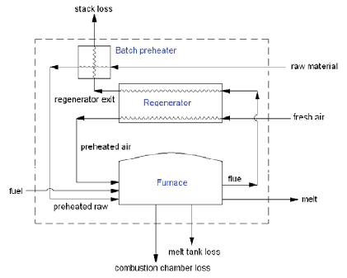

**Figure 15 | Waste heat recovery in a glass melting plant (Khoshmanesh et al. 2007).**

**a) Batch/cullet and Cullet preheaters**

Batch preheating is a commercially available technology which improves furnace efficiency by evaporating moisture in the batch and lowering the overall furnace peak temperature (Springer & Hasanbeigi 2017). The flue gases exiting the regenerator are cooled down to 450oC before entering the batch preheater, leaving it at 250oC. The heterogeneous mixture is conveyed to the top of the preheater (approx. 20–25m high), in which the mix is preheated by direct contact with either flue gases or steam (Hatzilau et al. 2016). For batch/cullet preheaters, preheating temperatures range between 275-325oC for air/fuel and 200-250oC for oxy/fuel firing (PB & DNV GL, 2015b; Wallenberger, 2010; Sorg, 2011).

As innovations such as electric heating and furnace insulation are applied, there would be less waste heat available for preheating (Fraunhofer, 2019a). Specific energy consumption is reduced as both the temperature and mass of the flue gases decrease, which subsequently lower the direct CO2 emissions by about the same amount (Hatzilau et al. 2016). The energy savings in the furnace using this technology range between 5–15%, the glass pull can be increased by 10% and the estimated lifetime is 20 years (HRE, 2018; Hatzilau et al. 2016).

Table 19 | Technology characteristics of a regenerative furnace with batch/cullet preheating.

|  |  |  |
| --- | --- | --- |
| **Performance and cost characteristics** | **Value** | **Units** |
| **Unit of main output** | 1 | tn molten glass |
| **Natural gas use per unit main output (furnace)** | 3.229 | GJ |
| **Electricity use per unit main output (for 8% electr. boosting)** | 0.702 | GJ |
| **Air preheating per unit main output** | 3.670 | GJ |
| **Batch preheating per unit main output** | 0.781 | GJ |
| **Stack loss (total) per unit main output** | 0.639 | GJ |
| **Direct CO2 per unit main output (melting activity)** | 196 | kg |
| **Purchase equipment cost (of Batch/cullet preheater)** | 1.5-2.1 | € mil. |
| **Operation and maintenance cost (of Batch/cullet preheater)** | 0.12-0.25 | € mil. |
| **Technology lifetime (of Batch/cullet preheater)** | 20 | Years |

Table 20 | Technical and economic feasibility assessment of batch/cullet preheating.

|  |  |
| --- | --- |
| **Technical feasibility** | |
| **Enablers** | **Barriers** |
| * Improves melting efficiency * Increases glass pull * Long lifespan of technology | * Batch moisture evaporation and dehydration of soda ash (Dolianitis et al. 2016) * Deterioration of the preheater structure due to corrosion and high temperatures * Space requirements |
| **Economic feasibility** | |
| **Enablers** | **Barriers** |
| * Return of investment = 8.6% * Payback period = 2-3 years | * High cost of bare equipment compared to  other preheating options * Additional cost for flue gas treatment |

**b) Heat Oxy-combustion**

This option exploits the mixing advantage of oxy-fuel firing and heat recovery for preheating of both natural gas and oxygen. It is already applied in the flat glass industry and no proven applications have been found in the context of container glass industry. However, oxygen preheating is used as part of an innovative heat integration system employed by the tableware sector (i.e. Optimelt Plus), a concept which is projected to be commercialised for container glass furnaces in the coming years (Laux et al. 2017). The technology is theoretically transferable to other glass sectors (Zerbinatti et al. 2017). Therefore the potential benefits in overall furnace efficiency have been investigated for determining reductions in fuel and carbon emission.

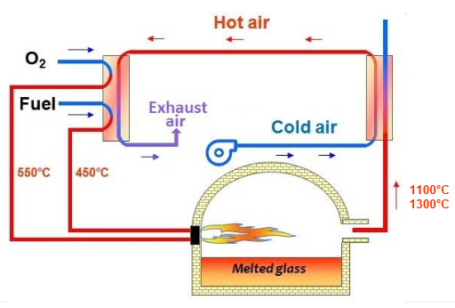

**Figure 16 | Heat recovery concept in oxy/fuel furnaces (Zerbinatti et al. 2017).**

The technology requires two heat exchangers per burner, as well as a heat recuperator or an existing regenerator after converting from air/fuel to oxy/fuel firing (Görüney et al. 2016). The energy recovery system is a two-step process. Firstly, the hot waste gases exiting the furnace are used to preheat the combustion air using the regenerator or a metallic recuperator. The preheated air will be, burner by burner, divided into two flows to preheat oxygen at 550°C and natural gas at 450°C in crosscurrent heat exchangers (AGC, 2015). Preheating the gas fuel increases the carbon content in hydrocarbon flames by increasing the fuel pyrolysis rate (Javadi & Moghiman, 2012). The process results in high flame temperatures with the prospects to achieve additional carbon emissions reduction by 10% compared to no preheating (Joumani et al. 2010).

Table 21 | Technical and economic feasibility assessment of NG/O2 preheating.

|  |  |
| --- | --- |
| **Technical feasibility** | |
| **Enablers** | **Barriers** |
| * High heat transfer rate to the glass bath * No higher risk than in cold reactants configuration | * High water content in the furnace atmosphere * Unproven for container glass furnaces * Infrastructure availability / capability |
| **Economic feasibility** | |
| **Enablers** | **Barriers** |
| * Low maintenance costs of preheaters * Return of investment = 10% * Payback period = 1-1.5 years | * Closely linked to the energy prices (AGC, 2015) * Additional cost of heat regenerator or recuperator  if not available |

**c) Thermo-Chemical Regenerator (TCR)**

Optimelt TCR refers to an advanced heat recovery technique in oxy/fuel fired glass furnaces. A small amount of recycled flue gases which contain CO2 and water vapour is used for endothermic reforming of methane-based fuels into a hot syngas in small regenerators (i.e. H2 and CO; approx. 1250°C) which has a higher energy content than natural gas (de Diego 2018; Hatzilau, et al. 2016). The technology can be combined with heat recovery options such as integrated batch/cullet or cullet preheating, regenerative oxygen preheating, generation of reforming steam for TCR, and Organic Rankine Cycle (ORC) turbo-generator (Laux et al. 2017). The potential TRLs might range between 6 and 8 depending on the specific concept. The technology entered the engineering phase in 2018 for 200tpd container glass furnaces and research continues on examining the technical barriers 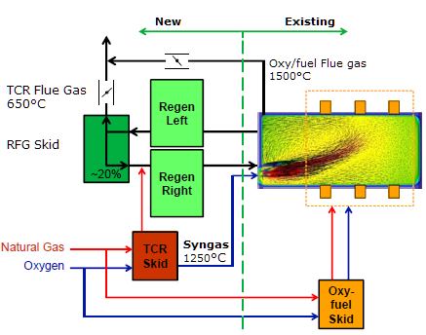of applying it to high-cullet batches.

**Figure 17 | Side-fired 50tpd furnace converted to end-port Optimelt (Laux et al. 2017)**

Regarding a 240tpd glass-container oxy/fuel baseline with 1MW electric boost and 30% cullet ratio, Praxair reported fuel savings of 21% for Optimelt TCR and an additional 5% for oxygen preheating (i.e. Optimelt Plus concept) (Laux et al. 2017). Reductions in energy consumption and CO2 emissions may reach 30% and 45-60% compared to air-regenerative furnace, respectively (de Diego et al. 2016). However, the high amount of CO may require the complete sealing of the regenerators to avoid leakage.

Table 22 | Technology characteristics of an oxy/fuel furnace with Optimelt TCR.

|  |  |  |
| --- | --- | --- |
| **Performance and cost characteristics** | **Value** | **Units** |
| **Unit of main output** | 1 | tn molten glass |
| **Natural gas use per unit main output** | 3.234 | GJ |
| **Electricity use per unit main output (for 5% electr. boosting)** | 0.426 | GJ |
| **Oxygen required per unit main output** | 193 | m3 |
| **Stack loss per unit main output** | 0.054 | GJ |
| **Direct CO2 per unit main output** | 196 | kg |
| **Purchase equipment cost** | 3.5 – 4.5 | € mil. |
| **Operation and maintenance cost** | 0.25 – 0.30 | € mil. |
| **Technology lifetime** | 10 – 15 | Years |

Table 23 | Technical and economic feasibility assessment of Optimelt TCR.

|  |  |
| --- | --- |
| **Technical feasibility** | |
| **Enablers** | **Barriers** |
| * Enhanced heat recovery * High efficiency non-catalytic reforming process * High operating temperatures/reforming rate | * Combustion occurs at rich conditions (i.e. at stoichiometric air-fuel ratios λ ≈ 0.9) * Possible implications on glass quality and safety * Low melting capacities and low-cullet batches |
| **Economic feasibility** | |
| **Enablers** | **Barriers** |
| * Reduced fuel consumption * Potentially reduced maintenance cost based on observed condition of refractory materials * Return of Investment = 6.5-10% * Payback period = 2-2.8 years | * Downtime and lost production unless postponing implementation until furnace rebuild * Additional requirements for advanced control systems |

**d) On-site Electricity generation**

On-site electricity generation for internal consumption can be applied in cases where there are no other uses for the recovered heat (HREII, 2018). This readily available option results in less dependency on fluctuating energy costs and on external energy sources (i.e. cope with a power outage). This application can be considered as an energy efficiency measure, since investing companies reduce their electricity consumption without additional use of primary energy (HREII, 2013). The temperature and the amount of heat recoverable need to be high enough to drive a steam turbine which drives the electricity generation equipment (Forni et al. 2014). However, the 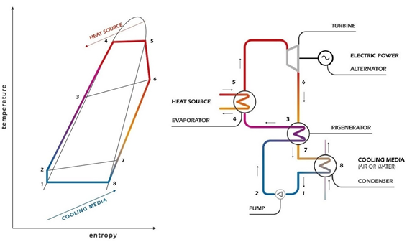aggressiveness of flue gases may impede the normal operation of this technology[34].

**Figure 18 | Organic Rankine Cycle (ORC) waste heat recovery[35].**

The Organic Rankine Cycle (ORC) is a theoretically feasible solution for generating electricity from heat sources of container glass plants, having a conversion efficiency of 15–19% (Figure 18). The additional heat exchanger is the main component for heat recovery, located before flue gas treatment (e.g. de-SOx, de-NOx) to eliminate the need for cooling down the flue gases (HREII, 2018). It is suitable for temperatures 450–500°C of flue gases, as well as for low-power and discontinuous flows of hot gases with temperatures around 300oC (Hatzilau et al. 2016). When combined with preheating systems, the quantity of recoverable energy is low for efficient power generation and supplementary firing may be needed to generate superheated steam to drive the turbines (IETD, 2018). In principle, if half the energy of exhaust gases is recovered, it is possible to produce between 30-60kWh of electricity for every tonne of produced glass (HREII, 2018).

Table 24 | Techno-economic feasibility assessment of on-site electricity generation.

|  |  |
| --- | --- |
| **Technical feasibility** | |
| **Enablers** | **Barriers** |
| * Generation of clean, reliable electric power * Valuable for sites located in industrial areas | * Low efficiency of electricity generation * Erosion due to aggressive flue gases |
| **Economic feasibility** | |
| **Enablers** | **Barriers** |
| * Low self-consumption * Less dependency on fluctuating energy costs and on external energy sources | * Heat exchanger may be built with more expensive materials if the flue gasses are corrosive * Additional cost for flue gas treatment |

## 5.4 Recycling and re-use

5.4.1 Increased cullet rate

The industry is already using high volumes of recycled cullet which results in significantly increased melting efficiencies. High-cullet batches melt better in conventional furnaces, since there was no need for transition to electric melting in the past. A high-cullet batch is responsible for decreased thermal limits and lowered residence times, resulting in a total 2.5-3.3% reduced fuel consumption for every 10% addition of recycled cullet (Madivate, 1998; see Chapter 3.1.1). Mainly driven by the reduced volumes of soda usage and other carbonates, each tonne of primary raw material replaced by cullet saves 1.9-2.35 GJ/tn packed glass.

In reality, 100% cullet is infeasible due to the quality of the cullet as well as the requirement of using fining agents in the process (see Chapter 3.2.2). A theoretical cullet-only batch may reduce process CO2 emissions by 45-55% compared to the emissions originating from a batch consisted exclusively of raw materials (Butler & Hooper, 2011). The treatment of recycled cullet requires 0.18GJ/tn of cullet which is considerably less than the energy needed for raw materials (Drummond, 2011). An advanced quantity/quality check of the cullet or a better separation system are essential removing contaminants and glass ceramics which have a direct impact on the yield and the glass quality[36].

Table 25 | Technical and economic feasibility assessment of increased cullet rate.

|  |  |
| --- | --- |
| **Technical feasibility** | |
| **Enablers** | **Barriers** |
| * Low residence time * Increased thermal efficiency * Contributes in the reduction of both process  and combustion emissions | * Depends on requested glass quality * Unknown future availability of preferred cullet quality cullet and colour * Big variation of organic contamination when it comes to high-cullet batches |
| **Economic feasibility** | |
| **Enablers** | **Barriers** |
| * Less dependency on raw material price * Reduced fuel cost | * Additional cost for on-site treatment of cullet (i.e. advanced separation unit) |

## 5.5 Product design

5.5.1 Alternative glass compositions

Variations in the batch mixing formula may have potential benefits in energy costs and environmental impact (Butler & Hooper, 2011). The energy consumption in the chain per packaged unit (i.e. from raw material to glass production) can be considerably reduced, where 0.65% less energy is required for every 1% weight saving per bottle (VNG, 2012; PB & DNV GL, 2015a). Potentially less evaporation of volatile and expensive raw materials such as boron and lithium will occur, which makes exhaust filtering much easier (Meuleman, 2017). On the other hand, changes in glass composition will result in colour and property changes which are interlinked to the client preferences (see Appendix B). An overview of savings of both melting energy and CO2 emissions for alternative glass compositions is presented in Appendix E.

Table 26 | Techno-economic feasibility assessment of alternative glass compositions.

|  |  |
| --- | --- |
| **Technical feasibility** | |
| **Enablers** | **Barriers** |
| * Preferred glass characteristics * Opportunities for light weighting * Reduction potential of furnace energy use | * Availability of alternative materials * Implications on requested glass quality |
| **Economic feasibility** | |
| **Enablers** | **Barriers** |
| * Dependency on less costly materials * Relatively small variations of operational costs among various formulas | * Additional cost for improved batch preparation * Potentially requires improved furnace design |

## 5.6 Residual energy use

5.6.1 Building Heating

Waste heat from the glass furnace or downstream smaller other technologies such as annealing lehrs or air compressors that contain sensible heat may be put to practical use. That way, adequate warehouse temperatures are maintained or general heating applications are facilitated (PB & DNV GL, 2015b; Bišćan et al. 2012, cited in Hatzilau et al. 2016). Steam generation and usage incur challenges of fouling and corrosion of the heat exchanger materials due to contaminated exhaust gases, therefore additional costs are required for flue gas cleaning (e.g. desulphurisation) (Worrell et al. 2008; Beerkens, 1986). Investment costs are compensated with lower energy consumption which leads to a reduction in operational costs (TNO, 2019). A continuous heat demand is also necessary for replacing conventional cooling systems with heat applications.

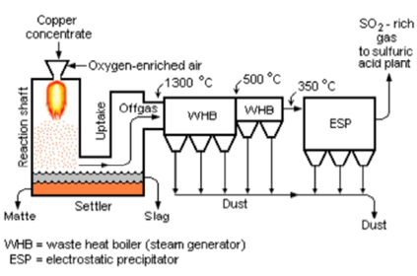

**Figure 19 | Waste heat recovery boiler in the copper industry (Fraunhofer, 2019a).**

5.6.2 District Heating

When plants are located in established industrial areas, there is potential for “over the fence” heat recovery for district heating (PB & DNV GL, 2015a). It is a technical solution to deliver low-grade heat to external thermal uses, such as for tertiary, agriculture or industrial processes in neighbouring facilities (HREII, 2018). Thermal energy can be provided by the heat recovery system to feed the district heating grid, which has in turn results in advanced heat integration on industrial plants (Ricardo AEA, 2013). The implementation of a district heating project is often impeded by factors such as missing infrastructure (e.g. pipelines, back-up systems), disagreements on where heat should be transferred to and taking up the risk of the investment (Forni et al. 2014).

## 5.7 Carbon Capture, Storage and Utilisation (CCS/CCU)

Commercial-size carbon capture, storage and utilisation projects are process integration techniques which help avoiding pollutants from industrial applications (IEA, 2011). Integrated CCS projects have not been deployed yet in the container glass industry. Three categories are distinguished: pre-combustion, post-combustion and oxy/fuel combustion capturing of CO2. Depending on the fuel input and the combustion agent, the capturing involves the removal of particulates, contaminants and water (i.e. SOx, NOx, H2O vapour) as well as the compression of CO2 into sealed containers (Fraunhofer, 2019a). Cooling down, liquefying and cleaning the CO2 is a cost- and energy-intensive operation which can be facilitated with the use of separation technologies (Chapter 5.3.3). The cost of emission control equipment (i.e. particulate and NOx) is estimated at €2.1 mil. for air/fuel and €0.6 mil. for oxy/fuel furnaces (Baukal, 2013).

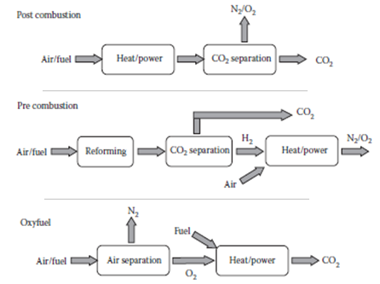

**Figure 20 | Options of capturing carbon sorted by combustion (Baukal, 2013).**

The CO2 of the container glass industry is more polluted than other industrial emitters[37]. This is mainly because of the sulphate used for fining, as well as other contaminants originating from the recycling cullet. For air-fired furnaces, the CO2 stream is diluted and its capture is rather costly. For oxy-fired furnaces, the CO2 stream is more condensed and might be more beneficial from cost perspective. The scale of CO2 emissions in the glass industry is such that the implementation of carbon capture at a facility is insufficient to justify the implementation of a full CCS chain (PB & DNV GL, 2015b). A potential proximity of the glass facility to a larger industrial cluster would provide access to a shared CO2 transportation and storage network while enabling the utilisation of the captured CO2 (CCU).

Table 27 | Technical and economic feasibility assessment of carbon capture[38].

|  |  |
| --- | --- |
| **Technical feasibility** | |
| **Enablers** | **Barriers** |
| * Technology is retrofitted * Removal of SOx and NOx * Suitable when pure oxygen is used for combustion | * Contaminants originated from sulphate and recycled cullet impede the capturing and compression of CO2 * Corrosion rate endangers the pipeline * Space requirements |
| **Economic feasibility** | |
| **Enablers** | **Barriers** |
| * Lower costs for cleaner CO2 streams * Lower costs for high-temperature flue gases * Condensed CO2 stream in oxy-combustion | * High investment and operational cost * Additional cost for equipment depending on the composition of flue gases * Increased cleaning cost for complying with the specifications of receiver industries |

# 6 The MORDM method

Interaction of humans with processes and technology over time results in a large number of scenarios and outcomes which are difficult to comprehend and evaluate manually (Padhi et al. 2013). Such outcomes often depend on highly uncertain factors beyond the control of the decision maker, such as economic variables and technology lifetime (Ben-Haim & Demertzis, 2015). As a result, potential options for deployment consideration that incorporate robustness and balance the outcomes of interest need to be identified. This creates room for interpretation of their implication on the industrial process.

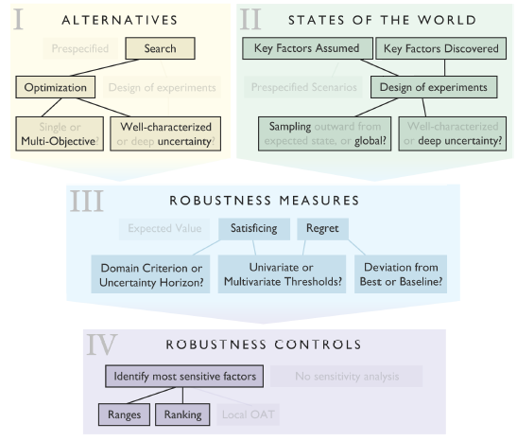

Figure 21 | A taxonomy of approaches for supporting the making of decisions under deep uncertainty (Quinn, 2017). The highlighted approaches denote the formation of the MORDM method for this study.

In response to the second sub-question, the Excel model will be coupled with the EMA workbench to develop a version of the MORDM approach and obtain a portfolio of robust decarbonisation options. By using a palette of techniques which are accessible through the workbench, the performance of policies can be tested iteratively across a spectrum of deeply uncertain states of the world (SOWs). The choice of combining those techniques that seem to fit to this study will be argued in the following chapters, enabling a more sophisticated analysis by stress-testing the Excel model (Figure 21). After the search phase, trade-offs and decision levers will be available to the analyst. A Pareto approximate set of policies (i.e. combination of decision levers) includes an amount of options, from which only a small proportion (i.e. best performing ones) will remain after examining their robustness. Those options consist of the policy advice offered by this study, followed by a discussion on the trade-offs associated with them (see Chapters 9 and 10).

**SQ2**: Which robust options enable a balance of reduced carbon emissions, energy consumption and cost effective container glass production?

## 6.1 Model specification

An ema_workbench interface was created which allows the construction of a computer-based model of the policy problem. By organizing the empirical information of the industrial activities according to the XLRM framework and by using the “Excel connector” of the library, the workbench can run computational experiments with input variables 𝑋 (i.e. uncertainties) and 𝐿 (i.e. levers) to evaluate the desirability of outcomes of the modelled system 𝑀. In practice, the glass_model function is the "system model" for this study. Any given parameterisation of the decision levers is known as a policy, while any given parameterisation over the uncertainties is known as a scenario.

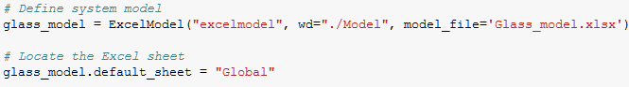

**Exogenous parameters (X)**

The economically best-performing choices of energy efficiency and decarbonisation measures are dependent on uncertainty factors which are not controlled by the glass producers. The future energy prices, the imposition of market regulations, the ETS market and the readiness of new technologies consist of highly uncertain entities which are treated as exogenous factors (Svensson et al. 2009; IEA, 2008). In the long-term, additional costs such as carbon pricing may reduce the ability of companies to cover their capital costs. Companies are vulnerable to these effects since the (in-) direct emissions lead to an increase in costs equivalent to a significant proportion of product value (ICMM, 2013). The latter is a key determining factor for competitiveness across competitors who produce similar or substitute products.

Table 28 | Exogenous parameters which are taken into account in this study.

|  |  |  |  |  |
| --- | --- | --- | --- | --- |
| **Uncertainty parameter** | **Value Range** | **Unit** | **Description** | **Reference** |
| Natural gas price | 0.038 – 0.060 | €/kWh | The full range of estimated prices based on three price scenarios in a horizon of 2050 | Eurostat (2018)  VNPI (2019) |
| Electricity price | 0.03 – 0.079 | €/kWh | The full range of estimated prices based on three price scenarios in a horizon of 2050 | Reynolds (2019)  Statista (2017)  VNPI (2019) |
| CO2 price | 18 – 60 | €/tn CO2 | The full range of estimated prices based on three price scenarios in a horizon of 2050 | VNPI (2019)  Pieters (2019) |
| O2 price | 0.05 – 0.10 | €/m3 | The full range of estimated prices of pure O2, accounting for the volatility of electricity prices | PBL database |
| Bio price | 0.5 – 0.9 | €/m3 | Consist of the physical and intrinsic price. The former depends on natural gas price, the latter is interlinked to the greenhouse gas characteristics of the production location. | Stürmer (2017)  Fiehl et al. (2017)  Ecofys (2018) |
| Emission factor | 0.0 – 0.5 | tn CO2 / MWh | The full range of estimated prices based on three price scenarios in a horizon of 2050. | VNPI (2019) |
| Losses factor | 0.90 – 1.2 | dmnl | Expresses the relation between furnace losses (i.e. tank, wall) and refractory materials, furnace lifetime etc. Factor higher than 1 denotes the wearing off of refractories. | Kahl (Personal communication) |
| Efficiency factor | 0.95 – 1.05 | dmnl | Expresses the volatility of regenerator efficiency depending on flue gas composition and technology lifetime. Factor lower than one includes efficiency gain. | Lavèn (Personal communication) |
| Cullet factor | 0.8 – 1.2 | dmnl | Expresses the relation between cullet percentage and availability, glass colour, requested glass quality and operating constraints. When factor equals to 1, the cullet percentage equals to 76%. | Verheijen  (Personal communication) |

Each source of information incorporates a different set of assumptions, based on which fuel price change or relative price of electricity to natural gas are predicted (Reynolds, 2019). As a result, the uncertainty ranges are set by combining those sources that provide a range about how these trends will evolve by 2050. Regarding the proportion of recycled glass in the glass product, this is also expressed as an uncertainty factor since it depends on market availability, glass colour, requested glass quality and operating constraints such as the product changes per year[39]. In the end, the total amount of uncertainties over their predefined range will consist of the uncertainty space (Table 28). From the point of view of the model or the workbench, the exogenous factors would not have a different impact on the results if they had been set as decision levers instead. By setting them in such a way, it will enable interpretation as well as a comprehensive connection between the model and the policy problem

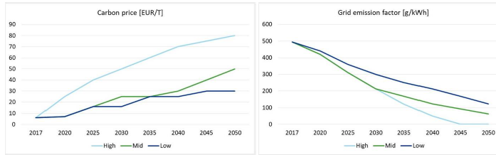**Figure 22 | Projections on future prices and emissions factor in NL. High: complete greening of the grid by 2045; Low: slower reduction of the CO2 emission factor; Mid: electricity generation via electrolysis from 2040 onwards (VNPI, 2018).**

**Decision Levers (L)**

Levers are defined in MORDM in order to examine their behaviour across the uncertainty space. By sequence, policies comprise a mosaic of different decision levers. By selecting only a few decision levers, the algorithm converges to the important and outperforms the least significant. In the end, the total amount of levers over their predefined value range consist of the decision space (Table 29). For testing the performance of three distinct furnace types which were identified in Chapter 5.3 (i.e. air/fuel, oxy/fuel, electric), technology aggregates are set as a form of fixed technology levers. Such aggregates consist of combinations of furnace types with supporting measures (i.e. preheaters and/or O2 substitution and/or electric boosting), whose technical feasibility was discussed in Chapter 5.

The lever of “Ratio Natural gas to Fuel” applies in the case of the first 9 technologies, since the energy carrier of Electric furnace is assumed to be 100% electricity. Oxygen substitution applies to air-combustion options (i.e. Technology 0 and 1), with the assumption that the oxy/fuel firing technologies (i.e. Technology 2 to 8) use by default no less than 100% oxygen for natural gas combustion. That way, decision levers are kept to the lowest possible number which help to save computational power. However, the oxyfuel was modelled in such a way that the benchmarking ratio of gas to fuel is 95%. As a result, any reduction or increase of electric boosting through the input parameter is designed to have a smaller impact on the ratio. This feature was implemented for facilitating the optimisation, which allowed the analyst to use only one lever to control this ratio for all heating methods. Same happens for the control parameter of cullet where – to the best our knowledge - electric furnaces cannot support cullet batches in percentages higher than 50%. As a result, this type of furnace was structurally modified in the model to respond differently to the changes (e.g. cullet factor) of exogenous factors compared to other furnaces. Without loss of generality, the glass type can be assumed to be as “flint” since the difference in fuel use among the different glass types is very low.

Important to notice that, in this study, the decision levers do not implicate with each other when performing optimisation. The reason for that is the absence of cyclical loops in the Excel model. In reality, heat recovery options would decrease the fuel consumption and, as a consequence, would decrease the available flue gas to be recovered. Decreased residual heat means that other options are now excluded. However, the goal here is to highlight the impact of a technology to the process rather than adapting the model to the new conditions. A way to do that is by allowing the levers to move within the limits that account for the expected changes in the industrial process (e.g. 25% electric boosting in a horizon of 2035). As a result, the effect of preheating options on the process will be interpreted separately.

Table 29 | Decision (policy) levers which are taken into account in this study.

|  |  |  |  |
| --- | --- | --- | --- |
| **Decision Lever** | **Value Range** | **Description** | **Reference** |
| Technology | 0 – 9 | 0: Regenerative furnace  1: Regenerative furnace with batch preheater  2: Oxy/fuel furnace  3: Oxy/fuel furnace with Batch/cullet preheater  4: Oxy/fuel furnace with NG/O2 preheater  5: Oxy/fuel furnace with Batch/cullet and NG/O2 preheater  6: Optimelt TCR furnace  7: Optimelt TCR furnace with Batch/cullet preheater  8: Optimelt Plus furnace  9: Electric furnace | Options and the combinations with supporting measures as described in Chapter 5 |
| Natural gas to Fuel ratio | 80 – 99 | Percentage of Natural gas out of total primary fuel used. The model is structurally constrained from applying 100% Natural gas. It is normally used in ranges 10-15%, with a longer term aspiration to reach 25%. The latter percentage is not possible in the existing model, because it implicates negatively to the preheating options. | Lavèn (Personal communication) |
| O2 Substitution | 0 – 80 | Percentage of pure oxygen out of the total oxidizer for combusting natural gas. The oxidizer is specified as a blend of O2 and air. Used in the case of the air-combustion technologies. It is kept below 60% to allow the operation of preheating options. | Baukal (2013) |
| Glass type | 1 – 3 | 1: Flint, 2: Amber, 3: Emerald green | Kahl (Personal communication) |
| Bio switch | 0 – 1 | The user is offered the option to switch from natural gas to Biomethane. | Fraunhofer (2019b) |

**Relationships (R)**

The system relationships in this study are expressed through the model relations which were constructed when performing techno-economic analysis (see Chapter 4). Levers and uncertainties come together and interact, affecting that way the outcomes of interest. It is expected that some of the uncertainties do not have a direct impact on all objectives. Firstly, this is because each uncertainty factor affects the objectives through different model relationships. Secondly, uncertainties may affect the decision of a producer to take action which will ultimately affect the preferred objective. For instance, higher gas price would not result into an automatic switch to cheaper energy carriers, but implicate on the strategy of the producer on responding to the price change. Such trade-offs will be further discussed in Chapter 8 and 9. It is also noteworthy that the fact that stakeholders and analysts do not know or cannot agree on the model that describes relationships between system elements is intrinsic to deep uncertainty (Kalra et al. 2014).

**Performance metrics (M)**

The objectives taken into consideration are the performance metrics (i.e. the criteria of stakeholders) which are used for framing the problem. The target is to bring selected technologies to the level where they cut energy use and contribute to the CO₂ reduction goals of the container glass industry. The economic dimension of the alternative measures targets to widen the point of view and facilitate decision making. As a result, Product cost, Return of investment (ROI) and Payback period are used and handled as separate outputs of interest. The former is strongly affected by fluctuations of fuel, carbon, material and oxygen prices, while the last two metrics are affected by the benefits gained from the new market conditions and the capital expenditure for the technology of interest.

The search over decision levers relies on the specification of the direction for each outcome of interest (i.e. minimise or maximise) which is only possible to use ScalarOutcome objects for optimisation. Consequently, robust options will be determined under deep uncertainty which are economic, minimise energy use and carbon emissions, maintain a low product cost, and maximise the return of investment in the modelling horizon of 2050.

Table 30 | Outcomes of interest which are selected for this study.

|  |  |  |  |
| --- | --- | --- | --- |
| **Objective** | **Unit** | **Direction** | **Description** |
| Direct CO2 | kg CO2 / tn of packed glass | MIN | Process and Combustion CO2 emitted from the furnace |
| Indirect CO2 | kg CO2 / tn of packed glass | MIN | CO2 emissions that result from the generation of electricity |
| Energy use | GJ / tn  of packed glass | MIN | Fuel use for melting; combination of Natural gas and Electricity. In this context, electricity is expressed in terms of secondary source of energy. |
| Product cost | € / packed glass | MIN | The cost of creating a packed glass |
| Return of Investment | % | MAX | Evaluate profitability of a process |
| Payback period | years | MIN | The amount of time it takes to recover the cost of an investment |

## 6.2 Policy determination

In the second step of MORDM, candidate strategies are discovered via modelling (i.e. a posteriori) which are Pareto optimal conditional on a reference scenario. These candidate strategies are points in the decision space which are identified through search with many-objective evolutionary algorithms (MOEA). The workbench uses a MOEA called ε-NSGAII by default, but alternative MOEAs can be found in Reed et al. (2013). These algorithms iteratively evaluate a large number of alternatives on various objectives until they find the best candidates. The model function (i.e. model interface developed in the previous step) is called for each candidate evaluation, and the corresponding six objective values are generated. The optimise method can take an optional argument, which can be used to set the scenario for which good policies will be sought (Watson & Kasprzyk, 2017). In this case, the reference scenario includes factors and prices that correspond to market conditions of the year that this study was conducted. The result is a pandas dataframe with decision variables and outcomes of interest.

A multiprocessing evaluator is used to speed up calculations (Kasprzyk et al. 2013). It requires that Platypus is installed (i.e. framework for evolutionary computing in Python) in order to specify the problem components and use the optimise method. The workbench also offers support for tracking convergence that ensures finding better solutions. The metrics used in this study are the epsilon progress and the hypervolume. Epsilon progress is the metric to indicate whether new solutions are being added to the set of non-dominated alternatives as the search progresses (Ward et al. 2015). A higher number of function evaluations (NFE) helps the optimisation to better converge, while more solutions are expected for a finer scan of the outcome space (i.e. lower epsilon). Establishing the NFE is generally a form of trial and error. Hypervolume is used in a supplementary way, where the predefined limits of a hypercube are the preferred goals for each outcome of interest. These limits must be large enough so that the Pareto approximate set will include points within the end-dimensional space. Otherwise, the convergence may look like a flat line across the function evaluations.

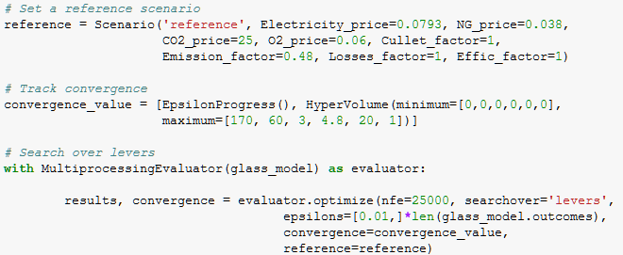

## 6.3 Uncertainty analysis

The assessment of the uncertainty of the output space given the uncertainty of the input space is generally referred to as uncertainty analysis (Pruyt & Islam, 2015). In this step, the MORDM uncertainty analysis interrogates each solution in the Pareto approximate set with a large number of alternative SOWs to see how the solution performs under a range of assumptions regarding the exogenous factors (Kasprzyk et al. 2013; Watson et al. 2017). At the end, the robust (constituent) solutions are chosen that have acceptable (Pareto satisficing) performance across a wide range of plausible future scenarios. It generally answers the question of “*Which of the uncertain input factors are more influential in determining the variability affecting the inference?*” (Cariboni 2007).

Uncertainty analysis involves two steps. Firstly, a large ensemble of vectors of the uncertainty parameters is built using the sampling method named Latin Hypercube. Secondly, robustness metrics are employed that cover the various ways in which robustness is being operationalised.

6.3.1 Uncertainty Ensemble

Alternative model instantiations are constructed which are simulated to generate a set of runs that is representative for the entire multidimensional uncertainty space (Pruyt & Islam, 2015). The sampling method named Latin Hypercube (LHS) is used to build a diverse ensemble of vectors of the uncertainty parameters. The LHS uses non-uniform distribution for drawing numbers within a boundary and is carried out across the uncertainty parameters identified in model specification (see Chapter 6.1). That way, it fills possible gaps that would appear by randomly drawing points to fill the space. These designs are independent to each other and they are combined into datasets. Given that there are not many points in the edges of the uncertainty space, normal distribution is outruled. In the end, each ensemble member or alternative scenario (i.e. future SOW) represents a set of values for each exogenous factor whose impact on future conditions is being explored (Walker & Haasnoot, 2011).

Based on the previous solutions dataframe, a list of policies is transformed into dictionaries and inputed to the perform_experiments function of the EMA workbench (i.e. input for the Policy class). The return of this function is by default a tuple of length 2, where the first item in the tuple is the experiments and the second one is the outcomes. Experiments and outcomes are aligned by index. The experiments are stored in a numpy structured array and the outcomes in a dictionary with the name of the outcome as key and the values are in a numpy array.

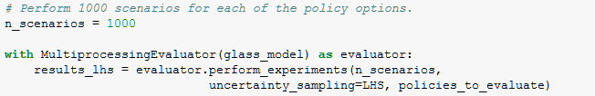

At this point, feature scoring can be applied to identify the most relevant features (i.e. uncertainties) to include in the model for each outcome of interest. It gives a first indication about the origin of the uncertainties, therefore understand the impact of uncertain inputs and interactions with the objectives.

6.3.2 Robustness metric

This stage involves both computational exploration and robustness calculation. Firstly, the analyst searches for the area in uncertainty space which produces desirable outcomes. That way, the uncertainty space is narrowed down by reducing subspace. Secondly, a robustness metric takes as input the performance of a candidate policy over a set of scenarios (i.e. the previous results) and returns a single robustness score.

The robustness metric is nothing but a way of aggregating performance over a set of scenarios. Different robustness metrics measure different dimensions/aspects of robustness. Therefore it is useful to look at more than one robustness metric since they all describe something different. The workbench does not include pre-defined robustness metrics, hence they have to be retrieved from the literature (McPhail et al. 2018).

The metrics used in this study are the Starr's domain criterion and the maximum regret.

* *Starr’s domain criterion* denotes a fraction of sampled scenarios in which a solution achieves a performance threshold for each outcome of interest (Hadka et al. 2015). This maximises the space where the analyst can act, therefore a policy satisfies all performance requirements.
* *Maximum regret* is calculated for each policy under each scenario, as the difference between the performance of the policy in a specific scenario and the performance of a no-regret (i.e. best possible result in that scenario) or reference policy. The maximum regret is then the maximum of such regret values across all scenarios.

## 6.4 Scenario discovery

Finally, the ensemble of simulation runs with associated case information is passed to Scenario Discovery. This method is used for developing descriptions of areas in the uncertainty space that remain vulnerable, despite searching for policy alternatives that are meant to be the most successful (Bryant & Lempert, 2010). The process includes setting performance thresholds (i.e. limit the model outcomes), identifying hypercubes in the uncertainty space that describe values which violate these thresholds, and interpreting the values which are important for uncertainties.

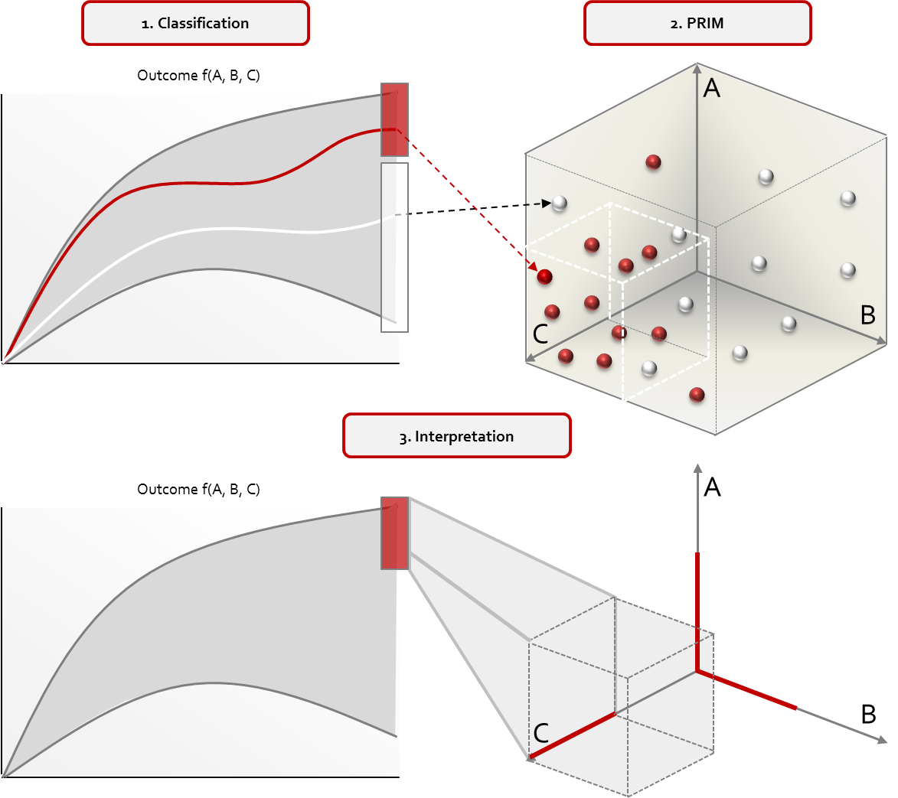

**Figure 23 | Steps followed for performing Scenario discovery (Greeven et al. 2016).**

6.4.1 Binary classification

The first of the three steps in Scenario Discovery involves setting performance thresholds using one or more measures. Uncertainty ensemble members (i.e. SOWs) that exceed these thresholds are considered acceptable and SOWs that violate them are considered vulnerable (Watson & Kasprzyk, 2017). A binary classification of results is created for separating interesting cases from others. For example, if the analyst specifies that 150kg of Direct CO2 emissions is the rule for determining an undesirable outcome, then the performance of candidate solutions that violate this threshold is considered poor. This will allow the identification of the most important uncertainties that affect system behaviour.

6.4.2 Subspace partitioning

In an effort to define ranges of those uncertainties that cause vulnerabilities, Scenario Discovery employs tools for statistical clustering analysis such as the Patient Rule Induction Method (PRIM; Friedman & Fisher, 1999). Based on the binary classification of scenarios, PRIM will help determine for which realisations of uncertainties that happens. The full space is divided into orthogonal subspaces, forming multi-dimensional scenario boxes that contain cases of interest. In this orthogonal subspace, PRIM iteratively slices an amount of data from the selected boxes, and scenarios with distinctively different outcomes are identified. The process is repeated by selecting one of the alternative boxes that PRIM suggests; the boxes lie on a Pareto optimal surface.

PRIM provides more opportunity for interaction compared to other ruling induction algorithms and requires less initial configuration for the analyst (Bryant & Lempert, 2010). The EMA workbench comes with a separate analysis package which contains PRIM, a stand-alone Python implementation of the Patient Rule Induction Method. The technique runs interactively using the Matplotlib library, and simple rules are defined in terms of percentile performance or minimum and maximum bounds.

6.4.3 Interpretation

In the last step of Scenario Discovery, combinations of uncertain variables that best predict a particular outcome will be identified. This is achieved by observing the trade-offs among individual policies, and then using this information to guide the choice of scenarios. There are three considerations that matter at this stage: interpretability, density, and coverage. Interpretability is a function of the number of dimensions per box and the total number of boxes, which indicates how easily users can understand the information. The density indicates how many of the captured points within a scenario are actually in the vulnerable set. The coverage expresses the ratio of the total number of cases of interest in the candidate box to the total number of cases of interest. Lastly, the “quasi-p value” (Qp) is used as an additional metric which denotes the uncertain parameters which are less important in describing the vulnerable cases.

The identification of such influential factors allows the iterative improvement of the model with inclusion of decision levers of the previous steps of MORDM (Kwakkel & Jaxa-Rozen, 2016). The outcome will help shaping a set of alternative decarbonisation options which are maximally robust across many possible futures (Bryant & Lempert, 2010). By looking at how individual glass plants can achieve a transition to a low-emissions future, this will be an indication of how the container glass industry could be shaped in a national level (FEVE, 2016).

# 7 Verification & Validation

An inherent limitation of models is their incapacity to imitate a real-world system with accuracy (Giere, 2004; Bankes, 1993). Questions arise of whether the resulting outcome is solid enough to be used for decision support, or whether the model and its individual modules are sufficiently accurate for the intended use. To confront with these issues, the conceptual model requires an iterative Verification and Validation (V&V) which takes place throughout the model development. For conducting V&V, a series of tasks is applied to the degree needed for the model’s intended purpose (Banks et al. 2010). The model and the resulting outcomes can be better understood by assessing the properties which are stated implicitly in the model (Dubois et al. 2013). The following chapter will elaborate on the different tasks applied with regards to verification and validation.

## 7.1 Verification

The employed technique for performing a thorough verification of the model include interviews with industry experts and literature review. During model verification, the goal is to identify and correct possible errors in the implementation of the model (Schlesinger, 1979). Model correctness, consistency, and completeness checks are often performed as relative measures for model verification (Zowghi & Gervasi, 2002).

The conceptual model of this study which was developed in MS Excel was regularly inducted back to the theory through literature review. This ensured that its elements are in line with the foundation and concepts described in Chapters 1 and 3. The model should match both the specifications and the assumptions with respect to the initial concept, which can often be examined by observing its behaviour in calculating performance measures. For this purpose, the model was then stress-tested by calibrating its input parameters and configuring the system relationships. The resulting objective values enabled a better understanding of the underlying system and, at the same time, matched the experts’ understanding and expectations.

The assumptions made with regards to the techno-economic analysis were explicitly discussed and investigated with industry experts, including company representatives and supervising professors. Those assumptions that do not reflect reality but have been crucial in forwarding the research (e.g. absence of flue gas treatment) have been documented in the discussion phase in Chapter 10, as well as in the comment section of the Excel model. The same approach was followed for system relationships which were vital to the model development but infeasible to be approximated (e.g. relation between the maximum furnace temperature and the recycled glass content instead of the glass quality demands).

7.1.1 Model-building approach

The multitude of information sources which were handled for conducting this study required a model-building approach that accounts for regular model adjustments along the process. Moreover, decision making is an iterative process which provides the opportunity for feedback, as well as model or policy refinement based on that feedback (Tsoukiàs, 2008). This allows incorporating a wide spectrum of potential future events into the analysis, but also examining the robustness of solutions and their capacity to account for conflicting objectives when dealing with deeply uncertain problems.

Revisiting the model specifications often leads to adjustments of model relationships, resulting in new findings which need to be interpreted and properly communicated. Model assumptions are reconsidered when feedback is received, leading to a refinement of model specifications (Kelly, 2013). The frequency that new increments need to be produced dictate a combination of iterative and evolutionary approach, which allows the construction of the “Glass model” (i.e. Excel model) in a stepwise manner, both in incremental and in rapid cycles (Larman & Basili, 2003).

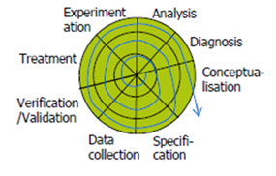

**Figure 24 | Iterative / evolutionary approach of model building followed in this study.**

Using this approach, each “release” of the model was thoroughly tested and built on previous functionality. This effectively gave an indication of the progress made at every stage of the research, enabling easy verification of the model structure and validation of the findings (see Chapter 7.2). Most importantly, it allowed communication of results with both the interviewing and the supervising experts at the early stage of the research, whose input was incorporated into the calculations without the risk of performing radical changes at later stages of model building. This guaranteed working with a robust outcome, keeping both the development and expansion of the model on track along the process. In the end, a solid structure was made available to future researchers for further expanding the model capabilities.

7.1.3 Interviews and expert input

Scheduled meetings with industry and glass experts enabled comprehending the container glass industry and its contradictions (see Chapter 2.5). At the same time, they provided with the opportunity to minimise ambiguities during model building through discussions on location-specific conditions. The following topics were considered during the discussions:

* Overview of the Dutch container glass industry (i.e. location-specific information of container glass plants, environmental regulatory requirements),
* Research objective (i.e. improve existing or adopt innovative technologies with the prospects of minimising carbon emissions in the container glass industry by 2050),
* Configuration (i.e. verification through Process flow diagrams and table of results),
* Feedstock parameters (i.e. raw materials, recycled cullet).
* Technology requirements (i.e. primary and secondary energy input),
* Air emissions (i.e. mainly CO2, SOx, NOx),
* Decarbonisation options (i.e. technical and economic feasibility, investment decisions).

The model concept as well as the consistency of the model were discussed by examining design decisions and the inclusion of model elements. For instance, the decision of merging the activities of melting and fining was argued by the fact that they are both performed to a glass mixture of the same state (i.e. molten glass). Model completeness was assessed based on the amount of design elements for approximating the actual production of container glass. Process flow diagrams which neglected specifics of the different production locations were provided to glass experts (Figure 8). This enabled the confirmation of which process activities are most commonly applied in the context of container glass production.

All forecasting methods contain deeply ingrained weaknesses, which stem from the inability to capture precisely the long-term multiplicity of plausible futures (Mietzner & Reger, 2005; Goodwin & Wright, 2010). As a result, design discussions gave also the opportunity for both determining and refining the input parameters of the MORDM method (see Chapter 6.1). Expert opinion was also used for exploring possible reference scenarios for policy determination, as well as for selecting robustness metrics for Uncertainty analysis.

## 7.2 Validation

At the end of the model development process and after verifications are completed, validation is performed for examining the accuracy of the model's representation of the real system. The use of multiple perspectives and information sources along with the transparency of calculations are mechanism for securing model validity. As a consequence, model validity will guarantee that the model has been built for serving a specific purpose or satisfying a set of objectives (Sargent, 2011).

7.2.1 Transparency of data sources

Intransparencies are quite regular in both company- and industry level, forcing the analyst to work with assumptions and incomplete or aggregated data. Past research often uses industry averages or over-simplified model relationships for performing calculations, making the empirical evidence heavily context dependent. For minimising the dependency on intransparent sources, expert opinion is essential for improving the accuracy of the findings. Despite the fact that expect opinion is not always impaired, the research validity is increased for the more input that is gathered (Young, So & Ockey, 2013).

When information is scarce (e.g. unknown operational characteristics of a technology), graphical representations of similar studies can be adapted to the conditions of the system under study. This approach was followed when estimating the effect of pure oxygen in the flame temperature, as well as the fuel savings from preheating the natural gas (Zheng, 2011; AGC, 2015; Baukal, 2013). At this point, it is important to test these model assumptions by comparing the input-output of the model with the expected input-output transformations of the real system. Any deviation of the actual from the expected result needs to be interpreted and reflect on the implications this may have on the accuracy of the model.

7.2.2. Model purpose

The research focus, as well as the conditionality and the system boundaries have been discussed in Chapter 2.6. Within this framework, the purpose of the developed model is to replicate the melting activity of a container glass plant which. The inventoried values are necessary for justifying the estimated energy use of the furnace, as well as the direct emissions originating from the melting activity (see Chapters 2.4.1 and 4.1). Using the energy and emission ranges per process activity – as indicated by company representatives – the complete picture of a container glass plant was obtained.

The extent to which model and its individual modules are sufficiently accurate for the intended use was evaluated in bottom up way. The estimated carbon emissions were multiplied with the annual production capacities shared by container glass companies, which were compared with the respective emissions from databases of the Dutch Emissions Authority (NEa). A deviation < 8% of the estimated carbon emissions from the real situation was observed when location-specific information was scarce, and < 5% deviation when information was abundant. Location-specific energy use and emitted pollutants can be approximated by adjusting the input parameters according to the respective plant configuration. The resulting strategies are not representative for a particular Dutch container glass company.

# III Results

*The findings of each of the employed methods will be presented in this section. After embedding CO2-reducing technologies into the benchmark plant configuration, the empirical evidence will give an indication on the conditions, possibilities and potentials for decarbonising the container glass industry. Robust alternatives that account for deep uncertainty will be presented, in an effort to support decision-making for achieving this target in the horizon of 2050.*

# 8 Research Findings

Following the established methodology, empirical evidence is extracted which help determining the conditions, the possibilities and potentials for decarbonising the container glass industry. The material and energy flow analysis will provide a complete picture of CO2 emissions and energy requirements per industrial activity and the plant as a whole, which will lead to the development of benchmarking configurations for several technology aggregates. Alternative decarbonisation solutions emerge by examining how these configurations respond to endogenous and external conditions. It will be shown which of these options manage to balance the conflicting objectives of the policy problem under many possible futures. Two iterations of the MORDM method are performed for identifying those strategies that retain their robustness in the modelling horizon of 2050. The findings will be communicated using the built-in visualisation tool of MS Excel as well as the Python data libraries of Matplotlib, Plotly and Seaborn.

## 8.1 Material and Energy flow Analysis

Techno-economic analysis was performed for the shortlisted decarbonisation options which were identified in Chapter 5 and evaluated in terms of their technically and economically feasibility. The possible combinations of heating methods (i.e. air/fuel, oxy/fuel, electric melting) with other supporting measures (i.e. heat recovery systems) result in a list of technology aggregates which is provided in Table 31. However the feasibility of these aggregates is a different concern, since a combination of technologies may not leverage the current operational capabilities as individual technologies would do. For this reason, each technology aggregate was incorporated into the Material and Energy flow analysis in effort to observe their impact on the manufacturing process.

Attention is required with regards to the units used. In principle, values are expressed in tonnes of molten glass when the discussion revolves around the melting area (e.g. energy use of furnace or preheaters) and expressed in tonnes of packed glass when referring to the plant configuration (e.g. footprint, product cost etc.). The notation “tpd” (i.e. tonnes per day) is used as a specification of furnace’s melting capacity, therefore the tonnage refers to molten glass (i.e. glass pull).

Table 31 | Shortlisted decarbonisation options consisted of technology aggregates.

|  |  |  |  |
| --- | --- | --- | --- |
| **No.** | | **Shortlisted options (i.e. technology aggregates)** | **Description** |
| **Air/fuel firing :**  Fuel-fired process heating using combustion air as the main oxidant | | | |
| **0** | | Regenerative furnace | “As-is” air/fuel furnace with 8% electric boosting; regenerators for air preheating, positioned at the end of the melting tank and operating with a typical energy efficiency of 70%. Used for the base plant configuration and the calculation of ROI’s. |
| **1** | | Regenerative furnace with Batch/cullet preheater | Air/fuel furnace with 8% electric boosting and regenerators; both raw materials and cullet are preheated through the heat content of flue gases. |
| **Oxy/fuel firing :**  Fuel-fired process heating using commercial oxygen as oxidant | | | |
| **2** | | Oxy/fuel furnace | “As-is” oxy/fuel furnace with 5% boosting and without oxygen production. |
| **3** | | Oxy/fuel furnace with Batch/cullet preheater | Oxy/fuel furnace with 5% boosting and without oxygen production. Both raw materials and cullet are preheated through the heat content of flue gases. |
| **4** | | Oxy/fuel furnace with NG/O2 preheater | Oxy/fuel furnace with 5% boosting and without oxygen production. Natural gas and oxygen are preheated through hot combustion air using heat exchangers. |
| **5** | | Oxy/fuel furnace with Batch/cullet and  NG/O2 preheater | Oxy/fuel furnace with 5% boosting and without oxygen production. Combination of the previous two preheating methods. |
| **6** | | Optimelt TCR furnace | Advanced heat recovery system in oxy/fuel furnace, where the input gas is converted into a hot syngas. Requires two small regenerators as well as TCR, RFG and O2 skids. |
| **7** | | Optimelt TCR furnace with Batch/cullet preheater | Advanced heat recovery system for the reforming of natural gas in oxy/fuel furnace, with an integrated batch/cullet preheating system. |
| **8** | | Optimelt Plus furnace | Combination of the non-catalytic reforming process (Optimelt TCR)  regenerative oxygen preheating (Plus) |
| **Electric melting :**  Glass is directly heated by molybdenum electrodes | | | |
| **9** | | Electric furnace (CVTM) | Thermally efficient all-electric furnace which relies on resistive heating by submerged electrodes. |

8.1.1 Waste heat recovery options

The heating methods under investigation employ a variety of fuel inputs. With the exception of electric melting, an adjustment of the oxidant can alter the composition and the heat content of the flue gases. Apart from the impact on the emitted CO2, this technique is particularly important for guaranteeing the normal operation of preheating options. As a result, switching from Natural gas (NG) to Biomethane (BM) or substituting combustion air with pure oxygen may result in undesirable properties for the exhaust gases.

In Figure 25, both stoichiometric and oxygen-enhanced combustion as well as electric heating are compared in terms of the estimated pollutant emissions. When the combustion of methane takes place in air (79 vol% N2), a significant portion of the methane’s heat content is lost through the stack. By contrast, the combustion of pure oxygen converts 79% of the methane’s energy content into useable heat. For combustion of Biomethane (BM) at stoichiometric fuel-to-air ratio, 23kg of CO2 less are produced per tonne of molten glass due to the absence of other hydrocarbons (i.e. propane, butane etc.). Further to this reduction, the combustion process could be considered entirely neutral in its CO2 emissions (Paolini et al. 2018; Fiehl et al. 2017). The flue gases from electric melting contain only the process emissions which originate from the decomposition of carbonates. As a result, the emissions are limited to 36 kg CO2/tn molten glass. A possible organic contamination originating from recycled cullet was included in the analysis, but it is taken into account as a limiting factor when it comes to cullet availability of high quality (see Chapter 6.1).

**Figure 25 | Composition of flue gases under various heating methods and oxidants for the production of flint container glass.**

At this point, the operation of a 300tpd regenerative furnace is replicated. This enables the creation of a benchmarking “as-is” technology which will allow comparisons with competing technologies in terms of fuel and emissions reduction. A reference configuration for a container glass plant is set afterwards, which gives an indication on plant’s footprint and the final product cost. As shown in Figure 26, the recovered heat from flue gas (approx. 68%) helps maintaining the energy input for melting at the levels of 3.95GJ for natural gas and 0.34GJ for electricity per tonne of molten glass, respectively. Electricity is used here as a secondary form of energy without considering its generation losses. These losses are incorporated later into the analysis, where the technology aggregates will be compared on the basis of their total energy input. Under the assumption that the regenerator efficiency is 70%, the estimated temperature of preheated air is 1385oC, and the temperature of the diluted flue gases exiting the regenerator is 455oC.

Furthermore, the rate of natural gas usage is decreased with the integration of a batch/cullet preheater into the process through the additional energy which is carried into the furnace (Khoshmanesh et al. 2007; Sundaram, 2013). By taking into account the limitations mentioned in Chapter 3.2.2 and 5.3.4.a, the preheated reactants helped reducing the fuel use by 10-18% in the case of air/fuel firing and 5-10% for oxy/fuel firing compared to the base case of cold reactants. By adjusting input parameters in the Glass model (e.g. preheater efficiency from 50% to 60%, O2 substitution from 0% to 50%, Natural gas-to-Fuel ratio from 92% to 85%), the preheated batch was kept in the temperature windows of 275-325oC for air/fuel and 200-250oC for oxy/fuel firing.

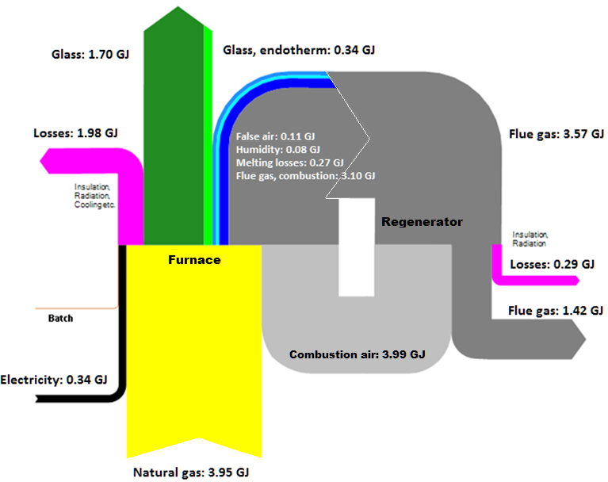

**Figure 26 | Heat Balance in a 300tpd regenerative furnace[40].**

In the end, the estimated recoverable energy under reduced rate of natural gas use was balanced with the energy required for preheating batch and cullet. The benefits are amplified when using batches of higher cullet rate, since the melting point of recycled glass is considerably lower compared to raw materials, decreasing that way the residence times in the melting area (Figure 27a). Further savings can be achieved using a direct cullet-only preheaters for oxy-fuel furnaces, which can be combined with an electrostatic precipitator for dust removal (Barklage-Hilgefort, 2009; cited in Hatzilau et al. 2016).

**Figure 27 | Fuel savings through preheating (a) Batch/cullet; (b) Natural gas/O2.**

Similar benefits are obtained by using a Natural gas/oxygen preheater in the case of oxy/fuel firing. This technology was combined with both an “as-is” oxy/fuel furnace as well as a furnace that leverages the Optimelt TCR concept. The former resulted in fuel gain of about 8-10% compared to a base case of cold reactants, and the latter of about 6-7% on top of the fuel savings from the reformation of natural gas. When the heat content of flue gases was not sufficient to justify the operation of both natural gas and oxygen preheating, priority was given to the former option and therefore the oxygen was preheated at lower temperatures (Figure 27b).

Overall, the addition of these preheating options resulted in higher pull rates by maximum of 10% compared to the benchmarking conditions due to the improved melting efficiency. Subsequently, it lowers combustion emissions by max. 20kg of CO2 per tonne of molten glass through the decreased use of fossil fuel. However, such systems require the majority of the heat content of flue gases for enabling preheating. Therefore the reduced usage of natural gas would lead to reduced flue gas amount and thus recoverable energy (Sundaram, 2013).

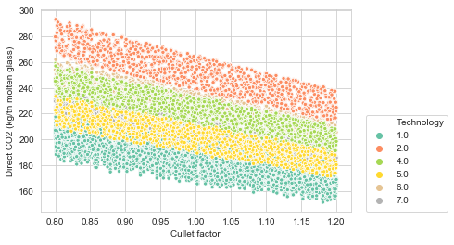

**Figure 28 | Relation between cullet use and direct emissions in the container glass furnace, as affected by varied external conditions (see Chapter 6.1).**

In Figure 28, it can be seen that recycled glass content can have a significant impact on the direct emissions of the furnace regardless of type. This is verified by the fact that both the theoretical energy requirement for melting (Eq. 14) and the maximum furnace temperature (Eq. 4) are interlinked to the recycled glass content of the batch. It indicates how sensitive the process is to external conditions, given that a change in the requested glass quality or the market availability of recycled cullet may cause a steep increase in CO2 emissions during that period. This is expressed through the “Cullet factor”, where 76% recycled glass content corresponds to a cullet factor equal to the unit (see Chapter 6.1).

8.1.2 Scale-up electric melting

After the model relationships are formed and the electricity input is estimated, the ability of the regenerative furnace to support additional glass pull must be replicated. Electric boosting can be employed as a temporary method for increasing the production capacity of glass furnaces (i.e. pull rate), responding that way to the fluctuating demand for glass. The boosting enables high mass flow rates due to the faster melting, which results into shorter residence times of the melt in the furnace. For that purpose, a ratio called “Boost-to-Pull” was created that expresses the relation between the boost power and the pull rate. By taking the average boost power of 19 furnaces by glass type (see Appendix C), the continuous boost power input per extra tonne per day was approximated at 0.396MWh/tn molten glass. Table 32 shows how this relation was automised.

Table 32 | Shortlisted decarbonisation options consisted of technology aggregates.

|  |  |  |  |  |  |  |
| --- | --- | --- | --- | --- | --- | --- |
| **Status** | **Glass Pull (tn)** | **Electric boosting** | | **Electricity to Fuel ratio (%)** | **Fuel (GJ)** | **Pull rate (%)** |
| **MWh** | **GJ** |
| fixed | 1 | 0.09 | 0.33 | 8 | 4.13 | 100 |
| fixed | 2 | 0.18 | 0.66 | 8 | 8.27 | 100 |
| fixed | 3 | 0.28 | 0.99 | 8 | 12.40 | 100 |
| fixed | 200 | 18.37 | 66.15 | 8 | 826.84 | 100 |
| extra (+1) | **201** | 18.77 | 67.58 | **8.2** | 828.27 | **100.5** |
| extra (+50) | **250** | 38.29 | 137.86 | **15.3** | 898.55 | **125** |

As a result, the electricity required for additional glass pull was calculated as follows:

E-boostingExtra = E-boostingMelt + Extra glass pull * Boost-to-Pull (25)

where: *Extra glass pull: user input in terms of additionally requested molten glass, E-boostingMelt*: electricity input of benchmarking technology, *E-boostingExtra*: adjusted electricity input of benchmarking technology, and *Boost-to-Pull* = 0.396MWh/tn molten glass. That way, the user has the ability to see how the glass demand is translated into both process and indirect emissions, with the assumption that the natural gas usage remains constant. It is estimated that an increase of capacity by 1 tonne corresponds to additional in 248 kg of indirect and only 52 kg of direct CO2 per tonne of molten glass. The direct emissions consist of both a constant increase of process emissions of 36kg/tn molten glass and a slight change in combustion emissions as consequence of increasing the theoretical energy requirement.

8.1.3 Total fuel use and emissions at plant level

The total energy consumption of a container glass plant for the production of flint glass type was estimated at 5.97 GJ/tn packed glass when using regenerative furnaces of 70% preheating efficiency, 5.21 GJ/tn packed glass when using oxy/fuel, and 5.7 GJ/tn packed glass when using electric furnaces of 300tpd capacity. In the first case, it was assumed that energy is coming from both gas (92%) and electrical boosting (8%) and the percentage of recycled cullet into the batch was 76% (Figure 29). For oxy/fuel furnaces, electric boosting was set at 5% without adding any preheating option for that benchmarking plant configuration. For electric furnaces, the cullet percentage was set at 50% in order to meet the constraint that electric furnaces currently cannot support high-cullet batches (see Chapter 5.3.3).

It can be seen that the melting activity draws the vast majority of the fuel input in terms of both natural gas and electricity (Figure 29). This makes the furnace the largest emitter of the plant, which justifies the decision to investigate decarbonisation options for the industry within the framework of the melting activity (Figure 30; see also Chapter 2.6).

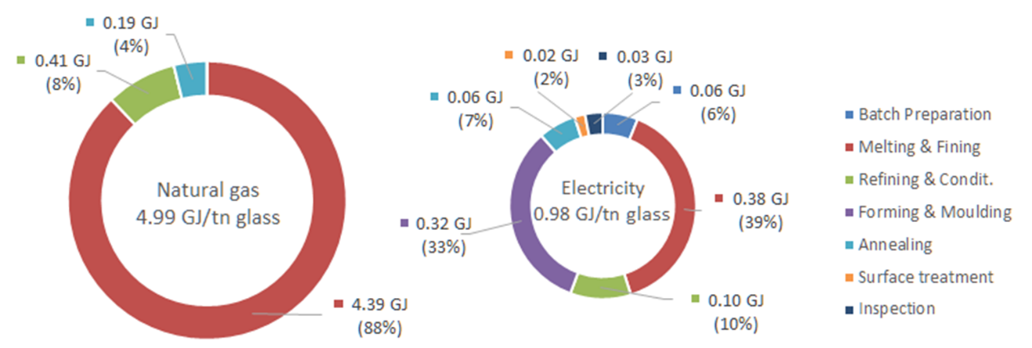

**Figure 29 | Energy input per industrial activity for container glass production[41].**

The Refining & Conditioning activity is the second larger consumer of natural gas after melting, which accounts for 8% of the total natural gas and about 8.6% of total energy use. The electricity used for the forming machines is about 5.5% of the total plant’s energy input, without considering the compressed air system for blowing out the bottles and cooling of mould materials. Annealing requires a very low amount of natural gas for the thermal treatment of the blown glass, and little energy requirement is needed for surface treatment to drive a bridge (electrically or by compressed air). Depending on location-specific conditions, the Batch preparation may include additional activities which would result in additional energy requirements (e.g. crushing, hammering, measure and weighing, mixing and grinding, screening, atomisation, separation and filtering processes) (Fraunhofer, 2019a). For an average annual production of 1 bil. bottles (VNG, 2012), the resulting direct emissions are 62.4 kton CO2 when using regenerative furnaces in the Glass model (i.e. “Technology” variable set to zero).

**Figure 30 | Carbon emissions per industrial activity for container glass production[42].**

The plant emissions which were obtained from NEa databases as well as the production capacities which were shared by company representatives (see Appendix B) will be used for validation. Ardagh Glass Dongen B.V. emitted 92.8 kton of CO2 in 2017, having a production capacity of 300 kton of packed glass[43]. By placing this capacity into the Glass model and assuming that bottles have an average weight of 0.195 kg, the resulting direct emissions are 87.9 kg CO2/tn packed glass. This value is extracted by taking the average of three different air/fuel configurations (i.e. Technologies 0-2) in order to account for the simplifications which were made when performing the calculations (e.g. absence of electrostatic filter, bag house filter, and sulphur removal; see Chapter 11.2). In the case of two container glass plants of Owens–Illinois (O-I) in Leerdam and Maastricht, their combined production capacity in 2017 was 600 kton and their emissions were reported to 171.9 kton of CO2[44]. The estimated annual direct emissions resulting from the Glass model are 163.6 kton of CO2, which are extracted by setting the benchmarking Technology to “3” and the O2 substitution to 100% (i.e. oxy/fuel furnaces; no preheating options currently applied). The results obtained from this procedure show deviations of 5.2% compared to the actual values for Ardagh Group and 4.8% compared to the actual values for O-I Netherlands.

8.1.4 Comparison of Technology aggregates

The focus is primarily on furnace energy reduction methods for improved energy efficiency and subsequent reductions in carbon emissions. For this purpose, comparisons were performed among potential plant configurations that employ different heating methods (Figure 31). It also follows the same layout of the “D1_Furnace” tab in the Glass model which includes the extended findings of the mass and energy flow analysis. The calculations were performed on the basis of the primary energy use and direct emissions of the furnaces. Notably that the intension is not to illustrate energy- and emission reduction potential through the use of interchangeable technologies, but performing comparison among alternative configurations.

Before performing comparisons, each technology aggregate should match the specifications mentioned in Chapter 8.1.3 and the values should be expressed in tonnes of packed glass. By taking into account conversion losses in electricity generation and assuming that electricity comes from one source with 40% efficiency, the natural gas input of every technology aggregate is counted together with the electricity input (Blok & Nieuwlaar, 2016). As a result:

**Primary energy use**: Ep = NG +Es /nε (26)

where *Ep*: primary energy use, *NG*: natural gas input, *Es*: electricity input in terms of secondary source of energy, *nε*: efficiency of electricity generation. After extracting the fuel use for every technology aggregate, the potential reductions are expressed in percentages[45]. The reductions are used for validation to ensure that the values retrieved from the literature are reflected into the calculations. This will enable performing many objective optimisation with the inclusion of solid findings (see Chapter 8.2).

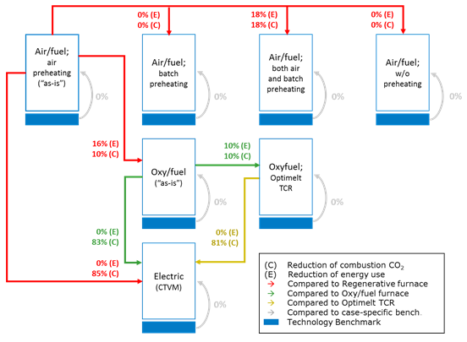

**Figure 31 | Comparison of benchmarking technologies of different heating methods. Reductions are expressed in terms of primary energy use and direct CO2 emissions.**

Oxy/fuel furnaces appear to have lower energy requirements than regenerative furnaces, with a subsequent impact on direct emissions. At the same time, furnaces that leverage the concept of Optimelt TCR yield additional energy and emissions reductions compared to base-case oxy/fuel furnaces. The use of batch/cullet preheaters in regenerative furnaces results in energy savings of 18% compared to an as-is regenerative furnace. This consists of an over-estimation compared to the values mentioned in Chapter 5.3.4.a, and will be further discussed in Chapter 11. The most important aspect is the reduction potential of direct emission when using electric furnaces (i.e. elimination of combustion emissions), but the high requirement for electricity does not result in energy savings compared to other heating methods.

## 8.2 Economic Analysis

The feasibility of the technology aggregates is then investigated in financial terms. The estimation of Product costs, as well as the metrics of Return of Investment (ROI) and Payback period are used for screening multiple alternatives rather than making a final selection. This gives an indication on whether these aggregates have the potential to be profitable in the future, therefore avoid loss of opportunity for sound financial returns. The analysis will allow drawing conclusions about the decarbonisation options from a performance and financial perspective (see Chapter 9).

Depending on the heating method and supporting measure which is deployed, each technology aggregate implicates differently on the total cost of production. The product cost is thus estimated in each of these cases by incorporating the empirical evidence from mass and energy flow analysis into Eq. (17). The average annual revenues of a container glass plant were estimated to be around €55 mil. The complete list of commodity prices is provided in Appendix F.

According to Figure 32, the input materials (i.e. both raw and recycled) for the production of 1bil. glass bottles account for the largest proportion of annual production costs. They are considered constant when examining each option, since the quantity of input materials is mostly dependent on external factors (see Chapter 6.1). The additional glass pull which results from the improvement of melting efficiency through the use of preheating options will be taken into account further on. Carbon cost is currently responsible for about 2% of the product cost, but the increasing permit pressure is having a proportionally high impact on the annual costs. With the deployment of preheating technologies, the cost for fuel input is considerably reduced compared to technologies “0” and “2” (i.e. regenerative and oxy/fuel furnaces, respectively). For instance, the deployment of a batch/cullet preheater in an oxy/fuel firing configuration (i.e. Technology 3) results in a fuel reduction of 10% compared to Technology 0 which leads to a decrease of product cost by 2.6%. It is also observed that oxy/fuel becomes more economical when the natural gas savings exceed 18% compared to air/fuel firing.

**Figure 32 |** **Varied costs for the production of 1 bil. container glasses per technology option[46]. Commodity costs refer to annual expenses; Bare-module costs consist of one-time investment.**

Pure oxygen is responsible for about 5% of annual production costs when oxy/fuel firing is employed (i.e. Technologies 3-8). The justifiable value of 300tpd electric furnaces (i.e. Technology 9) is the increasing CO2 prices and the variable costs of natural gas. However, current conditions with regards to electricity prices and upfront costs (i.e. €56.3 mil; Reynolds, 2019) make this energy intensive technology quite prohibiting (est. 4.1 GJ/tn molten glass). Approximately 35-45% of expenses are attributed to purchase equipment costs, while operation and maintenance costs (O&M) account for 35% of annual expenses (incl. annual cost of maintenance, labour, facility-dependent equipment, and water and air). As a consequence, the cost per packed glass ranges between 5.1 and 5.8 €-cent, with the exception of all-electric melting that results in 9.1€-cent/packed glass under current market conditions. Overall, the container glass production is heavily dependent on the cost of energy inputs. Economics prevent an increased electric share, therefore electric boosting is used in air/fuel and oxy/fuel furnaces as much as necessary due to the additional costs which are to be incurred.

Subsequently, the analysis of cash flows involves the estimation of the direct fixed capital of each technology option, which includes potentials costs and fees mentioned in Table 8. As expected, the resulting capital expenditure of each alternative is six times higher than the equipment cost (Osseweijer & Straathof, 2018). Their Net profits as well as the Benefits are then calculated using Eq. (19) and Eq. (20), respectively. With the assumption that risks are equal across all options, the ROI (Eq. 21) and Payback period (Eq. 24) are extracted and summarised in Figure 33.

**Figure 33 | Return of Investment (ROI) versus Payback period for ten technology options. Technology “0” was used as a benchmark for ROI estimations[47].**

Apart from technologies “0” (i.e. regenerative furnace), “2” (i.e. oxy/fuel furnace), and “9” (i.e. electric furnace), all other alternatives combine a positive ROI with low payback periods. This implies that the deployment of a preheating option (i.e. batch/cullet or NG/O2 preheating) in combination with an air/fuel or oxy/fuel firing method can potentially lead to greater returns than costs. In terms of cost efficiency and payback time, the oxy-combustion options will be easiest to justify for air/fuel furnaces with inefficient or no heat recovery. The combination of preheating systems with oxy/fuel furnaces (i.e. Technologies 3-8) results in significant NG savings, which is particularly important since the oxy/fuel options are highly dependent on the prices of required resources such as NG and oxygen. Nevertheless, the economical relevance of technologies is closely linked to local circumstances (e.g. oxygen supply line nearby). Technologies “1” to “9” appear to have the potential to improve the cost-effective production of container glass, even though their costs are currently higher than as-is technology.

The investment with the highest ROI is normally the preferred choice for companies when comparing investment options (Kokemuller, 2017) which, in this case, is the oxy/fuel furnace with Batch/cullet and NG/O2 preheater (i.e. Technology 5). The minimisation of payback time is also a parameter of high priority when choosing amongst technology options (Lawrence et al. 2019). Technology 4 is qualified in that case (i.e. oxy/fuel furnace with NG/O2 preheater), which is mainly due to the absence of batch/cullet preheater compared to Technology 5 (i.e. reduced capital expenditures by factor two).

Furnaces that use the Optimelt concept i.e. (Technologies 6-8) also consist of viable alternatives with returns that range from 6.5% (1.8-year payback) to 8.9% (2.7-year payback). At first sight, they combine satisfactorily good ROI and Payback results while keeping production costs at lower levels compared to the “as-is” regenerative and oxy/fuel furnaces. If the increased pull rates which result from improved melting efficiency are also taken into account (see Chapter 5.4), they have the potential to decrease the product cost by maximum 7% with a subsequent improvement on ROI through the increased Benefits (Eq. 21). Technology 9 results in a negative ROI which means that costs outweigh returns. However, the short lifetime of all-electric options may be an enabler in this case. This is because a furnace rebuild is an opportunity to modify capacity and optimise performance, which results in reduced operational expenses (Reynolds, 2019).

## 8.3 Policy Determination

So far, it has been observed that options that leverage at least one preheating option (regardless the heating method) outperform “as-is” technologies in terms of energy use, emission reduction potential and investment returns. In addition, the current circumstances do not enable the wide-spread application of electric furnaces despite their significant decarbonisation potential. All the aforementioned options were examined under constant input parameters (e.g. O2 substitution, Natural gas to full ratio, Fuel switch), which allowed to form a base configuration for each one of them. Both the technology options (i.e. 0-9) and the input parameters consist of decision levers, whose combination can have a potentially positive impact on the industrial process.

The toolkit provided by EMA workbench was used to analyse policies (i.e. combinations of decision levers) which are too cumbersome to be tackled algebraically or with the plotted diagrams of energy use and CO2 emissions. The model function was called for each candidate evaluation using the optimisation functionality of the workbench (see Chapter 6.1) and the corresponding six objective values were generated.

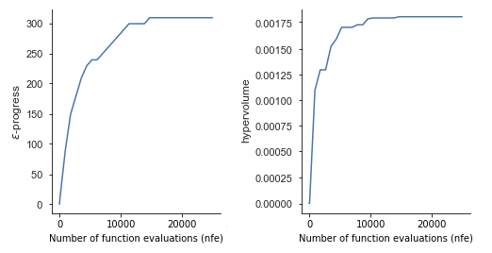

**Figure 34 | Convergence depicted for both epsilon and hypervolume metrics.**

After performing 25,000 runs, 224 candidate strategies were added to the Pareto approximate set. The epsilon progress indicated that the optimisation has converged (Figure 34). A stabilisation in convergence is observed after 15,000 NFE in both metrics, which means that no more solutions were added in the set after those runs.

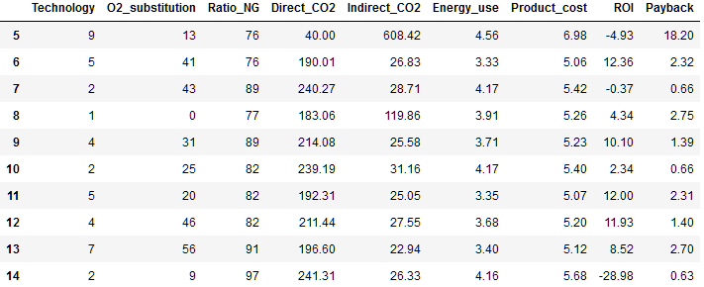

**Figure 35 | Part of the Pareto approximate set, which resulted from performing the 1st iteration of the MORDM method.**

At first sight, the set appears to be quite diverse in terms of heating methods and supporting measures. The lowest direct CO2 emissions which can be achieved are 40kg CO2/tn packed glass which correspond to electric furnaces (i.e. Technology 9), followed by 168.14kg CO2/tn packed glass for a regenerative furnace with batch preheater (i.e. Technology 1). It is observed that 46.8% of the best candidate strategies are regenerative furnaces with batch/cullet preheaters, 65.7% of which use electricity at a ratio over 10%. The maximum CO2 reductions that can be achieved by substituting combustion air with 60% pure oxygen is 18% compared to the base plant configuration (see Figure 30), but only 6% when batch/cullet preheater is installed. This is because of the low natural gas consumption of Technology 1 that leaves less space for improving the combustion, since the reduced heat content of flue gases affects the normal operation of the batch/cullet preheater. Similarly to that, the increased use of pure oxygen (i.e. high O2_substitution) does not justify for options with high electricity ratio (i.e. low Ratio_NG) which is reflected in the high payback times.

Furthermore, 50 solutions refer to oxy/fuel firing with at least one preheating option, and only a few cases refer to as-is technologies which were qualified due to their low level of indirect emissions, low payback periods and relatively high return of investment. Optimelt Plus (i.e. Technology 8) is dominated mainly by technologies which use the Optimelt TCR concept (i.e. Technology 6 and 7), therefore it was not included in the set. About 11% of the cases refer to electric furnaces (i.e. Technology 9) despite the high ROI and extended payback periods. As mentioned in Chapter 6.1, the levers “O2_substitution” and “Ratio_NG” refer to specific types of technologies, therefore their combination with unrelated technologies lacks context.

A parallel axes object is instantiated given a dataframe of results with the upper and lower limits for each axis (Figure 36). Solutions highlighted in blue are those cases that satisfy certain criteria (i.e. purple intervals) for which the objectives can be attained. If only a few solutions diverge from others, this reflects a different correlation structure or an incomplete convergence. The complete solutions set can be found in the Glass_MORDM.ipynb file at Github.

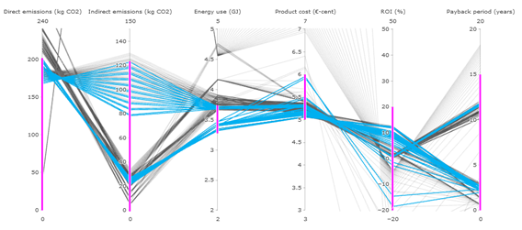

**Figure 36 | Parallel axis plot for the best-performing solutions in the Pareto set.**

The figure verifies that the best candidate strategies are within the best practical limits for container glass (i.e. 3.3-3.8 GJ/ton packed glass; Figure 2). The direct CO2 emissions are negatively correlated with indirect emissions, therefore an accumulation of cases at the bottom of indirect emissions axis imply that natural gas is the dominant energy input. Even though a considerable amount of solutions result in a 30-35% reduction of direct CO2 emissions compared to the base case (Figure 30), the options are technically constrained from achieving deeper reductions without compromising the normal operation of the preheaters, refractory wear, glass quality etc. Solutions of low energy consumption do not necessarily lead to the lowest possible emissions. This is the case of some oxy-combustion options (i.e. Technologies 5-7) where the emissions can be (at maximum) 50kg CO2/tn packed glass lower than the base case.

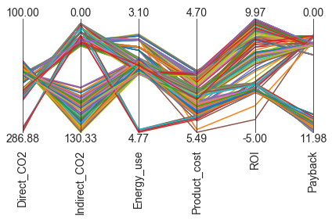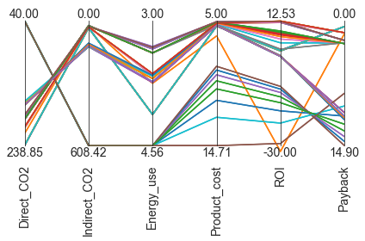It is good to see that the product cost stays within the range of 5.0-5.5 €-cent/packed glass, which shows that a possible future increase in fuel price can be absorbed through a decrease in energy use. In contrast, trade-offs can be observed between low scores on direct CO2 and high return of investment and vice versa. The investment on a CO2-reducng technology could be offset by the benefits gained from reducing direct emissions, since the impact of carbon price on the product cost will gradually become higher for emissions over the limit (see Chapter 3.3.1). A considerable amount of options are having a positive ROI and low payback periods, which will be further investigated to see if they perform well across the uncertainty space (see Chapter 8.4).

**Figure 37 | Parallel axis plots for options with (a) product cost lower than 5.5 €-cent/packed glass; (b) direct CO2 emissions between 40-180kg CO2/packed glass.**

The picture becomes clearer when excluding solutions with product price higher than 5.5 €-cent/packed glass (Figure 37a), as well as solutions with high payback time and direct emissions (Figure 37b). The parcoords module of the workbench is used to plot the trade-offs found, where the solution that technically satisfies all performance metrics would ideally be a horizontal line located at the upper bound of the plot. Options such as electric and regenerative furnaces with batch/preheater are now excluded from the subset. Deeper CO2 reductions are achieved by sacrificing payback time and ROI, as well as by compromising direct with higher indirect emissions. The high payback corresponds to ROI slightly higher than zero, which means that the investment costs cannot be covered in the short term based on the current revenue streams. A ROI close to 10% implies the use of supporting measures that target the furnace energy use, having a subsequent impact on the combustion emissions. Notably that policies which include one or more preheating options will lead to greater melting capacities which has a positive impact on ROI. Under these circumstances, Technology 5 (i.e. oxy/fuel furnace with batch/cullet and NG/O2 preheater) with increased electric boosting is a good candidate solution across the six dimensions.

## 8.4 Uncertainty Analysis

After obtaining candidate policies, an evaluation takes place over the assumptions with regards to exogenous factors. The previously determined subset of best performing solutions contains 46 policies, and each of them will be evaluated as a function of 1,000 scenarios using Latin Hypercube sampling. Firstly, the performance of the decarbonisation strategies will be explored under that range of plausible futures. Secondly, this will help identifying solutions with acceptable performance which will be aggregated across these scenarios for determining their robustness.

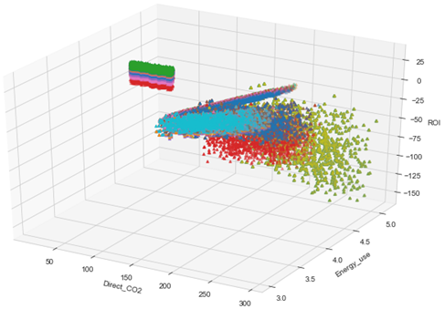

**Figure 38 | Solutions in the uncertainty ensemble, resulting from 46,000 experi-ments using the LHS method and examined over three performance metrics.**

Figure 38 reflects a chain of impact on direct emissions, which occurs from the effect of external factors on the production process. It can be seen that policies with significant decarbonisation potential generally have a negative ROI after an initial period. A reason for that is the timing of investment, since the market conditions may decrease the net operating income and prohibit high returns immediately after purchasing a technology. The isolated cases (i.e. upper left) correspond to all-electric technologies. This is because they work on different principles than the rest of the options and they are less affected by the same uncertainties. In contrast, the accumulated cases that shape thick lines (i.e. top-middle) denote air-combustion technologies. When considering these aggregates as one-time investments (i.e. without a gradual increase of oxidant or electricity over the years), the large variations of both oxygen and electricity use have a direct impact on their energy use and ROI. The scattered solutions in green and red indicate oxy-combustion technologies with one or more preheating options installed. In the analysis, their operation within acceptable temperature windows was strongly influenced the maximum furnace temperature.

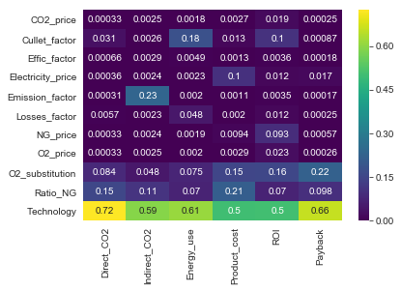

**Figure 39 | Feature scoring; relation between outcomes, uncertainties and levers.**

By using feature scoring for a preliminary examination of the results (Figure 39), it can be seen that the performance of the listed options is strongly dependent on the consumed natural gas when it comes to technical metrics (i.e. energy consumption, direct and indirect emissions) and the amount of pure oxygen used with regards to financial metrics (i.e. product costs, ROI and payback). It is shown that the conditions which can improve the ROI of future interventions are closely connected to the price of natural gas and the requested glass quality. The latter affects the decision on how much cullet to use in the process, which has a subsequent impact on all other objectives (e.g. increased ROI due to efficiency on the yield). Both the fuel type and the batch formulation of container glass have a direct impact on the product cost, where an increase in electricity prices can influence considerably the operational expenses. Other factors such as the losses impact the outcomes of interest without requiring any intervention in the short term.

8.4.1 Starr’s domain criterion

The performance of policy options is being operationalised using the Starr’s domain criterion. The robustness scores range from low to high, depending on the value of the user-selected minimum performance threshold. In this case, the focus is on the lowest three quartiles of the objectives. The alternative options are examined independently and the robustness trade-offs are investigated for identifying compromise solutions.

The graphs in Figure 40 illustrate how the estimate of robustness converges to the true robustness value. The achieved convergence indicates that the 1,000 scenarios were sufficient to obtain reliable robustness. Policies which refer to electric furnaces have reached robustness quite fast regarding the technical objectives (i.e. flat lines at the top of upper plots), which is a matter of restricting the robustness criterion even further. By contrast, their performance exceeded the threshold in terms of energy use and product costs, which means that their current specifications are prohibiting compared to alternative heating methods. The same happens with the performance of as-is oxyfuel furnaces, where the robustness score is zero in terms of Direct CO2.

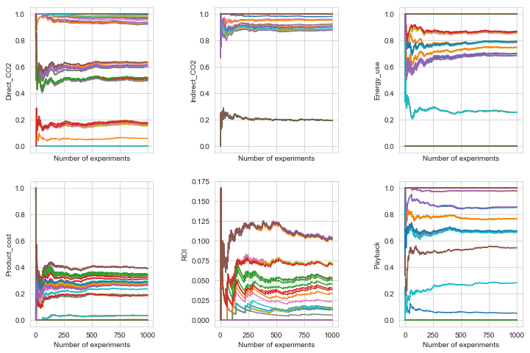

**Figure 40 | Robustness scores of candidate policies, identified in terms of each outcome indicator across 1,000 scenarios [48].**

The largest fluctuations are observed in the robustness values with regards to ROI. This is explained by the volatility of fuel prices which is intrinsic when making studies to 2050, as well as the adjustment of oxidant or the substitution of energy carrier which may not be cost effective. In this case, oxy/fuel furnaces with increased electricity ratio and both preheaters installed seem to be the most robust alternatives, followed by an Optimelt TCR furnaces with Batch/cullet preheater and about 95% gas to fuel ratio. The criterion of indirect emissions is satisfied by the majority of policies due to the practically limited proportion of electricity in the energy mix of air/fuel and oxy/fuel configurations. An exception to that rule is a policy consisted of air/fuel furnace with batch preheater, whose robustness score (approx. 0.2) is associated with a highly increased use of electric boosting (i.e. 25%). Similar policies underperform in terms of Payback, since refurbishments are required for supporting increased convective heat transfer to the melt.

Lastly, policies that refer to as-is oxy/fuel furnaces as well as their combination with NG/O2 preheaters perform poorly in terms of direct emissions. This is because the maximum achieved reductions using these technologies is 32 kg CO2/tn packed glass which is outperformed by all other technology aggregates with preheaters installed. This also shows that a hypothetical direct cullet-only preheating solution for oxy-fuel furnaces could perform well (see Chapter 8.1.1), achieving slightly higher emissions reduction in lower costs compared to batch/cullet preheaters.

8.4.2 Maximum regret

A complementary perspective on robustness is obtained using Maximum regret, which allows comparing policy options rather than examining them in isolation. A heatmap illustrates the regret values (see Appendix G) by taking the difference of the maximum performance and the actual values of a policy across all scenarios. Comparisons are performed on the basis of these regret values. Options with low regret are most preferable when maximising objectives, and vice versa.

Apart from the electric furnaces which have the best performance in terms of Direct CO2, the highest regret values of this objective (i.e. 0.36-0.38) can be observed on regenerative furnaces with batch preheaters, increased electricity ratio and oxygen use. Such policies (e.g. 91, 151) have a satisfactorily high performance in terms of both emissions and production costs. However their payback surpasses a period of 10 years, if these options are considered as one-time investments. Across the range of plausible futures, air-combustion options are outperformed by Optimelt TCR options with a batch/cullet preheater installed (e.g. Policy 76, 200) in terms of Energy use, ROI and Payback. By sacrificing 20kg from the maximum potential CO2 reductions, an investment on the latter technology would result in higher returns compared to alternative heating methods.

If direct CO2 should not be compromised in exchange for a more profitable investment, then Policy 222 (i.e. oxy/fuel furnace with both preheaters installed and 6% electric boosting) would be a satisfactorily good solution. In fact, it is among the best policies with regards to Energy use and Payback time, achieving the best possible score in terms of Product cost. The lower ROI compared to Optimelt TCR options is explained by the increased capital expenditure for the two preheaters. An interesting remark is the poor performance of as-is oxy/fuel furnaces (e.g. Policy 43, 57) with regards to Direct CO2 and Energy use, which is relatable to their aggregated performance using the domain criterion (see Chapter 8.4.1). Optimelt TCR without preheaters installed (i.e. Policy 44) is partially dominated by options with batch preheater in terms of emissions and energy use.

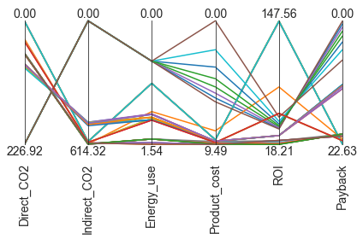

**Figure 41 | Parallel axis plots with the regret scores of candidate policy options.**

The trade-off analysis in the Figure 41 summarises these findings, while offering additional insight on solutions which are gathered to the preferred direction of an objective. Overall, oxy-combustion technologies seem to be among the best-performing options, either by combining oxy/fuel furnaces with preheating measures or by converting them to Optimelt TCR with a batch preheater. Payback time is sacrificed for achieving high performance in the rest of the objectives, while the regret on indirect emission is retained despite an expected greening of the electricity grid (see Chapter 5.1.1). The performance of air-combustion cases indicates that alternative fuels (e.g. biomethane) can potentially help achieving reductions in direct emissions without a heavy adaptation of technology levers (e.g. increased electricity or oxygen use). Lastly, electric furnaces are robust for the objectives of direct emissions, energy use and product costs but perform poorly across plausible futures in terms of ROI. One of the reasons is that the analysis did not consider a potential decrease in the costs of bare equipment over the years, where improved designs for commercialised 300tpd furnaces are expected in the coming time (see Chapter 5.3.3).

## 8.5 Scenario Discovery

In this last step of the MORDM method, Scenario Discovery is employed to identify those uncertain variables that influence the performance of the best policy alternatives. These alternatives remain vulnerable in certain areas of the uncertainty space, therefore it is determined which of them are most robust to future changes (Kasprzyk et al. 2013).

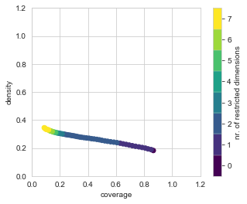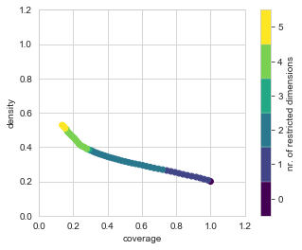As described in Chapter 6.4.1, PRIM requires a binary vector for each scenario which specifies whether it is in the interest of the analyst or not. In this case, the 80th percentile of cases with regards to the direct CO2 emissions is set as the rule for binary classification. This secures that a maximum of 20% of cases meet that rule, so that PRIM can find clearly distinct regions in the model input space that explain those cases of interest. A candidate box is obtained (i.e. orthogonal subspace) which includes the cases that have the largest extent of bad performing scenarios. By “peeling” away thin layers of this subspace (i.e. alpha = 0.05), points with vulnerable performance are identified and the dimensions of the proposed box iteratively increase.

**Figure 42 | Trade-off curve of: a) a five dimensional subspace; b) a seven dimensional subspace of the remainder of the cases.**

The density of the obtained box is not discriminating enough (i.e. 0.53), since about half of the cases are outcomes which are more sensitive to changes of the uncertainty variables (Figure 42a). By looking at the coverage/density ratio in the trade-off curve and comparing neighbouring points, it is observed that only the last point in the path leads to the highest possible density. A loss of interpretability is accepted for achieving that, which results in five parameters for defining the box (i.e. dimensions). The box also has a very low coverage (i.e. 0.14), which means that not many cases of interest of the total ones are included in box. For this reason, the density threshold was lowered to 0.3 to ensure that a second box will be obtained and their combined coverage will be satisfactorily higher. No better outcomes could be achieved by making the threshold less strict, since the regions in the model input space would start to become less distinct. This happens because of an increasingly larger inclusion of cases which are gathered between the emissions range of 170-190kg direct CO2/tn packed glass.

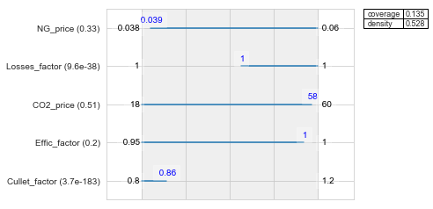

**Figure 43 | Uncertainty ranges in which the best performing policies are vulnerable.**

The realisations of uncertainties are examined to identify the value range of uncertainties that cause vulnerabilities (Figure 43). This five dimensional subspace refers to cullet availability, prices of natural gas and CO2 emissions, as well as technology efficiency and losses. Only two of these parameters are deemed as important after excluding dimensions with high Qp values. As a result, the performance of the candidate policies appears to be vulnerable under conditions of low cullet factor (i.e. 0.8 to 0.86) and losses factor (i.e. equals to the unit). In this case, it is assumed that the cullet factor refers exclusively to the availability of recycled glass. This is because the rest of the circumstances (i.e. glass colour, requested glass quality and operating constraints) cannot explain such a big drop of recycled cullet use in the process. The efficiency was included as a vulnerability factor, but its impact on the performance of the candidate policies was already proved negligible (Figure 39). In principle, the better the heat recovery system works, the lower business case is for combining preheating systems (due to low heat content of the flue gases).

The reasons for which the decision alternatives fail are explored by replicating this scenario into the Glass model. In the case of Optimelt TCR furnace with Batch/cullet preheater (i.e. Policy 200), the decreased use of recycled glass results in high preheating temperatures in which cullet starts to exhibit liquid characteristics before entering the furnace. For regenerative furnaces with high electricity-to-fuel ratio and batch/cullet preheater installed (i.e. Policy 206), the specific energy consumption of the furnace increases which raises the temperature of the preheated air above the acceptable interval (i.e. 1250-1480oC). Even though oxy/fuel furnaces with both preheaters installed performed well (i.e. Policy 222), the ROI of this option is dropped by half. This confirms the claim that a lowered recycling amount of glass increases the melting time (see Chapter 5.4.1), therefore the efficiency on the yield is considerably reduced (Figure 39; Feature scoring). All-electric options performed well (e.g. Policy 70), since the known examples of electric furnaces fit well to low-cullet batches. However it is not a flexible option when it comes to changing pull rates, which means that a sudden shortage of cullet can impact considerably the total glass production.

The second important uncertainty in this scenario is the losses factor. A factor which equals to the unit corresponds to combustion space and tank losses of 3.5% and 24% regenerator losses. The value for which the decision alternatives remain vulnerable indicates that some of the losses are unavoidable and that there is a limit on how much heat loss can be avoided[49]. The wall design is a compromise between ware, energy loss and lifetime, which is responsible for the annual increase of losses between 1.0-1.3% for air-fired even less for oxy-fired furnaces. By contrast, an increased insulation can raise the temperature of refractories inside the furnace which increases wear. The maintenance will result in additional operational costs as well as production loss due to downtime. Given that the electric and Optimelt TCR furnaces are the most thermally efficient alternatives (see Chapters 5.3.3 and 5.3.4.c), they are the most robust options to future changes of losses.

Since the first scenario had low coverage, a second scenario is identified to characterise some more of the remaining points (Bryant & Lempert, 2010). The density of the new box (i.e. 0.35) is right above the stopping condition which was set before (i.e. density threshold of 0.3). The algorithm cannot identify another subspace that meets the threshold criteria, and therefore the method is completed and PRIM results can be translated into a scenario that explains better outcomes (i.e. non-robust solutions). A point in the second trade-off curve is selected that balances between coverage and density (Figure 42b). The last point in the peeling trajectory yields the most desirable outcome, which leads to a combined box coverage of 0.22.

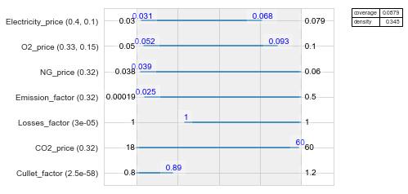

**Figure 44 | Uncertainty ranges in which the best performing policies are vulnerable.**

Even though the second box includes more dimensions, an overlap is observed between the two subspaces (Figure 44). The factors of cullet and losses are again the most important uncertainties, with a slight increase of the vulnerable interval of the former. A proactive approach to recycling would be to target the recycled cullet which is land-filled as waste[50]. The organic contamination caused by plastic labels, misplaced items which contaminate the entire load, or crushed cullet of extremely small particle size are among the main challenges. An advanced treatment of recycled glass (either centralised or on-site) with regards to better colour separation, identification and removal of glass-ceramics could increase the availability of high-quality cullet, securing that the best performing alternatives will not be exposed to uncertainties of this nature.

## 8.6 Second iteration of MORDM method

8.6.1 Overview of best performing policies

After the search phase, the best performing policies are identified together with the uncertainty areas that they fail, as well as the trade-offs associated with them. The Pareto approximate set initially included 224 options and, after robustness, only 4 of them remained. These are:

* Oxy/fuel furnace with 6.1% electric boosting, batch/cullet and NG/O2 preheating
* Optimelt TCR with 5.2% electric boosting and batch/cullet preheating
* Cold-top vertical 300tpd electric furnace (supporting approx. 50% recycled cullet)
* Regenerative furnace with 22% electric boosting, batch/cullet preheating and 60% substitution of combustion air with pure oxygen.

These options are perceived as one-time investments, which means that better returns would be expected if their control parameters are adjusted in the future to respond to the market changes. The performance of as-is regenerative and oxy/fuel furnaces was not satisfactorily good across all outcomes of interest (see Chapter 8.4), while the energy use and ROI of options of similar heating methods were vulnerable to factors related to refractory wear and scarcity of recycled cullet.

The potential reductions in terms of direct CO2 emissions range between 28-32% compared to a base plant configuration (Figure 29), with the exception of all-electric methods that 82-85% reductions are achievable due to the elimination of combustion emissions. As argued in Chapter 8.4, the decarbonisation potential of fuel substitution may enable a performance improvement of the air-combustion options. For this reason, options that use alternative fuels will be explored (see Chapter 5.1) with the prospects to address the identified vulnerabilities (see Chapter 8.5).

8.6.2 Model specification of 2nd MORDM iteration

A second iteration of the MORDM method is performed for incorporating these observations into the analysis. The model specifications are re-visited (see Chapter 6.1) and therefore both the uncertainty and decision space are adjusted accordingly. The efficiency is now excluded from the analysis, since the objectives were not considerably affected by this factor (Figure 39) and the alternatives were not vulnerable to its future changes (Figure 43). The outcome space is also modified by excluding the Payback metric to limit the search base. It was observed that Payback is relatable to the variations of ROI (see Figure G1) which is explained by the similarities of the established equations (i.e. Eq. 21, 24). By contrast, the new search will be performed using the same model function without applying any structural changes to the Glass model.

By including the lever of natural gas substitution with biomethane (i.e. Bio_switch) as well as the respective fuel price as an exogenous factor (i.e. Bio_price), the performance of the new candidate strategies will be investigated over the conflicting objectives. The conditionality of this lever was described in Chapters 2.6 and 5.1.2, where it is assumed that the future availability of biomethane will be enough to cover the requirements of the container glass industry.

8.6.3 Policy determination of 2nd MORDM iteration

The reference scenario which was defined in Chapter 6.2 will be re-optimised in the many-objective space, with the addition of biomethane price and exclusion of the efficiency factor. The scenario found using PRIM that best describes potential vulnerabilities could also be leveraged (see Chapter 8.5), but the inclusion of an alternative fuel creates the need for examining the policy problem under similar circumstances for making straight comparisons.

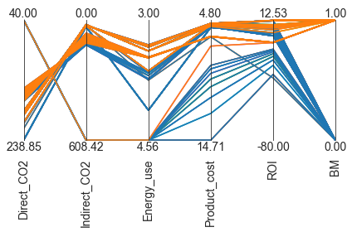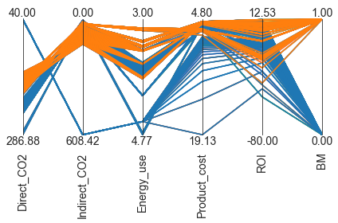After performing the second search, the new Pareto set contains half the solutions compared to the first set. Firstly, this is the consequence of limiting the decision space which decreases the mappings to the outcome space. Secondly, the high biomethane price increases the product costs, and hence solutions which use biomethane are often dominated by those that use natural gas. The two datasets are plotted in a two-coloured pairplot (Figure 45a) for discriminating the score pattern of each iteration (i.e. new set highlighted in orange). By focusing on strategies which emit less than 200 kg of CO2/tn packed glass, biomethane appears to have a positive impact on energy savings and CO2 emissions reduction. The absence of hydrocarbons from its composition (i.e. apart from methane) resulted in the formation of less direct CO2 by 8-10% across all air- and oxy/fuel technologies. About 25% of solutions refer to oxy-combustion technologies with both preheaters installed, and interestingly enough, nearly 34% of the cases correspond to Optimelt TCR furnaces with batch/cullet preheating. The on-site reforming of biogas into synthesis gas for CO2 emission avoidance has been explored in the past (Rathod & Bhale, 2014; Halmann & Steinfeld, 2014).

**Figure 45 | Parallel axis plots for comparing the Pareto set of 1st MORDM iteration with BM solutions (a) below 200kg CO2; (b) narrowed down for all objectives.**

For better clarity, a subset of 31 solutions is formed after filtering out the air- and oxy-combustion options which perform below 3.8 GJ/tn packed glass, below 211 kg of direct CO2/tn packed glass) and above 10% ROI. The plotted trade-offs show that the best performing solutions of the new subset satisfy the objectives equally well compared to the Pareto set of the 1st MORDM iteration (Figure 45b). In particular, the resulting biomethane strategies refer exclusively to regenerative furnaces. This is an indication that the performance of air-combustion technologies can be improved by substituting natural gas with fuel of higher calorific value, which is in line with the findings presented in Chapter 8.1. The options with the lowest recorded emissions are 152.7 kg CO2/tn packed glass which corresponds to a regenerative furnace with high electricity-to-fuel ratio and pure oxygen. For securing its technical feasibility, a reduction of oxygen use is required which results in batch preheating temperatures within the acceptable limits (i.e. 275-325oC).

Overall, an additional 5.2% reduction of CO2 emissions is achieved compared to the results of the 1st iteration by using biomethane as a replacement source of heat. Since biomethane lifecycle absorbs the emitted CO2 during production, it consists of a good alternative for both achieving emissions cuts and expanding the capabilities of air-combustion technologies. The strategies can be then re-evaluated under deep uncertainty for finding solutions that retain their robustness.

# IV Discussion

*This final part of the study includes a critical discussion on the demonstrated methods and a final word on the value of analysis. The results of the model-based approach will be discussed and qualitatively compared with the input of industry experts. Interesting business cases will emerge by examining how the CO2-reducing technologies affect the manufacturing process, as well as actions which are the most promising to address bottlenecks mentioned in the problem definition. Considerations that stemmed from the research study, as well as limitations and future avenues will also be stretched.*

# 9 Conclusions and Recommendations

The findings of the established policy problem will be leveraged to answer the research questions. The chapter will first address the supporting questions which were identified in the research definition (see Chapter 2.2) and developed in furtherance of the primary research question. The key developments of the study will be presented on the basis of the reviewed concepts and the performed methodology. Considerations with regards to method specifications, model concept-ualisation, and performed analysis are also discussed for bridging the performed research with the container glass industry as a whole.

## 9.1 Process and Developments

Great advances have been made in the context of the container glass industry over the years, as a result of gradual process improvements and growing understanding of the physical and chemical processes within the furnace (Fiehl et al. 2017). Increased air preheating or alternatively oxy-fuel combustion, improved refractories and enhanced insulation, waste heat recovery options and the increasing share of recycled glass contributed to the direction of improved thermal efficiency and subsequent carbon emission cuts. So far, the energy reduction investments were mainly driven by the pressure from the EU ETS (Hatzilau et al. 2016). Recognising that, in most situations, achieving net zero production of current plant designs is technically infeasible, deep CO2 reduction was set as a more appropriate target for the mass scale required to achieve Climate Agreement goals. Consequently, the technological limits to what can be achieved in this manner shifted the attention to alternative approaches for reducing CO2 emissions even further.

This study developed a systematic methodology to approach the decarbonisation of the container glass industry in the longer term horizon of 2050. It was achieved through the techno-economic analysis of alternative options for achieving deep decarbonisation, the formation of a base plant configuration as a reference for energy and emissions reduction, and finally the identification of maximally robust low-carbon strategies across many possible futures. The points which require further attention regarding the delivered methodology will be presented, accompanied with suggestions as to the best course of action for the container glass industry.

9.1.1 Techno-economic analysis

**SQ1**: How can a techno-economic analysis of best available and emerging technologies and their combinations help the container glass sector achieve deep CO2 reductions?

The first sub-question was a demonstration of how an industrial decarbonisation objective can be attained by using a stepwise methodology. In particular, techno-economic analysis was proposed in Chapter 4 and performed in Chapters 8.1 and 8.2 for determining the energy performance, decarbonisation potential and feasibility of process technologies for the production of container glass. Within the analysis of physical systems in MS Excel, material and energy flows entering and leaving the given system were estimated and used to formulate a base production process. It enabled the performance evaluation of both best-available and emerging technologies, helping understand their effect into the waste heat and material cycles, and hence the total emitted CO2.

As described in Chapter 2.6, particular emphasis was given to the melting activities of Dutch container glass plants. The maximal energy efficiency was obtained after finding the theoretical minimum requirement for melting. Combustion-related characteristics were concerned with predicting the temperature reached within the flame. Depending on material- and energy-related specifications, a representative picture of an operating regenerative furnace was obtained which represents the 75-80% of the plant’s energy use and 80-85% of total direct CO2 emissions. In the end, a typical production process was approximated by using the inventory of the Dutch container glass industry and reflecting on the input of industry experts. The approximation of plant-specific energy use and emitted pollutants is then enabled by adjusting the input parameters according to the location-specific circumstances.

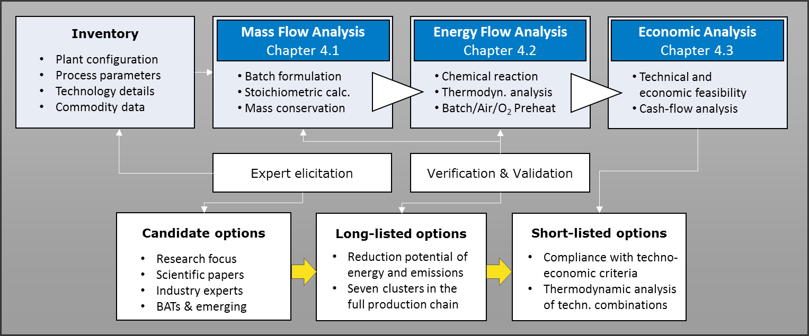

**Figure 46 | Steps followed for performing Techno-economic analysis.**

In terms of their replicability and wide-spread application, technologies such as oxy-combustion and all-electric melting were evaluated from both technical and financial perspectives as alternatives to state-of-the-art air-gas combustion. The evaluation of their feasibility in Chapter 5 enabled the shortlisting of options and the formation of technology aggregates for deployment consideration (i.e. combination of furnaces and preheating options). The shortlisted options which are perceived as the most promising for addressing the challenges mentioned in the introductory part (see Chapters 1.1 and 3.3) are summarized in Table 33. Benchmark characteristics refer to both the control parameters which are retrieved from expert input and the literature, as well as the market conditions of the year that this study was conducted.

**Table 33 | Benchmarking technology aggregates which are proposed in this study for achieving CO2 reductions in the container glass industry.**

|  |  |
| --- | --- |
| **No.** | **Shortlisted decarbonisation option** |
| 0 | Regenerative furnace (“as-is”) |
| 1 | Regenerative furnace with batch preheater |
| 2 | Oxy/fuel furnace (“as-is”) |
| 3 | Oxy/fuel furnace with Batch/cullet preheater |
| 4 | Oxy/fuel furnace with NG/O2 preheater |
| 5 | Oxy/fuel furnace with Batch/cullet and NG/O2 preheater |
| 6 | Optimelt TCR furnace |
| 7 | Optimelt TCR furnace with Batch/cullet preheater |
| 8 | Optimelt PLUS furnace |
| 9 | Electric furnace (CVTM; 300tpd) |

These development actions is argued to support decarbonisation of the container glass industry in the following years. Options are open to whether the investment decision is driven by technology selection or a shift to an energy carrier. To a large extent, the existing furnaces in Dutch container glass plants will be the operating ones in 2030[51] and much of the growth will be met by upgrading existing plants at scheduled rebuilds (JRC Report, 2013). Attractive options generally combine operational flexibility with high melting efficiency, where the resulting fuel gains and emissions reduction can offset the additional investment. The oxy/fuel technology will be easiest to justify for air/fuel furnaces with inefficient or no heat recovery, especially under conditions of high-cost elec­tricity or with a need for post-treatment of the flue gases (Baukal, 2013). The advanced heat recovery technique used in Optimelt TCR furnaces has the potential to achieve greater benefits compared to air-combustion technologies, provided that further additional research will be conducted in high-capacity and high-cullet container glass furnaces. Lastly, a combined full-electric option for container glass production would require more sophisticated control system to allow changing pull rates and new designs to handle the increased erosion and corrosion of the refractories under process changes[52].

Evaluation of the Methods used

The performed techno-economic analysis comprised of a combination of methods which allowed to focus on what matters in terms of the container glass production. The process steps were modularised which enabled both an independent review of the findings as well as further modifications in the proposed methodology (see Chapter 7.1). The advantage is that additional decarbonisation options can be incorporated into the analysis, ranging from furnaces to preheating options, fuels, and alternative materials for the production of a multitude of glass types. The objectives are addressed clearly after the completion of each module, which allows to draw conclusions about the benchmarking and adjusted conditions of technology options. Trade-offs emerge from adjusting input parameters, which enables updating the shortlisted options when the objectives are satisfied. On the other hand, estimates can be more speculative and confounded by uncertainties when techno-economic analysis is applied to technologies that are not yet commercialised (Frey & Zhu, 2012). The same is true for preliminary estimates of best-available process technologies, where there is an inherent tendency to overestimate the performance or underestimate their costs when simplifications are made or information is scarce. The limitations of the performed work are further elaborated in Chapters 11.1 and 11.2.

Regarding the benefits of the performed techno-economic analysis, the absolute error of the theoretical energy requirement for melting was minimised by building from the fundamentals of stoichiometry. This approach allowed observing the impact of adjusted oxidant in natural gas combustion, which resulted in the complete composition of the flue gases exiting the furnace. That way, the study became independent of fixed literature values for describing the inputs and outputs of the material and energy streams. In the end, the varied flue gas composition can be used to explore if the heat content is sufficient to justify the installation of a candidate preheating option, and it can be used as a starting point for further research on the feasibility of carbon capture options. By contrast, this can be a structural weakness when incorporating technologies into the analysis with unreported operation effects. For example, when examining the fuel gain of preheating options on the basis of the temperature of the entering flue gases, their normal operation could not be verified if the exiting temperature of output streams is not reported in the literature. This is mostly the case for emerging technologies, where experimental results are not publicly available with regards to the melting capacities or the manufacturing process of interest.

The generalisation of the methodology as well as the findings to other problems, analyses and relevant parties is further discussed in Chapters 10.2 and 10.3.

9.2 The MORDM method

**SQ2**: Which robust options enable a balance of reduced carbon emissions, energy consumption and cost effective container glass production?

The second sub-question referred to the determination of robust policies for addressing this deeply uncertain decarbonisation problem. Rather than making a predictive tool to closely model the future, an exploratory model was developed to determine options that balance satisfactorily well several conflicting objectives from an industry perspective. A decision support method was formulated in Chapter 6 that leverages the Glass model built within the techno-economic analysis. The model included the relationships of the system of interest and it was coupled with the Python-based toolkit named Exploratory Modelling and Analysis (EMA) Workbench as described in Chapters 8.3 to 8.6. This evidence-based many-objective robust decision-making (MORDM) approach helped recognising the legitimacy of different outcomes of interest and expectations about the future of this industrial sector.

A tailored optimisation approach consisted of a handful of techniques for further examining the findings of the previous phase. On the basis of the shortlisted options mentioned in Table 33, alternative solutions emerged by examining the behaviour of technology levers as well as their combinations against endogenous and external conditions. After searching over levers, a Pareto optimal set of options was generated which is conditional to a user-defined reference scenario. Additional insight was gained by performing Uncertainty analysis to assess the robustness of each alternative under a wide spectrum of potential future events. The remaining vulnerabilities as well as the trade-offs associated with the best performing alternatives were identified using Scenario Discovery, which helped determine the most robust options for deployment consideration.

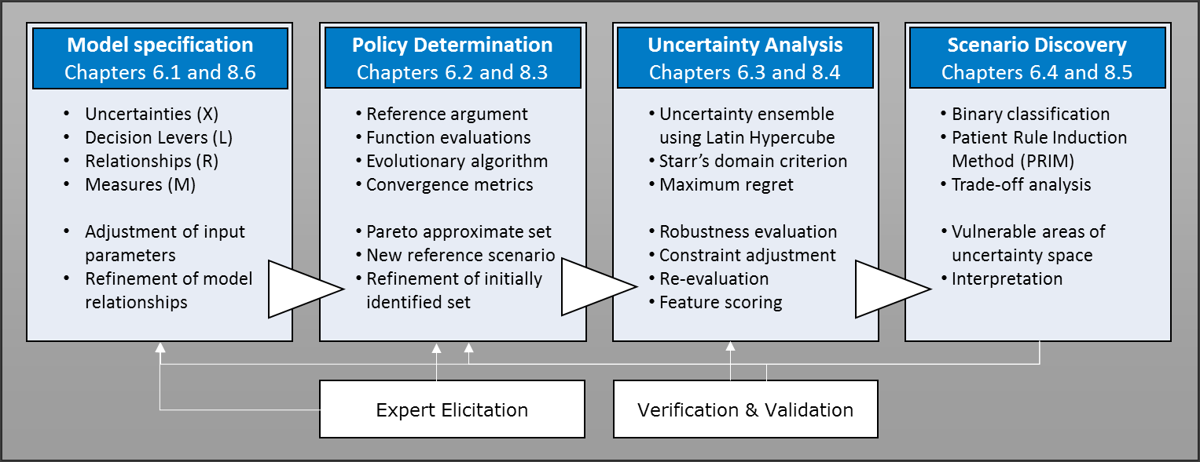

**Figure 47 | Steps followed for performing robust decision support method.**

More specifically, the model specification was designed in such a way that included new usage of resources (e.g. greening of the grid), as well as the effect of industrial pricing regimes and technology alternatives on the production process. The technological and financial basis of technology options was not overlooked, and therefore the performance metrics of energy use, (in-)direct emissions and production costs were incorporated into the analysis. The return and payback of investment decisions were examined as if the candidate options were one-time projects (i.e. technology aggregates consisting of a furnace, preheating option(s), and adjusted oxidant and/or natural gas to fuel ratio). The resulting strategies have the prospects to support the current capabilities of glass production while maximising the pay-off of these investments.

Two searches were performed in total over decision levers. In the first one, the Pareto approximate set included 224 options, whose performance was tested iteratively across a spectrum of deeply uncertain states of the world. Robust options are different in terms of their trade-off, and therefore Scenario discovery was employed to delve deeper into the problem situation. Interpretability was sacrificed for achieving more dimensions of the scenario boxes. It was argued by the large diversity of best performing alternatives, where the inclusion of more dimensions would enable a broader look at the conditions that best describe the vulnerabilities of the examined strategies.

It was found that the performance of as-is technologies (i.e. air/fuel and oxy/fuel furnaces) was not satisfactorily good across all outcomes of interest when evaluated under deep uncertainty. By contrast, the objectives of Energy use and ROI were perceived as more vulnerable to factors related to refractory wear and availability of recycled cullet with regards to options with preheaters installed. The former vulnerability is due to the increased furnace temperatures and oxygen use in the gas combustion, and the latter is due to the increased melting capacities which require greater amounts of input materials. Even though the air-combustion strategies were among the best performing ones, they would eventually require improved furnace designs to support the increased amount of electricity and oxygen use. Subsequently, this would have an impact on the plant’s operational costs (e.g. loss of production during downtime). It was reported that all-electric methods helped achieving the largest emissions reduction compared to the base case, followed by Optimelt TCR and oxy-combustion technologies with preheaters installed. Further actions need to be taken for improving the attractiveness of electric furnaces, as they performed poorly in terms of ROI and indirect emissions (see Chapter 9.3).

In the end, only four of the best performing policies remained after examining both the robustness and the areas where they fail. Better performance is expected from options with operational flexibility, since a future adjustment of control parameters can respond to the market changes without further implications on production process. The decarbonisation potential of fuel substitution was investigated in the second search. Both the uncertainty and outcome space were modified according to the lessons learned from the first MORDM iteration, and an alternative fuel (i.e. biomethane) was included in the analysis. Similar but fewer solutions were identified in terms of heating methods used, and a considerable amount of best-performing technology options were using biomethane in their configuration. The performance of air-combustion options was improved, which helped achieving additional emissions cuts compared to the first search. The feasibility of the new oxy-combustion strategies was questionable after interpreting the results, given that technical limits were reached after alternating the combustion process. This also implies that, an evaluation under a similar plausible futures as before would result in a trade-off between robustness in retaining Pareto optimality in the modelling horizon of 2050 and robustness with regards to system-wide best performance. The portfolio of options that consist the policy advice of this study are presented in Table 34.

**Table 34 | Best-performing policies for attaining conflicting objectives in the context of the container glass industry.**

|  |  |
| --- | --- |
| **No.** | **Robust decarbonisation option[53]** |
| 1 | Oxy/fuel furnace with 6.1% electric boosting, batch/cullet and natural gas/oxygen preheating |
| 2 | Optimelt TCR using on-site generated syngas with 5.2% electric boosting and batch/cullet preheating |
| 3 | Cold-top vertical 300tpd electric furnace (at approx. 50% recycled cullet) |
| 4 | Regenerative furnace with 22% electric boosting, batch/cullet preheating and 60% substitution of combustion air with pure oxygen |
| 5 | Regenerative furnace with 14% electric boosting and batch/cullet preheating; biomethane combustion with 12% substitution of combustion air with pure oxygen, and air preheat to theoretical maximum of 1480oC |

The proposed solutions will help prioritise actions for developing a robust-enabling environment for decarbonising the Dutch container glass industry. Incremental improvements of performance compared to today’s BATs can be achieved through adjusted heating methods in combination with innovative preheating options. The energy carrier has been the consequence of investment decisions, since priority was given to the attainment of CO2 reductions and the rest of the performance metrics (e.g. Energy use and ROI). The solutions secure that the container glass industry will account for the evolving landscape of fuel use, provided that both the availability and capability of infrastructure will be sufficient to support these process improvements[54]. The solutions are further interpreted in Chapter 9.2 through the prism of both research approaches.

## 9.2 Answering the Primary research question

*How can a model-based approach help prioritise the deployment of CO2-reducing   
technologies for decarbonising the Dutch container glass industry by 2050?*

The combination of research approaches which were selected in response to the supporting questions led to the development of a research methodology (see Appendix A). It was applied for extracting a portfolio of robust CO2-reducing options to be taken up by the container glass industry and frame the endeavours for its deep decarbonisation by 2050. The modelled system of interest helped determining both promising (i.e. shortlisted) and robust (i.e. best-performing) options for carbon emissions reduction. The resulting options from this model-based approach are cost-effective, maintain the levels of glass production, reduce the melting energy requirements, and minimise total CO2 emissions. The policy advice can be then tailored to local circumstances in order to prioritise the best suited decarbonisation strategies for the container glass industry.

The “2050 horizon” was incorporated into the analysis by considering prominent examples of technologies for container glass production which are expected to be commercialised in the longer term (e.g. Optimelt TCR and 300tpd electric furnaces). It was also considered by adjusting accordingly the uncertainty (e.g. expected decarbonisation of the grid), decision (e.g. expected operational ranges of technology levers) and output space (e.g. performance metrics of particular value in the future). These effects justify the added value from using the decision support method for this study. It took the single optimal combination of decision levers to the next level by incorporating the deep uncertainty of decision making into the analysis. Consequently, the resulting set of robust alternative options represents a promising optimum for this policy problem.

## 9.3 Future avenues for the Container glass industry

The findings of the model-based approach indicate that incremental CO2 reductions through process improvements can help the industry meet the target milestones. It was shown that waste heat recovery options have a significant decarbonisation potential, especially when combined with oxy-combustion technologies, as the majority of best-performing solutions have at least one preheater installed (e.g. for raw materials or fuel). They led to a satisfactorily high performance in terms of direct CO2 emissions, fuel energy and production costs. Benefits also stem from the higher melting capacities which can gradually offset the initial investment cost, while they would help to comply more easily with the environmental norms. The coupling of preheating options with innovative melting methods can be further investigated to guarantee their optimal use.

Technology aggregates which consist of oxy/fuel furnaces were presumed as the options that balance satisfactorily well direct CO2 reductions with high TRL values. Oxy-combustion has higher operational cost due to the oxygen cost, however local conditions can make it worthwhile. Switching from air/fuel to oxy/fuel firing is justified by their efficient energy usage in the combustion process as well as the stringent carbon emission regulations in the Netherlands. Given that the policy advice includes air-combustion technologies with high percentages of pure oxygen and electricity, hybrid configurations would also be attractive an alternative (see Chapter 9.3).

Lastly, fuel substitution could be used as an option to keep the current furnace designs, with a gradual shift to oxy-combustion or all-electric technologies before shifting to another design[55]. Within the scope of this study, it was shown that all-electric and Optimelt TCR (i.e. syngas combustion) furnaces are among the most thermally efficient alternatives which makes them robust options to future deterioration and wear. All-electric melting as well as biofuel combustion or methane reforming to syngas would be promising alternatives to traditional melting activities, provided that their impact on the process and the respective risks have been thoroughly investigated. Given that the carbon emissions are fossil-based, switching to electrically heated melting would be a more viable option for decarbonising the process.

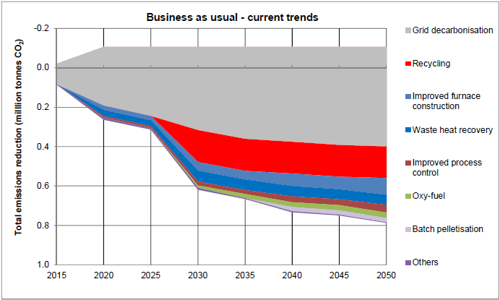

**Figure 48 | Projected trends in CO2-reducing technologies for the container glass industry; business-as-usual scenario (PB & DNV GL, 2015a).**

Until now, it was shown that process integration techniques would enable further CO2-reduction opportunities to be exploited. The proposed options as well as the reported considerations are in alignment with projected trends on the future of container glass industry (Figure 48). Apart from technical and physical limitations (e.g. infrastructure availability), emphasis needs to be given to external decisions in order to inform the policy-making process. The following sections will focus on the necessary conditions for creating a robust-enabling environment for deep decarbonisation.

9.3.1 Fossil-fuel free installations

Feasibility of solutions depends on the level of trials (i.e. certain scale) and, as a consequence, depends on level of investment by the companies and subsided programs by the government. It would be technically feasible to design a container glass facility as a part of long-term innovation project where the only energy carrier is electricity[56]. This initiative would allow testing the performance of new furnace designs over a long time and the feasibility of the overall operation. Nonetheless, research is currently conducted from a simulation point of view in small-scale electric melters in an effort to understand potential drawbacks and conclude on their process efficiency[57]. Overcoming the technological challenges that impede the transition to alternative forms of renewable energy such as green electricity, hydrogen power or combinations of natural gas with more sustainable gases will be a critical success factor for deep decarbonisation[58].

9.3.2 Hybrid melting

The Pareto approximate set which was extracted from the first optimisation search included many candidate policies that required very high percentages of electricity for melting (see Chapter 8.3). On the one hand, the facility can potentially maintain its competitiveness against the changes of fuel prices by using two energy carriers. On the other hand, it is likely that this combination cannot be supported by current furnace designs (see Chapter 9.2). For this reason, an option that is steadily gaining momentum is the hybrid furnace which combines direct electricity coming from the glass bath (i.e. through electrodes), and another source coming from the top (e.g. natural gas, biogas, hydrogen, or electrical heating elements). An innovative furnace design would eliminate the need for further improving the traditional furnace construction to surpass the current technical limits and help achieving higher flexibility by using both natural gas and electricity. Hybrid melting also refers to combinations of conventional firing with regenerative or oxy/fuel firing[59], in order to enable the economic viability of both regenerative and oxy/fuel systems (O’Connor, 2015). If the hybrid melter works successfully, and the pressure speaking off, the transition to this option is expected to be very fast (approx. 15-20 years depending on the overall furnace rebuild schedule)[60].

9.3.3 Low-carbon innovations

Despite the apparent decarbonisation potential from trapping the released gases from the process, post-combustion CCS remained as a long-listed option within the context of this study. The reasons that the criteria of technical and economic feasibility were not satisfied are further elaborated in Chapters 5.7 and 11.1. The uptake of CCS systems could be further enabled through collaborative research across sectors into CO2 trapping mechanisms (Cook, 2017).

The gap found between the lowest possible reductions for electric melters (i.e. 40 kg CO2/tn packed glass) and the runner-up technologies (approx. 65 kg CO2/tn packed glass) is expected to be covered through breakthrough technologies. This highlights the importance of research and innovation for the development of more cost-competitive technologies and dedicated to CO2 reduction rather than energy reduction (Dolianitis et al. 2016). Low-carbon innovations must be selected with the prospects of possessing a place in the future technology mix, given that the process industry in 2050 will have experienced substantial changes (de Pee et al. 2018; Bouman et al. 2017). Even more important is to avoid lock-in by implementing technologies on the shorter term which creates barriers for further innovation (ECN, 2018). If the information suffice, these innovations can be tested in the Glass model for observing their impact on the production process.

9.3.4 Regulatory framework

The efforts of the glass industry to achieve emissions reduction targets in terms of cumulative emissions by 2050 contribute to NL’s economic growth goals and help delivering the transition to a low-carbon economy (see Chapter 1). Container glass companies did well on benchmarking in the past years, and the industry is continuously innovating and researching on new technologies[61]. Despite the urgency for accelerating the availability of CO2-reducing options, the imposed measures should be taken proactively and in cooperation with the companies to increase the comprehensibility of goals, costs and opportunities. The roadmaps need to support planning and investment decisions under uncertainty, and therefore time must be given to companies in order to react, investigate and explore (Bhattacharyya et al. 2012). At the same time, attention must be given to the built up of infrastructure according to location-specific conditions in order to facilitate technology adoption (e.g. provide O2 and H2 through pipelines when demands are high).

Substantial changes are required in the regulatory and economic framework for achieving a radical shift compared to today (Fraunhofer, 2019b). It is imperative that this endeavour is accompanied with a robust policy framework for supporting innovation and long-term industrial investments which are needed for both the society and for a competitive low carbon economy (FEVE, 2016; Eurostat, 2011). The Dutch government must be actively involved in developing a sound legal and regulatory framework for a policy-induced deployment of CO2-reducing technologies (ECN, 2018; Shah, 2017; IEA, 2017). Provided that a robust-enabling environment for deep decarbonisation is in effect, investments in innovations can be triggered and contribute in practice to the decarbonisation efforts of the Dutch container glass industry.

9.3.5 Carbon pricing

From a transitional perspective, the Dutch companies make efforts to position themselves optimally within their organisations to enable reinvestment at their production sites (MEE, 2015). Such investments are expected to be significantly linked to climate-control measures such as the prices of EU allowances, given the pressure coming from the EU-ETS and the price volatility of energy carriers (Hatzilau et al. 2016; MINEZ, 2017; Chapter 3.3). However, this additional pressure may have counter effects such as spill-over effects in research and development and implications in the competitive position of Dutch companies over international players in the packaging industries (IETS, 2017; Schmitz et al. 2011; PB & DNV GL, 2015a).

Carbon pricing may indeed be an effective measure for industrial carbon abatement, as long as the carbon tax revenue is recycled back to firms that are especially affected (e.g. through tax cuts) to counterbalance the added pressure (Funke & Mattauch, 2018; ICMM, 2013). Ambitious carbon pricing programs from abroad have showed the way, where most of the revenue from the carbon tax can be refunded to offset investments or higher energy costs (Plumer & Popovich, 2019). Working on a bonus- and penalty system for CO2 tax might make the processes more sustainable. Companies would be able to submit plans on how they want to achieve the climate target, and hence they are eligible for a subsidy if they cooperate with effective measures (Pieters, 2019). Proactive measures of this nature comprise significant steps forward to achieve the ambitious CO2 reduction goals laid out in the Climate agreement.

9.3.6 Research and future focus

In an effort to get innovations off the ground, collaboration in the chain and pre-competitive cooperation within the sector will be essential steps forward. International cooperation in research and development (R&D) and knowledge transfer will be crucial for addressing the technical challenges that novel technologies confront with. Regarding the economic dimension of carbon mitigation, the carbon trading mechanisms should act as enablers to alleviate the high purchase costs of low-carbon emerging technologies (Springer & Hasanbeigi, 2017). The competitiveness of emerging over conventional technologies can be further enabled by governmental support and funding that targets R&D and their deployment.

Deep decarbonisation also requires an educational transition. The industrial decarbonisation is interwoven to forward-looking roadmaps, and therefore it is important to understand the innovations as well as their implications into the industrial process (ICTI, 2018). One aspect is that producers need to keep up with the cutting-edge developments in the industry and ensure that the new glassmaking environments comply with updated environmental, health and safety standards. This is an indication that faculties from engineering, management, and the social sciences will need to be committed to interdisciplinary engineering systems and policy programs. It is imperative that future practitioners receive integrated knowledge on the functioning and the contradictions of the industry for a deep-level comprehension of the industrial decarbonisation.

# 10 Reflection

The added value of this study is discussed against the backdrop of the knowledge gaps, the performed work and the relevance of research. The first part revisits the gaps in the literature and goes through the actions which were made for addressing them. A discussion follows on both the delivered methodology and its contribution to the decarbonisation of the container glass industry and the literature as a whole. The last part highlights the aspects of the study that enable for later generalisations of results, and therefore its contribution to both analysts and decision makers.

## 10.1 Response to Identified gaps

This chapter reviews the gaps in prior research which were identified in the introductory part of this study. It will be discussed how the progress was made towards addressing them and therefore how the performed research helped extending the previous knowledge.

10.1.1 Research Gap One

“Lack of publicly available empirical evidence and coherent mapping of the container glass industry, which are needed to examine the implications of current and future decarbonisation technologies on its manufacturing process.”

The decarbonisation potential of best available and emerging technologies was investigated by following a techno-economic approach. Plant-specific information of the container glass industry, as well as commodity prices and technology characteristics of an extended list of options were retrieved, made available and incorporated into the analysis. A stepwise procedure was developed and executed for both shortlisting and exploring the implication of technologies on the production process. The calculations were performed with transparency, which enable the replicability of empirical evidence as well as future modifications of the model for applications in similar research topics. This information leaded to the creation of a benchmarking configuration of a container glass plant and was depicted in a process flowchart for facilitating communication with industry experts. Findings with respect to emission, material and energy flows were verified and leveraged for estimating costs and informing investment decisions. The aggregated values showed a very small deviation from the actual values, and therefore the findings are sufficient for mapping the container glass industry with coherency. Observations, results and conclusions on the followed procedure were carefully documented and critically discussed. The end result is made publicly available through the TU Delft repository.

10.1.2 Research Gap Two

“Limited use of robust decision support methods for carbon emissions reduction   
in the container glass industry, which address deep uncertainty when making   
strategic decisions in technology adoption.”

The use of model-based decision aid approaches that fall under the umbrella of exploratory modeling has been an understudied area within the context of the glass industry. For this reason, an MORDM-based method was developed for broadening up perspective and incorporating the deeply uncertain factors of this policy problem into the analysis. This enabled the identification of potential options that perform well under many possible futures and satisfy conflicting objectives, among which the carbon emissions reduction. These robust alternatives consist of technologies for deployment consideration in combination with supporting measures (e.g. increased electricity or oxygen use). A further investigation on where these options fail as well as the trade-offs associated with them leaded to a cohesive policy advice to support decision making about the size and timing of investments in CO2-reducing technologies. Additional research that can be done for identifying robust options for industrial decarbonisation is further discussed in Chapter 11.

## 10.2 Reflection on the delivered methodology

The main axis of the delivered methodology was the development of a system model (i.e. an abstraction of the system of interest) which would be combined with several techniques in a meaningful way for supporting decision making. This resulted in a model-based type of analysis, and the leveraged techniques (e.g. metrics, evolutionary algorithms and visuals) expanded what could be done with that model (Walker, 2000; cited in Walker & Haasnoot, 2011). The model helped to consider the effects of alternative policies under a range of conditions, which is a requisite when analysing complex systems. The horizon of 2050 allowed for broadening the palette of options with the inclusion of emerging technologies which are currently not commercially available. These options have the prospects to be adopted in the next investment cycles starting from 2030, which created the need to widen the uncertainty space for considering future market conditions (e.g. price ranges, and greening of the grid).

Following the structure which is laid out in Appendix A, data was combined from a variety of sources to obtain a composite image of what matters within this topic. Among other research outposts, the methodology included the building of an inventory for an industrial sector, the extraction of empirical evidence through a techno-economic method, the formulation of reference scenarios, the determination of options for deep decarbonisation as well as the investigation of their performance and the exploration of their trade-offs. In the process of finding options that balance between economic level and environmental impact, some alternatives dropped that impact, and some others required a plant overhaul which would influence production. Acknowledging the effect of CO2-reducing technologies provided policy makers a more appropriate representation of investment trade-offs for achieving energy savings, costs reductions and, most importantly, deep decarbonisation.

Overall, both the stepwise methodology and the improved concepts of melting activities (e.g. incremental process improvements and fuel switching) can be adapted to the tableware, flat, and fibre glass sectors, as well as to industrial processes that also use melting technologies such as the production of lime, cement, iron and steel (AGC, 2017). Their thermodynamic systems share a similarly property to the container glass industry which is the high-temperature melting and, subsequently, the appreciable CO2 emissions (Goski & Smith, 2014). The findings can be therefore generalised to industries of high energy intensity, contributing that way to the research topic of long-term industrial decarbonisation.

## 10.3 Using the Results

The scientific relevance of this study involves the generalisation of the proposed methodology to other interest groups and circumstances. A discussion will follow on the key takeaways and potential uses of this study for two of the relevant parties, namely policy analysts and decision makers. The former group refers to people with expertise in advising on the best courses of action regarding a policy problem, which often involves model development in association with stakeholders. The latter refers to people that bear the responsibility of making strategic decisions.

10.3.1 Relevance to Policy Analysts

This study contemplates the role of model building and robust decision making in existing policy analysis research. It consists of a powerful example of how decision-support models can be constructed by bridging technical knowledge with analytical thinking. More specifically, it provided scientific and practical aspects to model development (see Chapters 4 and 6) and model use to support the evidence base for policies (see Chapter 8). Both industry experts and company representatives were engaged into discussions for extracting solid empirical evidence and performing targeted model building. The study demonstrated coherent and transparent use of a model which enabled the assessment of results for implementation of policy advice. It also presented a way for linking models with decision support methods which, in this case, offered the flexibility to explore the decarbonisation potential of technologies without being limited to future projections (e.g. predetermined assumptions about decarbonisation trends). Consequently, the study built on the ability to handle complex information for addressing research challenges, enabled conceptual thinking from an engineering perspective, converted this information into a well-structured methodology, and conducted policy analysis that leaded to the formation of robust decarbonisation strategies.

10.3.2 Relevance to Decision makers

Methodologies that incorporate model-based methods are necessary for supporting companies to their endeavours for more sustainable behaviour through long-term strategic planning (Pruyt et al. 2011; UKWIR, 2016). In this study, the benefit of the performed techno-economic analysis is the observation of the consequences of decision making on the industrial process as well as the the communication and visualisation of model results. The transparency of calculations, as well as the reported assumptions and perceived bottlenecks offered the necessary evidence for the construction and proposal of alternatives, with attention to the limitations that the industry faces. The decision support method was employed to satisfy the increasing need for more robust technology-adoption decisions in the manufacturing industry (Andrews et al. 2017; Svensson et al. 2009). That way, the best performing solutions were accountable for multiple futures rather than a best estimate forecast (Lempert, 2018; Agusdinata, 2008).

Overall, the added value of this study is that it provides the means to extract a portfolio of commercial and emerging technologies which can be deployed to potentially address the increasing energy use and CO2 emissions of an industry under examination. This is particularly valuable for the decision making process, since no single technology will be the best or only solution for a more energy efficient industry (Springer & Hasanbeigi, 2017). In the end, the plans can be stress tested, used for identifying market opportunities under increasing uncertainty, and therefore be deployed by decision makers to promote technical change in the industry.

# 11 Limitations and Future work

The developed methodology went through several steps from its conceptualisation until its final execution. The limitations which are associated with the respective methods and the Glass model per se will be discussed in the following chapters. These limitations are mostly linked to the design decisions which were made throughout the research, and their acknowledgment will enhance the interpretation of the findings. Actions for better leveraging the findings will be discussed and areas that require additional research will emerge.

## 11.1 Limitations of Techno-economic analysis

A basic conjecture of this study is that an increase of recycling content of the batch by 10% reduces specific energy consumption by 3.3% (Madivate, 1998; Drummond, 2011). This enabled a first estimation of the batch melting point and furnace temperatures as a function of the cullet used in the process (Figure 28). However this is not valid over the complete cullet range of 0-100% cullet[62]. After estimating the furnace energy use, a 4.5% fuel reduction was observed for every 10% cullet addition above 50% and 5.5% reduction above 80%. This would require calibrating the Glass model to the new findings, with attention to maintain the benchmarking temperatures extracted from equations (4) and (5).

As shown in Figure 6, the estimation of the specific energy consumption of the furnace is followed by the fuel calculation. The necessary natural gas is then calculated and placed into the heat balance equation (Eq. 16) in order to obtain the energy of air preheating. This gives the full effect of an operating regenerative furnace, and allows observing the impact of waste heat recovery on fuel reduction. In reality, an iterative calculation is needed to establish the maximum preheating temperature achievable when the natural gas usage is reduced (Sundaram, 2013). That iteration is not permitted in MS Excel because of the inability to use cyclical loops. This limitations can be addressed using the built-in tool called “Excel VBA”, which allows to save model instantiations under varied input parameters (i.e. new furnace energy use leads to new natural gas requirements). The drawback of this technique is that connectivity problems arise when coupling the Glass model with the workbench for performing directed search (see Appendix H).

A similar limitation was faced with regards to economic analysis (Figure 9). According to Eq. (21), ROI is expressed as the Benefits of investing in a new technology (i.e. old product costs - new product costs) divided by the Total investment cost for that technology. However, the old product cost of Technology “0” cannot remain constant when configuring the control parameters of other technologies. For that reason, the calculated old product cost was stored in a cell and was kept constant to enable the estimation of benefits. Keeping the costs of every technology constant would be permitted with the use of Excel VBA[63]. As a result, the ROI of technologies is expressed in percentages to enable straight comparisons with the benchmarking costs.

The financial metrics which were leveraged in this study (i.e. Payback, ROI) have inherent limitations.In particular, the payback period analysis disregards several key factors, including the time value of money and the risks associated with the investment or financing (Maverick, 2019). Therefore the complexity of cash flows regarding capital investments is not taking into account given the simplicity of this metric. In that case, the technology database should include the time frame of technology implementation, which includes both the market availability of the option and the replacement moments of the site and infrastructure. This would give a better timeframe of how long it will take to get an adequate return on the investment, leading to additional advice on the year of investment or its postponement. More sophisticated methods like Net Present Value (NPV) and Internal rate of return (IRR) may help decide among projects with different duration, since they account for differences in the value of money over time (Kenton, 2019).

Several promising options were not shortlisted in this study, among which the carbon capture solution (see Chapter 5.7) and the identified emerging technologies (see Appendix D). By installing a post-combustion CCS unit in the container glass plant, the energy loss from reintroducing the flue gases back the furnace through preheating systems could not be compensated with any known methods other than increasing the fuel input. As a result, this would result in greater carbon emissions, which would require an even more complex and costly CCS system. The technology is included as a long-listed option, given the unproven technical feasibility of commercial-size CCS projects in the container glass industry. On the other hand, the scarce information with regards to emerging technologies did not allow the investigation of their implications into the industrial process. This would take place by replicating their operation into the Glass model, which is the method followed for all other decarbonisation options.

## 11.2 Model-related limitations

In the Glass model, the temperature changes of the input and output flue gases, materials or combustion air in the preheating systems are sensitive to the user-selected parameters. For securing that these temperatures will stay within acceptable ranges, the model is structurally constrained from performing certain actions.

When the flue gasses which enter the regenerator exceed the limits of [1250, 1480]oC, then the preheating of air is not permitted. In that case, the user can refer to air-combustion technologies with batch/cullet preheating or no waste heat recovery at all (i.e. Options 1b and 1c in the tab “D1_furnace”, respectively). This is often the case when the option “O2 enrichment” is over 20% or “Excess air” is over 12% (i.e. the fuel savings have already peaked and the oxygen measurement in the stack exceeds 2%). The idea behind the adjustment of the oxidant is to improve temperature stability by allowing a more stable combustion. High-temperature flames are achieved by enriching the air with O2, which results in higher pull rates. Therefore this is useful when the profit from extra produced glass compensates the cost of oxygen and natural gas. This is also the reason that a combination of these three measures is not permitted, which would lead to a suboptimal situation. Same for “O2 substitution” in percentages over 80%, which is the point where the dissociation reactions become appreciable and the adiabatic flame temperature (AFT) starts to drop (Baukal, 2013).

Following the logic of Khoshmanesh et al. (2007), the ratio of AFT to flue gas temperature was set at 0,755 for constant composition of combustion agent or for using excess air. When the combustion is enriched with oxygen, this ratio is expressed through the recycled flue gas ratio of about 68% for stoichiometric conditions (Zheng, 2011, Figure 9.2a). For facilitating the application of the first thermodynamics law, tables of the multiplication product *m*cp* have been created for temperature intervals of 500oC, where *m* is mass of the products and *cp is* the respective heat capacity under constant pressure (see “Fuel” tab of Glass model). The *cp* originates from stoichiometric tables and the *m* has been calculated based on stoichiometry. As a result, when the products of combustion have a temperature of 1600oC, then the user can retrieve the *m*cp* which corresponds to the interval [1500, 2000]oC and then multiply by ΔT = (1600oC – Tambient) to obtain the heat value. The use of intervals is motivated by the need to avoid greater simplifications in the heat calculations, which is often the case when the heat capacity of a compound is expressed by only one value across the full temperature range.

In the “Fuel” tab of the Glass model, tables with benchmark values were added on the bottom of each technology which remain constant regardless the user input in the Summary tab. They were created to enable comparisons among the furnace types with regards to the natural gas use and emitted CO2. It was made by creating two sets of stoichiometric calculations in the “Fuel” tab: those that can be adjusted based on the fuel input and combustion agent, and those that the fuel input remains constant and dependent on the Energy balance prior to the addition of preheating options. This gives the flexibility to the user to adjust either the technology configuration or the benchmarking conditions (i.e. using the control parameters on these tables) and observe the changes in terms of energy, emissions, pull rates, required oxygen etc.

Subsequently, this creates the need to separate the benchmarking conditions of the air/fuel from an oxy/fuel furnace. For this purpose, the Fuel tab includes stoichiometric calculations which refer to the changes of Excess air, O2 enrichment, O2 substitution and Fuel switch (i.e. biomethane), as well as two sets of stoichiometric calculations for air/fuel and oxy/fuel firing, respectively. This is because an increase of the flame temperature results in a decrease of the particulates’ mass in the flue gas, hence the benchmarking conditions of these two furnace types must be separated. Following the same logic, the calculations of the syngas production were separated and included in a separate tab to avoid confusion (i.e. “Syngas” tab).

The model overestimates the availability of flue gases at high temperatures and the benefits associated with the fuel gain from using preheating options. This is due to the absence of flue gas treatment in the Glass model, because it was unclear which compounds of flue gases are normally captured when exiting the furnace. This would have an impact on the heat content of the flue gases, but also create the need for implementing other options downstream the regenerator (e.g. installation of ESP, de-SOx or de-NOx systems). In reality, the CO2 is cleaned to a degree that it is necessary for the authorities and anything more would result in economic loss[64].

## 11.3 Limitations of the MORDM approach

In the MORDM method, the “Model specification” stage was developed in such a way that it leverages most of the capabilities of the Glass model. For this reason, the uncertainties that used to be user-selected parameters were replaced by so-called “factors” that have a subsequent impact on the actual values. For example, the percentage of cullet which is used in the batch mixture is a parameter in the Glass model which can be adjusted by the user. For the purposes of optimisation, a proxy called “cullet factor” was used for quantifying the cullet availability in a scale of 0.8-1.2, since the recycling content is a market-driven factor rather than an energy efficiency decision made by the glass producer. Other user inputs of the Glass model were translated into decision levers (e.g. “O2_substitution”) and exogenous factors (e.g. electricity price), and the outcomes of interest became the performance metrics of the many objective search (e.g. Direct CO2). The value ranges were set in such a way that reflect on the input of the interviewed experts and permit as many combinations of decisions levers with exogenous factors as possible (e.g. high “Ratio_NG” and “O2_substitution” could disrupt the normal operation of the furnace). As a result, the MORDM method used a version of the Glass model in which the user inputs are constrained in order to limit the search base and allow as many acceptable combinations as possible.

The interpretation of the candidate policies which are included in the Pareto approximate set is an essential part of this study. As described in Chapter 8.3 and Appendix H, combinations of levers which are infeasible in reality (e.g. “Ratio_NG” and “Electric melting”) appear in the set because there is no such constraint when performing a many-objective search over levers for a reference scenario. The model does not permit a change in the objectives when performing such combinations, therefore the Technology lever is the only one that matters in such cases. Same happens for oxy-combustion technologies (i.e. Technology 2-8) where the combination of this levers with “O2_substitution” has no impact on the objectives. This is because of the assumption that oxy-combustion technologies use 100% pure oxygen, which also helps reducing the computational cost when performing optimisation.

The findings are bound to the validity of the model, as well as the selected reference scenarios. In this case, a slightly adjusted reference scenario compared to the initial one was used for the 2nd search. The intention was to see the impact of alternative fuels in the melting activity after including them in the decision space rather than determining the policies that retain their robustness. Uncertainty analysis and Scenario discovery were not performed after the 2nd search due to technical issues regarding the computational power. It was assumed that the option which consisted of a regenerative furnace with biomethane combustion (Table 34) is also robust apart from a promising candidate, since biomethane options outperformed the respective robust policies which use natural gas across all performance metrics.

11.3.1 Searching over levers with multiple seeds

A genetic algorithm uses random numbers to produce a set of solutions. This means slightly different results are extracted every single time the algorithm runs. Seed analysis is necessary when applying evolutionary algorithms and it is considered a good practice to run the MOEA multiple times using a different random seed. An inspection on the Pareto approximate sets can show whether the sets are similar in terms of decision variables or objective values, which indicates that there is limited value in adding more seeds.

After performing a test search over levers with three random seeds and 25,000 NFE, the resulting sets were similar to a large extent in terms of the objective values. This means that the convergence of optimising worked well and just a couple of seeds would be enough. The results from the different runs could be combined into one Pareto approximate set, and then do another run of non-dominated sort to get the final Pareto front. The new front which was formed contained over 750 solutions, which was not very practical to work with. The optimisation problem also became computationally very expensive, which prohibited a frequent revision of model parameters for experimentation. As a result, the first iteration of the MORDM method was performed using only one seed, resulting in a Pareto set of 224 solutions.

11.3.2 Alternative approaches

What is optimal for one scenario does not particularly optimise other scenarios (Watson & Kasprzyk, 2017). Therefore a new single scenario can be used for the 2nd MORDM iteration and optimise in the many objective space. This choice can be guided by the findings of Scenario Discovery, where trade-offs among individual policies were observed and combinations of uncertain variables that best predict a particular outcome were identified. A scenario can be alternatively extracted using Worst case discovery (Halim et al. 2016) with the limitation that the results would be overly conservative.

The scenario classification which is performed through Scenario Discovery can be further investigated. Families of scenarios that share common objectives are identified using an approach of multiple boxes (Guivarch et al. 2016). That way, more insight is provided on the diversity of drivers in scenarios leading to specific outcomes. Apart from the areas in the decision space which lead to the unwanted output spaces, vulnerability analysis can be performed for identifying mutually strengthening policy combinations.

Dimensional stacking is often used prior to Scenario Discovery as a diagnostic tool. A pivot table is created that maps the relative multidimensional relations of the most influential uncertainties. This method indicates whether multiple boxes will be needed or more scenarios have to be performed. Lastly, pre-processing the input to Scenario Discovery using Principal Components Analysis (PCA) helps finding a way of rotating the data in the cases where the experiments of interest are described by interaction effects among multiple uncertainties. As a result, the cases of interest are better organised into an orthogonal box, achieving much higher density and coverage (Kwakkel & Cunningham, 2016).

Other approaches that build on the work of MORDM are Multi-scenario MORDM and Many-Objective Robust Optimization (MORO). The former provides a more diverse mechanism to evaluate performance of a policy alternative (Watson & Kasprzyk, 2017). The latter determines robustness by examining how each solution responds to changes in key model variables (Deb & Gupta, 2006). In recognition of their limitations, setup complexity and high computational cost makes the use of these approaches prohibiting for this study. MORO might be biased in an unpredictable way to produce more conservative solutions with a high cost of robustness. As a result, there is big loss in optimality in order to retain robustness in the uncertainty space.

# REFERENCES

Abbasi, H. (2003). *GTI Combustion Technologies for the Industry.* Gas Technology Institute. Retrieved from: <https://texasiof.ceer.utexas.edu/texasshowcase/pdfs/presentations/a1/habbasi.pdf>

AGC (2015). *Preheated oxygen and natural gas in flat glass furnaces*. Retrieved from <http://www.agc-hoxygas.eu/AGC_Glass_International_Nov2015.pdf>

AGC (2017). *Hoxygas Layman’s Report.* Retrieved from <http://www.agc-hoxygas.eu/Annex%2019%20-%20Layman's%20report%20EN.pdf>

Agee, J. (2009). Developing qualitative research questions: a reflective process. *International Journal of Qualitative Studies in Education. 22*(4), 431-447.

Agusdinata, B. (2008). *Exploratory Modeling and Analysis: A Promising Method to Deal with Deep Uncertainty.* Doctoral dissertation, TU Delft, Delft University of Technology.

Alexander, J. (2009). Electrostatic Batch Preheating Technology: E-Batch*. In 61st Conference on Glass Problems:* *Ceramic Engineering and Science Proceedings, 22*.

Andersson, V., Franck, P. Ÿ., & Berntsson, T. (2016). Techno-economic analysis of excess heat driven post-combustion CCS at an oil refinery. *International Journal of Greenhouse Gas Control*, *45*, 130-138.

Andrews, K., Armstrong, M., Jackson, W., & Ritchie, J. (2017). Measuring Technology Readiness for Investment: Accelerating Technology Development and Improving Innovation Performance. *Manufacturing Technology Centre. Technical Report.*

Anglarill, G.A. (2018). *Life cycle assessment of a conventional float glass production and comparison with regenerative alternatives* (Bachelor's thesis, Universitat Politècnica de Catalunya).

Babovic, F., Mijic, A., & Madani, K. (2018). Decision making under deep uncertainty for adapting urban drainage systems to change. *Urban Water Journal 15(3), 1-9.*

Bankes, S. C. (1993). Exploratory modeling for molicy analysis. *Operations Research*, *41*(3), 435-449.

Banks, J., Carson, J.S., Nelson, B.L., & Nicol, D.M. (2010). *Discrete-Event System Simulation*. Fifth Edition, Upper Saddle River, Pearson Education, Inc.

Baukal Jr, C. E. (Ed.). (2013). *Oxygen-enhanced combustion*. CRC press.

Beerkens, R. (1986). *Deposits and condensation from flue gases in glass furnaces*. Eindhoven Technische. Universiteit Eindhoven/ Retrieved from <https://pure.tue.nl/ws/files/1742411/255404.pdf>

Beerkens, R. (2012). *Concepts for Energy & Emission Friendly Glass Melting: Evolution or Revolution in Glass Melting*. Presented at the 9th International Conference on Advances in Fusion and Processing of Glass, Cairns, Australia, July 11–14.

Ben-Haim, Y., & Demertzis, M. (2015). *Decision making in times of uncertainty: An info-gap perspective.* DNB Working Paper, No. 487. Retrieved from <https://www.dnb.nl/binaries/Working%20paper%20487_tcm46-334319.pdf>

Berntsson, T. (2017). *The Role of Industry in Meeting the GHG Mitigation Targets*. International Energy Agency.Retrieved from <https://iea-industry.org/app/uploads/thore-berntsson_170403.pdf>

Bhattacharyya, D, Shaeiwitz, J., Turton, R., & Whiting, W. (2012). Diagrams for Understanding Chemical Processes*.* In Turton, R., Bailie, R., Whiting, W., Shaeiwitz, J (Eds.), *Analysis, synthesis, and design of chemical process (Chapt. 1.2).* Prentice Hall International Series in the Physical and Chemical Engineering Sciences. 4th Edition. Retrieved from <https://ptgmedia.pearsoncmg.com/images/9780132618120/samplepages/0132618125.pdf>

Blok, K., & Nieuwlaar, E. (2016). *Introduction to energy analysis*. Routledge.

Boateng, A. (2016). *Rotary Kilns, in Chapter 6 “Combustion and Flame”. Transport Phenomena and Transport Processes,* 107-143. Retrieved from <https://www.sciencedirect.com/science/article/pii/B978012803780500006X#f0010>

Bouman, E. A., Lindstad, E., Rialland, A. I., & Strømman, A. H. (2017). State-of-the-art Technologies, Measures, and Potential for Reducing GHG Emissions from Shipping - A Review. *Transportation Research Part D: Transport and Environment, 52,* 408-421*.*

Bowen, A. (2011). *The case for carbon pricing. Grantham Research Institute on Climate Change and the Environment*. Policy Brief. Retrieved from <http://www.lse.ac.uk/GranthamInstitute/wp-content/uploads/2014/02/PB_case-carbon-pricing_Bowen.pdf>

Brown, C. (2010). *The End of Reliability*. Retrieved from <https://ascelibrary.org/doi/full/10.1061/(ASCE)WR.1943-5452.65>

Brown, C., Werick, W., Leger, W., & Fay, D (2011). *A decision-analytic approach to managing climate risks: Application to the Upper Great Lakes*. Journal of the American Water Resources Association, 47.

Bryant, B., & Lempert, R. (2010). Thinking Inside the Box: A Participatory, Computer-assisted Approach to Scenario Discovery. *Technological Forecasting and Social Change, 77,* 34–49.

Business Encyclopaedia (2019). Return on Investment ROI Metric Measures Profitability. Building the Business Case. Retrieved from<https://www.business-case-analysis.com/return-on-investment.html>

Butler, J., & Hooper, P. (2011). Waste: A Handbook for Management. In Chapter 11: Glass Waste. Department of Environmental and Geographical Sciences, Manchester Metropolitan University, UK, 151-165.

Cariboni, J., Gatelli, D., Liska, R., & Saltelli, A. (2007). The role of sensitivity analysis in ecological modelling. *Ecological modelling*, *203*(1-2), 167-182.

Carty, W.M. (2013). *Selective glass batching methods for improving melting efficiency and reducing gross segregation of glass batch components*. Retrieved from <http://www.google.com/patents/US20130192309>.

CAT (2017). *Manufacturing a low carbon society: How can we reduce emissions form cement and steel?* CAT Decarbonisation Series. Climate Action Tracker. Retrieved from <https://newclimate.org/wp-content/uploads/2017/10/memo_decarb_industry_final1.pdf>

CE Delft (2016). *Calculation of additional profits of sectors and firms from the EU ETS.* Publication code: 16.7H44.18.

Chang (1995). *Turning raw materials into finished products*. Business Engineering. Retrieved from <https://www.laserfocusworld.com/articles/print/volume-31/issue-11/world-news/turning-raw-materials-into-finished-products.html>

Chen, J. (2019). *Economic Conditions*. Investopedia. Retrieved from <https://www.investopedia.com/terms/e/economic-conditions.asp>

Conradt, R. (2008). *The industrial glass melting process*. WTH Aachen, Institut für Gesteinshüttenkunde und Lehrstuhl für Glas und keramische Verbundwerkstoffe.

Cook, P. J. (2017). CCS Research Development and Deployment in a Clean Energy Future: Lessons from Australia over the Past Two Decades. *Engineering*, *3*(4), 477-484.

de Diego, J., Kobayashi, H., Wu, K.T., Laux, S., Francis, A.W., Bell, R.L., & Iyoha, U. (2016). Fuel Savings and Operating Experience with OPTIMELT. Retrieved from <https://www.lifeoptimelt.com/pdf/Furnace%20Solutions%20C%20OPTIMELT%20TCR%20FINAL.pdf>

de Diego J., van Valburg, M., Schuurmans, F., Sperry, E., Laux, S., Bell, R., Francis, A., & Kobayashi, H. (2018). Operation of OPTIMELT™ Heat Recovery on Tableware Glass Furnace at Libbey Leerdam. Praxair.

De Jong, B. H. W. S., Beerkens, R. G. C., Nijnatten, P. A., & Le Bourhis, E. (2011). Glass, 2. Production. In Wiley-VCH Verlag GmbH & Co. KGaA (Ed.), *Ullmann’s Encyclopedia of Industrial Chemistry*. Weinheim, Germany: Wiley-VCH Verlag GmbH & Co. KGaA.

de la Banda, M., Stuckey, P., Van Hentenryck, P., & Wallace, M. (2014). The Future of Optimization Technology. *Constraints*, *19(2),* 126-138.

de Pee, A., Pinner, D., Roelfsen, O., Somers, K., Speelman, E., & Witteveen, M. (2018). *Decarbonization of Industrial Sectors: The Next Frontier.* McKinsey&Company. Report.

Deb, K. & Gupta, H. (2006).Introducing robustness in multi-objective optimization. *Evolutionary Computation, 14(4),* 463–494.

Deng, W., Wright, R., Boden-Hook, C., & Bingham, P. (2018). *Melting behavior of waste**glass cullet briquettes in soda‐lime‐silica container glass batch.* Journal of Applied glass science. Retrieved from <https://ceramics.onlinelibrary.wiley.com/doi/full/10.1111/ijag.12555>

Directive 96/61/EC. Council Directive 96/61/EC of 24 September 1996 concerning integrated pollution prevention and control. *Council of the European Union, Official Journal L 257.*

Directive 2010/75/EU. *Directive of the European Parliament and of the Council*. Official Journal of the European Union. Retrieved from <https://eur-lex.europa.eu/legal-content/EN/TXT/HTML/?uri=CELEX:32010L0075&from=EN>

Dolianitis, I. Giannakopoulos, D., Hatzilau, C., Karellas, S., Kakaras, E., & Nikolova, E. (2016). Waste Heat Recovery at the Glass Industry with the Intervention of batch and cullet preheating. *Thermal Science, 20(4),* 1245-1258.

Drummond (2011). *Collection of Papers Presented at the 71st Conference on Glass Problems The Ohio State University, Columbus, Ohio October 19-20, 2010.* Ceramic Engineering and Science Proceedings.

Dubois, C., Famelis, M., Gogolla, M., Nobrega, L., Ober, I., Seidl, M., & Völter, M. (2013, October). Research questions for validation and verification in the context of model-based engineering.

EBA (2013). EBA’s BIOMETHANE fact sheet. Retrieved from <http://european-biogas.eu/wp-content/uploads/files/2013/10/eba_biomethane_factsheet.pdf>

ECC (1993). *Glass Industry: Output of a Seminar on Energy Conservation in Glass Industry*. The Energy Conservation Center (ECC), Japan.Retrieved from <http://www.bvsde.paho.org/bvsacd/cd46/glass.pdf>

ECN (2018). *A First-order Roadmap for Electrification of the Dutch Industry*. Retrieved from <https://www.topsectorenergie.nl/sites/default/files/uploads/Electrification%20Roadmap%20for%20the%20Dutch%20Industry%20-%20%20Final%20(RVO%20-%20TKI-E%26I%20-%20ECN.%202018).pdf>

Ecofys (2009). Methodology for the free allocation of emission allowances in the EU ETS post 2012: Sector report for the glass industry. Retrieved from <https://ec.europa.eu/clima/sites/clima/files/ets/allowances/docs/bm_study-lime_en.pdf>

Ecofys (2018). *Gas for Climate: How gas can help to achieve the Paris Agreement target in an affordable way*. Ecofys. Project number: SISNL17592.

Elliott, N. (2007). *Energy Investment Decisions in the Industrial Sector*. American Council for an Energy-Efficient Economy, Washington, DC. Retrieved from <https://www.eia.gov/outlooks/documentation/workshops/pdf/energy_investments.pdf>

Emhart Glass (2012). *How glass containers are made*. Retrieved from <https://www.emhartglass.com/node/22765>

Eurostat (2011). Glass production statistics. Eurostat, Archive NACE Rev. 1.1.

Eurostat (2018). Gas prices for non-household consumers, first half 2018 (EUR per kWh). Retrieved from <https://ec.europa.eu/eurostat/statistics-explained/index.php?title=File:Gas_prices_for_non-household_consumers,_first_half_2018_(EUR_per_kWh).png>

Eurotherm (2019). *Electric boosting solution*. Retrieved at 8th April, 2019 from <https://www.eurotherm.com/glasspowersolutions>

Evans (2018). *Emissions Pollution in Industry: Steps Industry Can Take to Reduce Impact on Climate Change.* Retrieved from <https://www.thebalancesmb.com/reducing-co2-emissions-3157794>

Felder, R. M., & Rousseau, R. W. (2005). *Elementary principles of chemical processes.* Wiley 3rd Edition.

FEVE (2015). *Glass recycling hits 73%. Press Release*. The European Container Glass Federation. Retrieved from <https://feve.org/wp-content/uploads/2016/04/Press-Release-EU.pdf>

FEVE (2016). *Container Glass Production under the EU-ETS reform post-2020: An asset for Europe’s low-carbon economy*. The European Container Glass Federation. Retrieved from <https://feve.org/wp-content/uploads/2016/06/FEVE-Position-on-EU-ETS-Reform-post-2020_FINAL180516.pdf>

Fiehl, M., Leicher, J., Giese, A., Gorner, K., Fleischmann, B., & Spielmann, S. (2017). Biogas as a co-firing fuel in thermal processing industries: implementation in a glass melting furnace. *Energy Procedia, 120,* 302-308.

Fraunhofer (2009). *Methodology for the free allocation of emission allowances in the EU ETS post 2012*. Sector report for the glass industry. Retrieved from <https://ec.europa.eu/clima/sites/clima/files/ets/allowances/docs/bm_study-glass_en.pdf>

Fraunhofer (2019a). *Industrial Innovation: Pathways to deep decarbonisation of Industry*. Part 1: Technology Analysis. ICF Consulting Services Limited. Retrieved from <https://ec.europa.eu/clima/sites/clima/files/strategies/2050/docs/industrial_innovation_part_1_en.pdf>

Fraunhofer (2019b). *Industrial Innovation: Pathways to deep decarbonisation of Industry*. Part 2: Scenario analysis and pathways to deep decarbonisation. Retrieved from <https://ec.europa.eu/clima/sites/clima/files/strategies/2050/docs/industrial_innovation_part_2_en.pdf>

Frey, H.C., & Zhu, Y. (2012). Combined Cycle Systems for Near-Zero Emission Power Generation, in Ch. 11 “Techno-economic analysis of combined cycle systems”. *Woodhead Publishing Series in Energy,* 306-328.

Friedman, J.H., & Fisher, N.I. (1999). Bump hunting in high-dimensional data. *Statistics and Computing, 9,* 123-143.

Focus Technology (2019). Commodity prices. Retrieved from <https://www.made-in-china.com/>

Forni, D., Campana, F., & Di Santo, D. (2014). *Innovative system for electricity generation from waste heat recovery*. Conference Paper.

Furnaces International (2018). *Reducing NOx emissions; in “Furnace technology for thermal processing of metals, glass and materials”.* March 2018. Retrieved from <https://issuu.com/quartzbusinessmedia/docs/furnaces_international_march_2018>

Funke, F. & Mattauch, L. (2018). *Why is carbon pricing in some countries more successful than in others?*. Retrieved from <https://ourworldindata.org/carbon-pricing-popular>

Gasunie (1980). *Physical Properties of Natural Gases*. Retrieved from <https://www.google.com/url?sa=t&rct=j&q=&esrc=s&source=web&cd=1&ved=2ahUKEwjj9MmkhOXiAhXCYVAKHWe8AggQFjAAegQIBBAC&url=https%3A%2F%2Fwww.gasunietransportservices.nl%2Fuploads%2Fdownload%2Ff3f60835-79d1-4f95-8466-3af3d4c70238&usg=AOvVaw3yXUbxWdIlXjkkQPieoyoT>

GFE (2011). *Europe’s flat glass industry in a competitive low carbon economy.* Glass for Europe. Retrieved from <https://glassforeurope.com/europes-flat-glass-industry-in-a-competitive-low-carbon-economy/>

Giere, R. (2004). How models are used to represent reality. *Philosophy of science, 71(5),* 742-752.

Glusing, A. K., & Conradt, R. (2003). Melting behavior of recycled cullet: effects of impurity dissolution, pulverization and solution pre-treatment. *VERRE-PARIS THEN VERSAILLES-*, *9*(1), 42-47.

Görüney, T., Arzan, N. Koç, S., Öztürk, O., Şahin, H., Kim, H., Kang, T., Joumani, Y., Paubel, X., Jarr, L. (2016). Oxy-fuel Tableware Furnace with Novel Oxygen-and Natural Gas Preheating System. Air Liquide. Retrieved from <https://www.ecoheatox.com/sites/ecoheatox/files/2017/02/08/oxy-fuel_tableware_fruance_with_novel_oxygen_and_natural_gas_preheating_system.pdf>

Gonterman, R. (2006). *High intensity plasma glass melter project*. Final technical report. Retrieved from <https://www.osti.gov/servlets/purl/894643>

GPI (2019). *Learn About Glass*. Glass Packing Institute. Retrieved from <http://www.gpi.org/learn-about-glass/what-glass/glass-colorization>

Greeven, S., Kraan, O. D. E., & Chappin, É. J. (2016). The Emergence of Climate Change and Mitigation Action by Society: An Agent-Based Scenario Discovery Study. *Journal of Artificial Societies and Social Simulation*, *19*(3) 9).

Griffin, R. (2016). Just the Facts: Textbook Key facts. *Management, 11th Edition*. Retrieved from <https://books.google.nl/books?id=jcRhDQAAQBAJ&printsec=frontcover&dq=inauthor:%22CTI+Reviews%22&hl=en&sa=X&ved=0ahUKEwjnsI3Wu4bfAhXEUlAKHVozDK0Q6wEIKzAA#v=onepage&q&f=false>

Goodwin, P., & Wright, G. (2010). The Limits of Forecasting Methods in Anticipating Rare Events. *Technological Forecasting and Social Change, 77 (3), 355-368.*

Goski, D., & Smith, J. D. (2014). *Proceedings of the Unified International Technical Conference on Refractories (UNITECR 2013)*. John Wiley & Sons.

Guivarch, C., Rozenberg, J., & Schweizer, V. (2016). The diversity of socio-economic pathways and CO2 emissions scenarios: Insights from the investigation of a scenarios database. *Environmental modelling & software*, *80*, 336-353.

Hadka, D., Herman, J., Reed, P., & Keller, K. (2015). An open source framework for many-objective robust decision making. *Environmental Modelling & Software*, *74*, 114-129.

Halim, R. A., Kwakkel, J. H., & Tavasszy, L. A. (2016). A scenario discovery study of the impact of uncertainties in the global container transport system on European ports. *Futures*, *81*, 148-160.

Halmann, M., & Steinfeld, A. (2015). Reforming of blast furnace gas with methane, steam, and lime for syngas production and CO2 capture: a thermodynamic study. *Mineral Processing and Extractive Metallurgy Review*, *36(1)*, 7-12.

Hamarat, C., Kwakkel, J.H., Pruyt, E., & Loonen, E. (2014). An exploratory approach for adaptive policymaking by using multi-objective robust optimization*.* *Simulation Modelling Practice and Theory, 46,* 25–39.

Hamarat, C., Kwakkel, J.H., & Pruyt, E. (2013). Adaptive Robust Design Under Deep Uncertainty. *Technological Forecasting and Social Change, 80(3),* 408-418.

Hammarberg, K., Kirkman, M., & de Lacey, S. (2016). Qualitative research methods: when to use them and how to judge them. *Human reproduction*, *31*(3), 498-501.

Harmsen, R., van Zuijlen, B., Manz, P., Fleiter, T., Elsand, R., Reiter, U., Palacios, A., Catenazzi, G., Jakob, M. (2018). *Heat Roadmap Europe 2050*. Deliverable 4.2 and 4.3: Report on cost-curves for built environment and industrial energy efficiency options*.* Retrieved from <https://hre.aau.dk/wp-content/uploads/2018/09/4.2-4.3.pdf>

Hasanbeigi, A. (2018). Glass Industry: 16 Emerging Technologies for Energy-efficiency and GHG Emissions Reduction Energy Efficiency. Retrieved from <https://www.ee-ip.org/articles/detailed/34260b0b3988ea8db952bd0136a17120/glass-industry-16-emerging-technologies-for-energy-efficiency-and-ghg-emissions-reduction/>

Hatzilau, C., Karellas, S., Dolianitis, I., Giannakopoulos, D., Skarpetis, G., & Zitounis, T. (2016). *Energy saving incentives for the European glass industry in the frame of the EU Emissions Trading Scheme*. ECEEE Industrial Summer Study Proceedings.

HCSS (2018). *Why Carbon Pricing and Climate-related Disclosures are Important for Dutch Low-carbon Action*. HCSS Geo-Economics. Energy Transition Programs. Retrieved from <https://hcss.nl/sites/default/files/files/reports/HCSSEnergy_October2018_PDF_0.pdf>

Hendershot, R. J., Lebrecht, T. D., & Easterbrook, N. C. (2010). Use oxygen to improve combustion and oxidation. *Chemical Engineering Progress*, *106*(7), 57-61.

Herman, J. (2013, April 16). *Many Objective Robust Decision Making (MORDM): Concepts and Methods.* Retrieved from <https://waterprogramming.wordpress.com/2013/04/16/robust-decision-making-rdm-concepts-and-methods/>

Herman, J., & Kasprzyk, J. (2013, April 16). *Many Objective Robust Decision Making (MORDM): Concepts and Methods.* Water Programming: A Collaborative Research Blog. Retrieved from <https://waterprogramming.wordpress.com/2013/04/16/robust-decision-making-rdm-concepts-and-methods/>

HRE (2018). *Cost-curves for heating and cooling demand reduction in the built environment and industry*. Heat Roadmap Europe 2050: A low carbon heating and cooling strategy.

HREII (2018). *Waste heat recovery expertise*. Retrieved from <http://www.hreii.eu/demo/public/130801_GLASS%20WORLDWIDE%20%28impianto%20vetro%20AGC%29.pdf>

Hong, Z. (2013). *Optimization of Production Planning and Emission-reduction Policy-making.* Doctoral dissertation, Ecole Centrale Paris.

Hubert, M. (2015). *Lecture 2: Melting and Fining processes in industrial glass furnaces*. Retrieved from <https://www.lehigh.edu/imi/teched/GlassProcess/GlassProcessingSpr2015.html>

Hujova, M., & Vernerova, M. (2018). Influence of fining agents on glass melting: Part 1. *Ceramics-Silikáty, 61(2),* 119-126.

ICTI (2018). *Doctoral Program in Engineering and Public Policy*. Information and Communication Technologies Institute. Carnegie Mellon, Portugal. Retrieved from <http://ftp.cmuportugal.org/tiercontent.aspx?id=112>

ICMM (2013). *The cost of carbon pricing: competitiveness implications for mining and metals industry.* International Council on Mining & Metals. Retrieved from <https://www.iisd.org/sites/default/files/publications/icmm_the_cost_of_carbon_pricing.pdf>

IEA (2008). *Energy Policies of IEA Countries: The Netherlands*. International Energy Agency. Retrieved from <https://www.iea.org/publications/freepublications/publication/Netherlands2008.pdf>

IEA (2011). *Technology Roadmap: Carbon Capture and Storage in Industrial Applications.* International Energy Agency and United Nations Industrial Development Organisation. Retrieved from <https://insideclimatenews.org/sites/default/files/IEA-CCS%20Roadmap.pdf>

IEA (2012). *Energy Management Programmes for Industry: Gaining through Saving*. Institute for Industrial Productivity, International Energy Agency. Retrieved from <http://www.iipnetwork.org/sites/iipnetwork.org/files/file_attachments/resources/PolicyPathway_IEAIIP.pdf>

IEA (2017). *An evolving energy system.* International Energy Agency. Retrieved from <https://www.iea.org/etp2017/summary/>

IEA (2018). *Energy Technology Perspectives: Technology Approach*. International Energy Agency. Retrieved from <https://www.iea.org/etp/etpmodel/technologyapproach/>

IETD (2018). *Energy Management Systems*. The Institute for Industrial Productivity. Retrieved from <http://ietd.iipnetwork.org/content/glass#technology-resources>

IETS (2017). *Report: The Role of Process Integration for Greenhouse Gas Mitigation in Industry*. IEA Expert Workshop, Berlin. Retrieved from <https://iea-industry.org/app/uploads/report_iea-expert-ws-pi-for-greenhouse-mitigation-in-industry.pdf>

ISPT (2019). *The Dutch climate agreement on industry*. Institute for Sustainable Process Technology. Retrieved from <https://www.ispt.eu/the-dutch-climate-agreement-on-industry/>

Javadi, S. M., & Moghiman. M. (2012). Experimental study of natural gas temperature effects on the flame luminosity and NO emission in a 120 kW boiler. *International journal of spray and combustion dynamics, 4(2),* 175-184.

Joumani, Y., Contino, A., Jarry, L., Leroux, B., Douxchamps, O., & Behen, J. (2010). *Results of a technology recovering waste heat to Preheat oxygen and natural gas for oxy-fuel furnaces*. GMIC-TNO Workshop “Waste Heat Management in the Glass Industry.

JRC Report (2013). *Best Available Techniques (BAT) Reference Document for the Manufacture of Glass.* Industrial Emissions Directive 2010/75/EU. Joint Research Centre.

Karellas, S., Giannakopoulos, D., Hatzilau, C., Dolianitis, I. Skarpetis, G. & Zitounis, T. (2018). The potential of WHR/batch and cullet preheating for energy efficiency in the EU ETS glass industry and the related energy incentives. *Energy Efficiency, 11 (5),* 1161-1175.

Kalra, N., Hallegatte, S., Lempert, R., Brown, C., Fozzard, A., Gill, S. & Shah, A. (2014). *Agreeing on Robust Decisions: A New Process for Decision making Under Deep Uncertainty*. WPS-6906, World Bank.

Karem (2018). A new review in glass furnaces energy saving field by pairing between recuperative and regenerative systems. *International Journal of Advanced Research and Development, 3(6),* 18-20.

Kasprzyk, J., Nataraj, S., Reed, P., & Lempert, R. (2013). Many objective robust decision making for complex environmental systems undergoing change. *Environmental Modelling & Software, 42,* 55–71.

Kelly, A. (2013). *Three Styles of Agile: Iterative, Incremental, and Evolutionary*. Retrieved at 28th February, 2019 from <https://dzone.com/articles/3-styles-agile-iterative>

Kenton, W. (2019). Net Present Value. Investopedia. Retrieved from <https://www.investopedia.com/terms/n/npv.asp>

KIDV (2016*). Collection and recycling of packaging waste, an international comparison*. Kenninstitut Duurzaam Verpakken. The Hague.

Köhler, J., de Haan, F., Holtz, G., Kubeczko, K., Moallemi, E.A., Papachristos, G., & Chappin, E. (2018). Modelling Sustainability Transitions: An Assessment of Approaches and Challenges. *Journal of Artificial Societies and Social Simulation, 21(8).*

Kokemuller, N. (2017). *What does a negative ROI mean?* Bizfluent website. Retrieved from <https://bizfluent.com/info-12005678-negative-roi-mean.html>

Khoshmanesh, K., Kouzani, A. Z., Nahavandi, S., & Abbassi, A. (2007). Reduction of fuel consumption in an industrial glass melting furnace. In *TENCON 2007-2007 IEEE Region 10 Conference*, 1-4.

Kwakkel, J.H. (2017a). *Supporting decision making under deep uncertainty: on adaptive plans and exploratory modeling.* CECAN Seminar. Retrieved from <https://www.cecan.ac.uk/events/cecan-seminar-supporting-decision-making-under-deep-uncertainty-on-adaptive-plans-and>

Kwakkel, J.H. (2017b). The Exploratory Modeling Workbench: An open source toolkit for exploratory modeling, scenario discovery, and (multi-objective) robust decision making. *Environmental Modelling & Software, 96,* 239-250.

Kwakkel, J.H (2018). *PyNetLogo Documentation: Release 0.2.1*. Retrieved from <https://buildmedia.readthedocs.org/media/pdf/pynetlogo/latest/pynetlogo.pdf>

Kwakkel, J.H., & Cunningham, S.C. (2016). Improving scenario discovery by bagging random boxes. *Technological Forecasting and Social Change*, *111*, 124-134.

Kwakkel, J.H., & Jaxa-Rozen, M. (2016). Improving Scenario Discovery for Handling Heterogeneous Uncertainties and Multinomial Classified Outcomes. *Environmental Modelling & Software, 79, 311–321.*

Kwakkel, J.H., Haasnoot, M., & Walker, W. (2016). Comparing Robust Decision-Making and Dynamic Adaptive Policy Pathways for model-based decision support under deep uncertainty. *Environmental Modelling & Software, 86,* 168-183*.*

Kwakkel, J.H., Walker, W.E., & Marchau, V.A.W.J., (2010). Classifying and communicating uncertainties. *In model‐based policy analysis. International Journal of Technology, Policy and Management 10(4),* 299 ‐315.

Larman, C., & Basili, V.R. (2003). Iterative and Incremental Development: A Brief History. IEEE Computer Society. Retrieved from <http://www.craiglarman.com/wiki/downloads/misc/history-of-iterative-larman-and-basili-ieee-computer.pdf>

Laux, S., Iyoha, U., Bell, R., Pedel, J., Francis, A., Wu, K. T., & Kobayashi, H. (2017). Advanced Heat Recovery For Oxy-Fuel Fired Glass Furnaces with Optimelt™ Plus Technology*. 77th Conference on Glass Problems: Ceramic Engineering and Science Proceedings, 38(1),* 83-90.

Lawrence, A., Karlsson, M., Nehler, T., & Thollander, P. (2019). Effects of monetary investment, payback time and firm characteristics on electricity saving in energy-intensive industry. *Applied energy*, *240*, 499-512.

Lempert, R.J. (2002). A new decision sciences for complex systems*. Proceedings of the National Academy of Sciences, 99 (Supplement 3),* 7309-7313*.*

Lempert, R. J. (2018, August 8). *Building Resilience to a Changing Climate: A Technical Training in Water Sector Utility Decision Support*. Retrieved from <https://www.wucaonline.org/assets/pdf/11-0917-training-dmdu.pdf>

Lempert, R. J. (2019). Robust Decision Making (RDM). In *Decision Making under Deep Uncertainty* (pp. 23-51). Springer, Cham.

Lempert R., Popper S., & Bankes S. (2003*). Shaping the Next One Hundred Years: New Methods for Quantitative, Long-term Policy Analysis.* Santa Monica, CA: The RAND Pardee Centre.

Levine, E. (2001). Oxy-Fuel Firing for the Glass Industry: An Update on the Impact of This Successful Government-Industry Cooperative Effort. Retrieved 12th May, 2019 from <https://aceee.org/files/proceedings/2001/data/papers/SS01_Panel1_Paper33.pdf>

Levine, E., Greenman, M., & Jamison, K. (2003). *The Development of a Next Generation Melting System for Glass Production: Opportunities and Progress*. In ACEEE Summer Study on Energy Efficiency in Industry.

Lexinnova (2013). Oxy fuel combustion systems. Combustion systems. Retrieved from <https://www.wipo.int/edocs/plrdocs/en/lexinnova_oxy_fuel_combustion_systems.pdf>

Lievre, K., Inskip, J., & Hewertson, R. (2008). Combustion efficiency: *Environmental benefits and lower cost too. Air Products.* Retrieved from [*https://www.airproducts.co.uk/microsite/uk/glass/calculator/pdf-Environmental-benefits.htm*](https://www.airproducts.co.uk/microsite/uk/glass/calculator/pdf-Environmental-benefits.htm)

Lukianova, N. A., & Fell, E. V. (2015). Meaning making in communication processes: The role of a human agency. *Procedia-Social and Behavioral Sciences*, *200*, 614-617.

Maier H., Guillaume J., van Delden H., Riddell G., Haasnoot M. & Kwakkel J. (2016). An uncertain future, deep uncertainty, scenarios, robustness and adaptation: How do they fit together? *Environmental Modelling and Software, 81,* 154 ‐164.

Madivate, C. (1998). Calculation of the Theoretical Energy Requirement for Melting Technical Silicate Glasses. *Journal of the* *American Ceramic Society, 81(12),* 3300–306.

Masselink, D. (2008). *Barriers to Investments in Energy Saving Technologies: Case Study for the Industry*. ECN, The Netherlands. Retrieved from <https://www.ecn.nl/publications/PdfFetch.aspx?nr=ECN-E--08-057>

Maverick, J.B. (2019). Limitations of Using a Payback Period for Analysis. Investopedia. Retrieved from <https://www.investopedia.com/ask/answers/062915/what-are-some-limitations-and-drawbacks-using-payback-period-analysis.asp>

McPhail, C., Maier, H., Kwakkel, J., Giuliani, M., Castelletti, A., & Westra, S. (2018). Robustness metrics: How are they calculated, when should they be used and why do they give different results? *Earth’s Future, 6(2),* 169–191.

MEE (2015). *Nederlandse Glasindustrie.* MEE-Sectorrapport 2015, Kenmerk: 223/GG/CC/156026. Retrieved from <https://www.rvo.nl/sites/default/files/2016/11/MEE-Sectorrapport%20Glasindustrie%202015.pdf>

Meuleman, R. (2017). *The efficient future for the glass industry is “all-electric”.* Presented at: 14th International Seminar on Furnace Design Vsetin, Czech Republic

Mietzner, D., & Reger, G. (2005). Advantages and Disadvantages of Scenario Approaches for Strategic Foresight. *International Journal Technology Intelligence and Planning, 1(2),* 220-239.

MINEZ (2017). *Energy Agenda: Towards a Low-carbon Energy Supply*. Dutch Ministry of Economic Affairs. Retrieved from <https://www.government.nl/documents/reports/2017/03/01/energy-agenda-towards-a-low-carbon-energy-supply>

Ming, X., Borgnakke, D. S., Campos, M. A., Olszewski, P., Atreya, A., & Borgnakke, C. (2003). Possibility of combustion furnace operation with oxygen-enriched gas from nitrogen generator. *University of Michigan, ACEEE Summer Study on Energy Efficiency in Industry*.

Moallemi, E., de Haan, F., & Köhler, J. (2018). *Coping with Deep Uncertainties in Sustainability Transitions Using Exploratory Modelling.* The 9th International Sustainability Transitions Conference (IST 2018). University of Manchester*.*

Moore, J., & Sharp, D. E. (1951). Effect of Composition and Temperature on the Specific Heat of Glass. Journal of the American Ceramic Society, 34(9), 260–271.

Moore, J., & Sharp, D. E. (1958). Note on calculation of effect of temperature and composition on specific heat of glass. Journal of the American Ceramic Society, 41, 461-463.

Moran, S. (2019). An applied Guide to process and plant design*, in Ch. 9: “How to do a mass and energy balance“*. Elsevier. Retrieved from <https://www.sciencedirect.com/science/article/pii/B9780128148600000100>

NAP (1995*).* Unit Manufacturing Processes: Issues and Opportunities in Research. In *What Are Unit Manufacturing Processes?* (Chapt. 2). Retrieved from <https://www.nap.edu/read/4827/chapter/5>

Navigant (2019). *Verkenning uitbreiding SDE+ met industriële opties*. Opgesteld voor Directie Topsectoren en Industriebeleid. Reference No.: 206469.

Nijpels, E. (2018). *Proposal for key points of the Climate Agreement*. Climate Change Conference. Retrieved from <https://www.klimaatakkoord.nl/documenten/publicaties/2018/09/19/proposal-for-key-points-of-the-climate-agreement>

NPI (1998). *Emissions Estimation Technique Manual for Glass and Glass Fibre Manufacturing.* National Pollutant Inventory. Retrieved from <http://cwm.unitar.org/publications/publications/cbl/prtr/pdf/cat5/fglass.pdf>

O’Connor, S. (2015). *Regenerative Firing vs. Oxy Fuel Firing: An Applications Approach*. Retrieved <https://www.bloomeng.com/uploads/Regenerative%20Firing%20vs_%20Oxy%20Fuel%20Firing%20-%20AIST2013.pdf>

OECD (2003). *Policies to Reduce Greenhouse Gas Emissions in Industry - Successful Approaches and Lessons Learned: Workshop Report.* OECD Environment Directorate and International Energy Agency, Information Paper. Retrieved from <https://www.oecd.org/env/cc/2956442.pdf>

Olszak-Humienik, M., & Jablonksi, M. (2015). Thermal behavior of natural dolomite. *Journal of Thermal Analysis and Calorimetry, 119,* 2239–2248.

Osseweijer, P., & Straathof, A. (2018). Process Economics. Department of Biotechnology, Faculty of Applied Sciences. Delft University of Technology. Retrieved from <http://delftxdownloads.tudelft.nl/TBP01x-BiobasedProducts/Week6/TBP01x-6.2-slides.pdf>

Padhi, S., Wagner, S., Niranjan, T., & Aggarwal, V. (2013). A simulation-based methodology to analyse production line disruptions*. International Journal of Production Research, 51(6),* 1885–1897.

Paolini, V., Petracchini, F., Segreto, M., Tomassetti, L., Naja, N. &, Cecinato, A. (2018) Environmental impact of biogas: A short review of current knowledge. *Journal of Environmental Science and Health, Part A, 53 (10),* 899-906.

PB & DNV GL (2015a). Industrial Decarbonisation & Energy Efficiency Roadmaps to 2050: Glass. *London, UK: WSP Parsons Brinckerhoff & DNV GL*. Retrieved from <https://assets.publishing.service.gov.uk/government/uploads/system/uploads/attachment_data/file/416675/Glass_Report.pdf>

PB & DNV GL (2015b). Industrial Decarbonisation & Energy Efficiency Roadmaps to 2050: Glass Appendices. *London, UK: WSP Parsons Brinckerhoff & DNV GL*. Retrieved from <https://assets.publishing.service.gov.uk/government/uploads/system/uploads/attachment_data/file/415958/Glass_Appendices.pdf>

Pidun, U. (2017). *The Art of Capital Allocation***.** CFO Excellence Series. Retrieved at 15th of March, 2019 from: <https://www.bcg.com/publications/2017/corporate-development-finance-function-excellence-art-of-capital-allocation.aspx>

Pieters, J. (2019). Energy Agreement reached: Gas price hike, electricity cheaper, burdens more evenly split. NL Times. Retrieved from <https://nltimes.nl/2019/06/26/energy-agreement-reached-gas-price-hike-electricity-cheaper-burdens-evenly-split>

Plumer, B. & Popovich, N. (2019). *These Countries Have Prices on Carbon. Are They Working*?. The New York Times. Retrieved from<https://www.nytimes.com/interactive/2019/04/02/climate/pricing-carbon-emissions.html>

Pruyt, E., & Islam, T. (2015). On generating and exploring the behavior space of complex models. *System Dynamics Review*, *31*(4), 220-249.

Pruyt E., Kwakkel J., Yucel G., & Hamarat, C. (2011). *Energy Transitions towards Sustainability: A Staged Exploration of Complexity and Deep Uncertainty*. Proceedings of the 29th International Conference of the System Dynamics Society, Washington, USA.

Qorpak (2019). *Glass Bottle Manufacturing Process*. Retrieved from <http://www.qorpak.com/pages/glassbottlemanufacturingprocess>

Quinn, J. (2017). *Project Platypus*. Retrieved from <http://www.deepuncertainty.org/wp-content/uploads/2018/01/14Nov-1630-Quinn-Project-Platypus.pdf>

Rao, M., Fernandes, A., Pronk, P., & Aravind, P. V. (2019). Design, modelling and techno-economic analysis of a solid oxide fuel cell-gas turbine system with CO2 capture fueled by gases from steel industry. *Applied Thermal Engineering*, *148*, 1258-1270.

Rathod, V., & Bhale, P. V. (2014). Experimental investigation on biogas reforming for syngas production over an alumina based nickel catalyst. *Energy Procedia*, *54*, 236-245.

Reed, P. M., Hadka, D., Herman, J. D., Kasprzyk, J. R., & Kollat, J. B. (2013). Evolutionary multiobjective optimization in water resources: The past, present, and future. *Advances in water resources*, *51*, 438-456.

Reuters (2018, June 27). *Dutch parliament to set target of 95 percent CO2 reduction by 2050*. Retrieved from <https://www.reuters.com/article/us-netherlands-climatechange-law/dutch-parliament-to-set-target-of-95-percent-co2-reduction-by-2050-idUSKBN1JN1X5>

Reynolds, A. (2018). *Electric Boosting and Melting Technology: Overview of developments and current work programs at FSL*. Glassman Asia 2019. Retrieved from <https://www.glassmanevents.com/content-images/speakers/Andy-Reynolds-Fives.pdf>

Reynolds, A. (2019). All-electric Melting Technology and application to Container Glass. Glassman Asia 2019. Retrieved from <https://www.glassmanevents.com/content-images/main/Fives.pdf>

Ricardo AEA (2013). *Decarbonisation of heat in industry: A review of the research evidence*. Report for the Department of Energy & Climate Change, R/ED58571 Issue 1

Rosen, R. A., & Guenther, E. (2015). The economics of mitigating climate change: What can we know? *Technological Forecasting and Social Change*, *91*, 93–106.

Rue, D. (2005). *Submerged Combustion Melting - Next Generation Melting System*. Retrieved from <http://www.gmic.org/Project%20Management/gp-SCM-1005.PPT>

Ruuska, J., Sorsa, A., Lilja, J., & Leiviskä, K. (2017). Mass-balance based multivariate modelling of basic oxygen furnace used in steel industry. *IFAC-PapersOnLine*, *50*(1), 13784-13789.

Sargent, R.G. (2011). *Verification and validation of simulation models.* Proceedings of the 2011 Winter Simulation Conference. Retrieved from <https://www.informs-sim.org/wsc11papers/016.pdf>

Sayers, P. (2012). *Robust decision-making under uncertainty – towards adaptive and resilient flood risk management infrastructure*. In *Flood Risk: Planning, Design and Management of Flood Defence Infrastructure* (Chapt. 11). ICE Publishing.

Schlesinger, S. (1979). *Terminology for model credibility*. SAGE Journals, 32(3), 103-104.

Schmitz, A., Kamiński, J., Maria Scalet, B., & Soria, A. (2011). Energy consumption and CO2 emissions of the European glass industry. *Energy Policy*, *39*(1), 142–155.

Shah, J. (2017). *How to Boost Heavy Industry's Energy Efficiency*. Institute for Industrial Productivity.Retrieved from <https://www.greenbiz.com/article/how-boost-heavy-industrys-energy-efficiency>

Smothers, W. J. (Ed.). (2009). *47th Conference on Glass Problems* (Vol. 88). John Wiley & Sons.

Sollaci, L. B., & Pereira, M. G. (2004). The introduction, methods, results, and discussion (IMRAD) structure: a fifty-year survey*. Journal of the medical library association, 92(3),* 364*.*

Sorg (2011). *Glass Melting Technology*. SORG Report. Retrieved from <https://www.sorg.de/content/themes/sorg/resources/assets/pdf/Glass_Melting_Technology.pdf>

Springer, C., & Hasanbeigi, A. (2017). Emerging energy efficiency and carbon dioxide emissions-reduction technologies for the glass industry. China Energy Group. Retrieved from <https://china.lbl.gov/sites/default/files/lbl_glass_final.pdf>

Statista (2017). Prices of electricity for industry in the Netherlands from 2008 to 2017. Retrieved from <https://www.statista.com/statistics/596254/electricity-industry-price-netherlands/>

Stormont, R. (2017). *Electric Glass Melting and Conditioning: Current Practice and Future Trends*. Retrieved: <https://www.glassmanevents.com/content-images/main/Richard_Stormont.pdf>

Stürmer, B., Kirchmeyr, F., Kovacs, K., Hofmann, F., Collins, D., Ingremeau, C., & Stambasky, J. (2017). *Technical-economic analysis for determining the feasibility threshold for tradable biomethane certificates*. Biosurf Report. Retrieved from <http://www.ergar.org/wp-content/uploads/2018/07/BIOSURF-D3.4.pdf>

Suleman, F. (2014). *Comparative study of various hydrogen production methods for vehicles* (Doctoral dissertation).

Sundaram, S.K. (2016). *76th Conference on Glass Problems, Version A: A Collection of Papers Presented at the 76th Conference on Glass Problems, Greater Columbus Convention Center, Columbus, Ohio, November 2-5, 2015*. John Wiley & Sons.

Svensson, E., Berntsson, T., Strömberg, A.-B., & Patriksson, M. (2009). An optimization methodology for identifying robust process integration investments under uncertainty. *Energy Policy*, *37*(2), 680–685.

Tapasa, K., & Jitwatcharakomol, T. (2012). Thermodynamic calculation of exploited heat used in glass melting furnace. *Procedia Engineering, 32,* 969 – 975.

TASIO (2015). Energetic flowchart for cement, glass, steel industries and petrochemical sectors. In *Waste Heat Recovery for Power Valorisation with Organic Rankine Cycle Technology in Energy Intensive Industries.* Grant Agreement No. 637189. Retrieved from <http://www.tasio-h2020.eu/wp-content/uploads/2018/02/TASIO-D2.1-Energetic-flow-chart_Review2.pdf>

TNO (2007). *Inventory of SO2 emissions and emission reduction potential in the Netherlands glass industry*. TNO report, TNO-033-EH-2007-01900/rie.

TNO (2010). *Cullet preheating using steam generated by flue gas*. TNO reference project for the glass industry. Retrieved from <https://optimumenvitech.nl/wp-content/uploads/2017/10/tno.pdf>

TNO (2019). *Next generation of heat pumps developed in collaboration with industry.* Retrieved from <https://www.tno.nl/en/tno-insights/articles/next-generation-of-heat-pumps-developed-in-collaboration-with-industry/>

Tobler-Rohr (2011). Handbook of Sustainable Textile Production, in Ch. 3:”Product specification function and textile process technology“. *Woodhead Publishing Series in Textiles,* 150-262.

Tsoukiàs, A. (2008). From decision theory to decision aiding methodology. *European Journal of Operational Research*, *187*(1), 138–161.

UKWIR (2016). WRMP 2019 Methods – Decision making process: Guidance. In *Application of decision making tools* (Chapt. 12). UK Water Industry Research, Report Ref. No. 16/WR/02/10.

van Berchum, E., Mobley, W., Jonkman, S., Timmermans, J., Kwakkel, J., & Brody, S. (2018). *Evaluation of Flood Risk Reduction Strategies Through Combinations of Interventions.* Journal of Flood Risk Management, e12506.

van Bueren, E., Klijn, E., & Koppenjan, J. (2003). Dealing with wicked problems in networks: Analyzing an environmental debate from a network perspective. *Journal of Public Administration Research and Theory,* 13(2), 193–212.

van Valburg (2017). *Dutch glass industry continues to innovate*. Retrieved from <https://lifeoptimelt.com/pdf/Dutch%20glass%20industry%20continues%20to%20innovate%20published.pdf>

Verheijen, O.S. (2008). Thermal and Chemical Behavior of Glass Forming Batches. *Ceramics, 52(4)*, 206–17.

VNG (2012). Routekaart 2030 Nederlandse glasindustrie. Vereniging Nederlandse Glasfabrikanten. Retrieved from <https://www.rvo.nl/sites/default/files/Routekaart%20glasindustrie%20-%20rapport%20-%20juni%202012.pdf>

VNPI (2018). *CO2 Reductie Roadmap van de Nederlandse raffinaderijen*. DNV GL Report, Referentienummer: PP196828.

Walker, W., & Haasnoot, M. (2011). *White Paper Uncertainty Analysis and Decision-making under Uncertainty with the Deltamodel*. Retrieved from <http://publications.deltares.nl/1204151_014b.pdf>

Walker, W. E., Lempert, R. J., & Kwakkel, J. H. (2013). Deep uncertainty, entry. *In S. I. Gass & M.C. Fu (eds.), Encyclopedia of operations research and management science,* 395–402, 3rded. New York: Springer.

Wallenberger, F. (2010). *Fiberglass and Glass Technology: Energy-Friendly Compositions and Applications*. Springer New York Dordrecht Heidelberg London.

Ward, V., Singh, R., Reed, P., & Keller, K. (2015). Confronting tipping points: Can multi-objective evolutionary algorithms discover pollution control tradeoffs given environmental thresholds? *Environmental Modelling & Software*, *73*, 27–43.

Watson, A., & Kasprzyk, J. (2017). Incorporating deeply uncertain factors into the many objective search process. *Environmental Modelling & Software, 89, 159–171.*

Watts, L. (2017). *Glass Redox - SO3 Retained in Glass 0.30 UVA Green 0.20 Oxidised Flint 0.15 Reduced Flint 0.10 Emerald Green Amber*. Retrieved from <https://www.bullseyeglass.com/images/stories/bullseye/PDF/news/GSLtd_redox-and-refining.pdf>

WBG (2004). *Environmental, Health, and Safety Guidelines for Glass Manufacturing*. World Bank Group, Glass manufacturing.

WEC Report (2018). *Hydrogen – Industry Catalyst: Accelerating the decarbonisation of our economy to 2030.* World Energy Council. Retrieved from <http://www.wereldenergieraad.nl/wp-content/uploads/2019/02/190207-WEC-brochure-2019-A4.pdf>

WEF Report (2018). *Fostering Effective Energy Transition: A Fact-Based Framework to Support Decision-Making.* World Economic Forum. Retrieved from <http://www3.weforum.org/docs/WEF_Fostering_Effective_Energy_Transition_report_2018.pdf>

West (2017). *Industrial Energy Use and CO2 Emissions in IEA Modelling: Key Challenges and Tools for Modelling Progress Integration*. International Energy Agency, IETS Process Integration Workshop, Berlin.Retrieved from <https://iea-industry.org/app/uploads/iets_pi_workshop_abstract_kw.pdf>

Worrell, E., Galitsky. C., Masanet, E., & Graus, W. (2008). *Energy Efficiency Improvement and Cost Saving Opportunities for the Glass Industry.* An ENERGY STAR Guide for Energy and Plant Managers.

Wynn, D., & Clarkson, P. (2018). Process models in design and development. *Research in Engineering Design, 29(2),* 161–202.

Young, J., So., Y., Ockey, G. (2013). *Guidelines for Best Test Development Practices to Ensure Validity and Fairness for International English Language Proficiency Assessments.* Educational Testing Service. Retrieved from <https://www.ets.org/s/about/pdf/best_practices_ensure_validity_fairness_english_language_assessments.pdf>

Zerbinatti, C., Paubel, X., Albini, S., Kang, T., Jarry, L, Görüney, T., & Arzan, N. (2017). *Heat oxy-combustion.* Nexelia. Retrieved from <https://www.ecoheatox.com/sites/ecoheatox/files/2017/01/31/2016-10-21_nexelia_heat_oxy-combustion.pdf>

Zheng, L. (Ed.). (2011). *Oxy-fuel combustion for power generation and carbon dioxide (CO2) capture*. Elsevier.

Zowghi, D., & Gervasi, V. (2002, September). The Three Cs of requirements: consistency, completeness, and correctness. In *International Workshop on Requirements Engineering: Foundations for Software Quality, Essen, Germany: Essener Informatik Beitiage*, 155-164.

# APPENDIX A – Research flow diagram

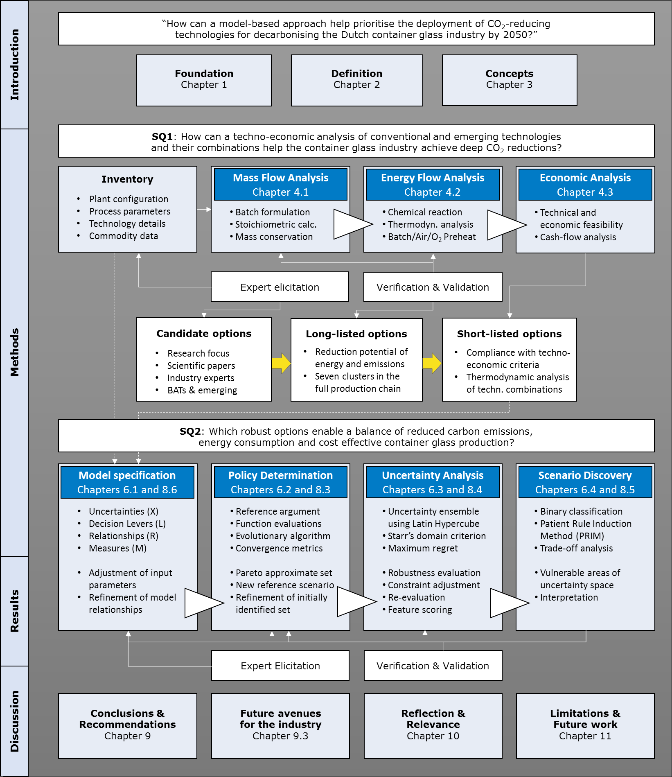

**Figure A1 | Research process flow chart. The study follows the “Introduction, Methods, Results, and Discussion” (IMRaD) format for its organisement.**

# APPENDIX B – The Dutch glass manufacturing industry

B.1 Plant-specific characteristics

The Dutch glass industry has been at the forefront of using latest technologies, performing at world level in terms of quality, production and energy efficiency, and environmental performance (VNG, 2012). Typical examples are the introduction of the first oxy/fuel furnaces in Europe by O-I in 1994, the first batch and cullet preheater by Ardagh Group in 1997, and the world's first fully thermochemical-based glass melting furnace installed at Libbey (technology owned by Praxair/Linde) in 2017 (van Valburg, 2017). The Dutch glassmaking operations are highly diverse, consisting of five glassmaking sectors with 8 production sites and 19 melting furnaces. Container glass exceeds 75% of total glass production in a national level and the rest comprise glass wool, stone wool, glass fibres, tableware, and special glass production. Six companies participate in the [Emissions Trading System](https://ec.europa.eu/clima/policies/ets_en) (ETS) as part of internationally operating groups[65], while the flat glass production was discontinued in 2015.

Table B1 | Overview of ETS registered glass producers in NL (2017).

|  |  |  |  |  |  |
| --- | --- | --- | --- | --- | --- |
| **Producer** | **Location** | **Main activity** | **Number of Furnaces** | **CO2 emissions**  **(ktn CO2/yr)** | **Production capacities  (ktn/yr)** |
| **Ardagh Glass** | Dongen | Glass-containers for food and beverage | 3 | 92.8 | 300 |
| Moerdijk | Glass-containers for food and beverage | 2 | 60.2 | 200 |
| **Owens -Illinois (O-I) Netherlands** | Leerdam | Glass-containers for beverage | 3 | 75.0 | 320 |
| Maastricht | Glass-containers for food and beverage | 3 | 96.9 | 280 |
| **Saint-Gobain Isover** | Etten-Leur | Glass wool  insulation product | 2 | 55.0 | 45–50 |
| **EGF NL** | Westerbroek | Fiber glass for  optical products | 3 | 39.0 | 75-80 |
| **Libbey Glass** | Leerdam | Tableware glass for daily applications | 2 | 28 | 165 |
| **Qsil** | Groningen | Special glass for automotive industry | 1 | - | 7.5–11 |

Nearly 550,000 tonnes of primary raw materials are used annually in the broader Dutch glass production sector: silica sand (55%), limestone (20%), soda ash (17%) and other materials (8%) (JRC Report, 2013). Recycled glass in the form of cullet is used in the majority of glassmaking sectors to substitute virgin raw material, among which the container and fibre glass are the products with the highest recycled content (Schmitz et al. 2011).

B.2 Applications and characteristics of container glass products in NL

Glass products contribute in a major way to society’s sustainability goals for the reduction of energy use, renewable energy production and efficient use of resources (WBG, 2004). At the same time, the production meets the strictest requirements in food and other critical contacts, responding to growing marketplace and the high levels of customer demand for more sustainable packaging (PB & DNV GL, 2015). Container glass manufacturers provide with a comprehensive line of stock products for the following categories:

* Beer, wine, spirits, specialty, non-alcoholic beverages (i.e. bottles) - 75%;
* Food (i.e. jars, bowls, plates, cups), pitchers, vases - 20%;
* Pharmaceuticals, chemicals, cosmetics (i.e. flacons), and personal care - 5%.

Depending on the batch mixing formulas, variations in the chemical compositions give desired characteristics and properties to the glass product (Qorpak, 2019). Soda Lime Glass (Na2O.CaO.SiO2) is commonly used for the production of container, flat and tableware glass, as well as lenses and lighting. Annealed and tempered soda-lime are two of its grades, which show differences in terms of mechanical, thermal and electrical properties[66]. Flint and emerald green consist of oxidised glasses, while light/dark amber of are known as “reduced” glasses containing high level of carbon (GPI, 2019). The low-cost feedstock allows the mass production of this type.

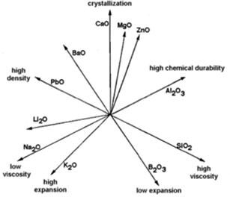

Figure B1 | Relation between oxides and effect on glass properties (Hubert, 2015).

An increase of sodium oxide (Na2O) content may decrease the viscosity of the glass product, which is a measure of its resistance to flow and its tendency to prevent crystallisation. Calcium oxide (CaO) obtained from limestone can prevent the dissolution of the produced glass in water, while an increased content of aluminium oxide (Al2O3) makes a favourable influence on the tensile strength (Figure B1).

B.3 Dutch glass market and value

Being dependent on sales of food and beverages, the demand for glass containers does not fluctuate greatly with business cycles compared to flat glass demand (Butler & Hooper, 2011). Yearly production of glass containers in Europe is projected to reach 17.74 million metric tons by 2020 with a compound annual growth rate of 3.32%[67]. In the Netherlands, the organic growth of container glass industry is estimated at 1.0-1.5% per year[68]. Despite the closing down of the float glass facility by AGC, the total production capacity of 1.26 mil. tonnes reduced by only 0.5% in 2015 compared to 2012 (van Valburg, 2017).

The light-weighting industry trend, as well as the growth of end use industries have been some of the main drivers of the glass market (Hatzilau et al. 2016). At the same time, the fluctuating electricity prices and the competition from alternative materials play a catalytic role in shaping price levels in the glass industry. Depending on market preferences, costs and packaging developments, the position of glass relative to its competitors varies widely between regions and products. Such competitors can be the plastics (e.g. PET-polyethylene), metals (e.g. steel and aluminium) and laminated cartons (JRC Report, 2013).

Under these circumstances, glass furnaces which contain a large amount of molten glass should be able to accommodate the flexibility needed to profit from rewards, grants and lower electrical tariffs (Eurotherm, 2019). Lower peak power demand can lead to lower tariffs, therefore the overall cost of electrical energy can be decreased by ensuring that agreed peak power levels are not exceeded (Eurotherm, 2019). Glass container manufacturers have a scope to increase their margins by joining forces with glass recycling companies to develop efficient glass collecting practices[69]. According to CE Delft (2016), the opportunity costs of the freely obtained ETS allowances were forwarded in glass-container product prices to a lesser extent than other glass products (i.e. 20-50%)[70].

B.4 Glass recycling, waste and disposal

The Netherlands is amongst the best performing countries in Europe in the field of recycling waste, setting higher collection targets for packaging glass than its European counterparts (KIDV, 2016). At the same time, the glass recycling landscape is evolving and there is a lot of public attention for further increasing the return of container glass from household residual waste to the glass industry. In 2013, the amount of packaging material introduced to the Dutch market per capita was 167 kg and the total percentage for collected packaging waste was 94% (Eurostat, 2016, cited in KIDV, 2016). In 2015, 83% of the consumed 492.000 glass tonnes were collected, resulting in a gradual increase of 3% compared to the previous year[71].

The cullet ratio depends on glass colour, level of impurities and market availability (Glusing & Conradt, 2003). In theory, container glass can be made from 100% cullet and can be endlessly recycled without losing its intrinsic properties (FEVE, 2016). However, there are practical limitations to this approach. Firstly, the marginal environmental and financial burdens of collecting too much post-consumer waste may exceed the marginal benefits (Butler et al. 2011). Secondly, at least 1% of batch composition is typically used for controlling the colour and fining of the glass. By melting a cullet-only batch, the final product would contain lots of gaseous inclusions called “blisters”, which can be released by heating the glass at high temperature for a long time25. Bubble removal takes place by adding fining agents to initiate the fining process (approx. 0.2-0.55% of total amount of glass) and to neutralise contamination from recycled cullet.

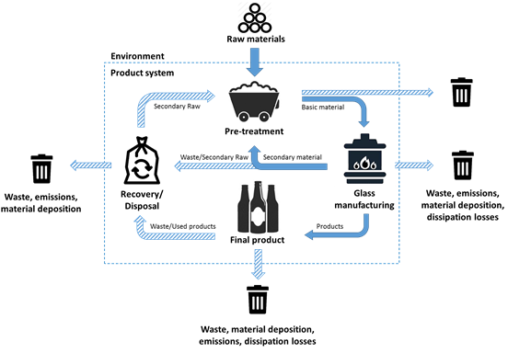

**Figure B2 | Life cycle of primary/secondary material for container glass[72].**

The industrial process does not create residual waste glass. Everything is reused as domestic cullet, with the exception of some very contaminated glass which were disregarded during quality check (approx. 25tn neglected every 6 years). In a national scale, up to 20 wt% of all recycled cullet is land filled as waste. The reason behind this is the likelihood of problems associated with foaming, bubbles and refining when using low-quality cullet. This happens due to organic contamination caused by plastic labels, misplaced items which contaminate the entire load, or crushed cullet of extremely small particle size[73].

# APPENDIX C – Conventional technologies

C.1 Electric boosting and Bubblers

Electric boosting refers to the application of electrical energy as an additional energy source in conventional fossil fuel-fired furnaces. Boosting is kept in low percentage because of the electricity price (approx. 8-12% for air/fuel and 2–10% for oxy/fuel furnaces of the total energy input), but companies are looking for ways to increase it to 20-25% in the future[74]. It supports the pull rate of a furnace as it nears the end of its operating life, and provides flexibility by increasing the production capacity (Figure C2a; Worrell et al. 2008). At current designs, a larger percentage would also lead to glass quality issues (Fraunhofer, 2009).

This extra boost power is applied in melting areas which are difficult to heat using gas, particularly when melting coloured glass (Eurotherm, 2019). The key is in the electrode arrangement and the energy release pattern that the electrodes create in the furnace, which in turn directly affects temperature profiles, convection currents, flow paths and residence time (Stormont, 2010; Karem, 2018). Depending on the furnace geometry, the majority of melting boosters have an installed power in the range of 400-1200kVA[75].An alternative option would be the [fluidised bed combustion](https://dspace.library.uu.nl/bitstream/handle/1874/26434/NWS-E-2007-46.pdf?sequence=1) (i.e. “bubbling”); a simple method for increasing bottom temperature and assisting the retention of unmelt batch in melting area (Sorg, 2011). Air or other gases are blown through special bubbler nozzles installed in the furnace bottom, hence the upward movement of bubbles produces strong localised convection currents around their path. These currents move bottom glass upwards causing an increase in the glass temperature at the bottom of the tank.

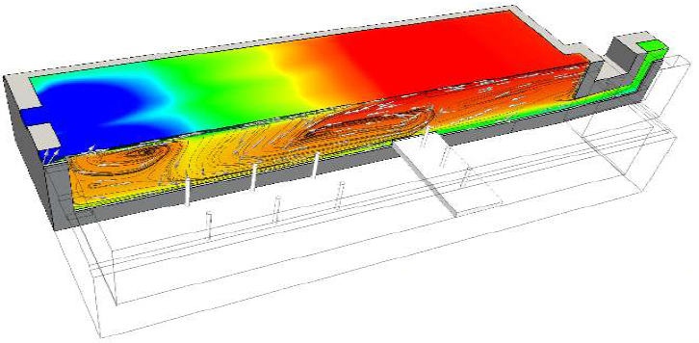.

**Figure C1 | Boosting for improving heat transfer into batch layer (Reynolds, 2019).**

C.2 Excess Combustion Air

In a combustion process, the complete burning cannot be accomplished with the exact theoretical amount of air (i.e. stoichiometric conditions). Therefore it is essential to supply an excess amount of air for the combustion of high calorific gases, ideally in a ratio of approximately 10:1 (Boateng, 2016). This corresponds to a 1-2% oxygen measurement in the stack. By contrast, too much excess air leads to lower flame temperature, hence less heat gets into the system. As a result, the best combustion efficiency occurs at the optimum air-to-fuel ratio and controlling this provides the highest efficiency (Figure C2b). With suitable preheaters, the use of excess air can be used on a large scale with economic advantage over oxygen enrichment, although much depends on the availability and price of oxygen (Hendershot et al. 2010).

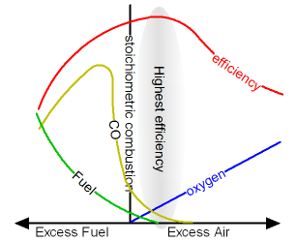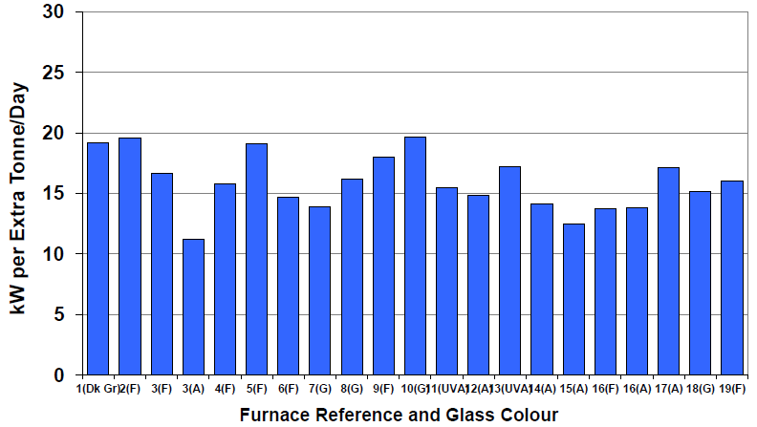

**Figure C2 | (a) Electric boost power input per extra tonne per day by glass type (Stormont, 2017); (b) Relation between combustion efficiency and excess air[76].**

C.3 Improved furnace construction

Both revolutionary furnace designs and modifications to existing furnace designs concern medium to long-term investments (VNG, 2012). Depending on the glass type, the deteriorating refractories, melt tank and combustion chamber contribute to an annual increase of losses by approximately 0.8-1.3% for air/fuel and oxy/fuel furnaces. A reconstructed crown and basin using improved refractories lead to higher operating temperatures, hence improved product quality and payback rates (PB & DNV GL, 2015a; Khoshmanesh et al. 2007). Making such improvements to a certain extent provides with better insulation to combat high corrosion rates and extend furnace lifetime while reducing heat losses by 50-60% (TASIO, 2016). On the other hand, a change from air/fuel to oxy/fuel results in a total rebuild of an existing furnace and usually comes with a total change of footprint. Burners, gas and oxygen supply, refractory material will be new and in almost all cases the design will be significantly changed[77]. The implementation of options requiring retrofit in regenerative and oxy/fuel furnaces will either be postponed until furnace rebuild, or experience unplanned downtime and production losses (Ricardo AEA, 2013).

# APPENDIX D – Emerging technologies

Information with regards to emerging or advanced energy-efficiency and low-carbon technologies that have not yet been commercialised is often scattered or scarce. More importantly, it is challenging to model the implications of these technologies to the melting process, in order to make safe conclusions about the behaviour of the melting process for high-cullet batches and the quality of glass. For completeness, Table D1 includes all these additional novel technologies which have been found in the literature. The savings mentioned in Table D1 refer to reductions compared to as-is conventional technologies.

**Table D1 | List of emerging technologies for the container glass industry.**

|  |  |  |  |
| --- | --- | --- | --- |
| **Technology** | **TRL** | **Description** | **Reference** |
| E-batch preheating technology | 8 | Batch/cullet preheating technology with a patented electrostatic mechanism. It precipitates particulates in the furnace flue gases onto the batch surface, preventing them from escaping as emissions. Achieve 15-25% reduction in furnace energy use. | Alexander (2009)  Springer et al. (2017) |
| Oscillating Combustion | 7 | Forcing oscillations in the fuel flow rate to a furnace, creating successive fuel-rich and fuel-lean areas in the furnace. It can be retrofitted onto existing furnaces. Achieved 5-25% fuel use reduction by lowering the peak temperature of the furnace; reduces NOx by 30-50%. | Springer et al.(2017)  Abbasi (2003) |
| Flameless burners | 7 | Gas burners where mixing of the combustion gas and air is delayed until they enter the combustion chamber at a high flow rate. It improves energy transfer to the melting glass, and achieves reductions in specific energy consumption, CO2 and NOx (-50%) emissions. | Springer et al. (2017)  Furnaces International (2018) |
| Plasma melter | 6 | Plasma electrodes allow plasma (e.g. ionized argon gas) to circulate and heat the batch via an electrical current. Achieves high enthalpy and reactivity; enable rapid and flexible melting; Improves energy intensity by 50%-70%. | Verheijen (2008)  Gonterman (2006)  Levine et al. (2003) |
| Submerged combustion melting | 4 | Fuel and oxidants are fired directly into and under the blanket of the melting mixture. Improves heat transfer through the bubble release and reduces residence time of the melt. Flexibility in operation, and energy range between 5%-20%. | Worrell et al. (2008)  Rue (2005)  Springer et al. (2017) |
| Segmented Melter | 3 | Melter that separates for raw materials and cullet, which optimises the melting process given their melting temperatures and residence times. The mixture is then introduced to an oxy/fuel melting chamber of low temperature. Increases pull rates, lowers thermal losses and maintenance costs. | Worrell et al. (2008)  Springer et al.(2017) |
| Microwave heating | 2 | Rapid melting of material due to higher heating rate with the use of electricity. Eliminates combustion emissions and has the potential to decrease glass melting time. | Springer et al.(2017) |

# APPENDIX E – Alternative glass compositions

**Table E1 | Overview of alternative container glass types (per tonne of molten glass)**

|  |  |  |  |
| --- | --- | --- | --- |
| **Type**  **No.** | **Chemical Reactions per Glass Type** | **Description** | **Chem. reaction**[78] **/ Melting**  **/ Direct CO2** |
| **1** | CaMg(CO3)2(s) + Heat --> CaCO3(s) + CO2(g) + MgO(s)  Na2CO3(s) + CaCO3(s) --> Na2Ca(CO3)2  Na2Ca(CO3)2 + 2SiO2 --> **Na2O.CaO.2SiO2** + 2CO2(g) | Carbonate route: reacting at 850-1000oC and use of Dolomite | 0.82 GJ  5.09 GJ  319 kg |
| **2** | Na2CO3(s) + CaCO3(s) --> Na2Ca(CO3)2  Na2Ca(CO3)2 + 2SiO2 --> **Na2O. CaO.2SiO2** + CO2(g) | Carbonate route and use of Limestone | 0.67 GJ  4.52 GJ  259 kg |
| **3** | 2SiO2 (s) + Na2CO3(s) --> Na2O.2SiO2 (s) + CO2(g)  CaMg(CO3)2(s) + Heat --> CaCO3(s) + CO2(g) + MgO(s)  CaCO3(s) + Heat --> CaO(s) + CO2(g)  2CaO + (SiO2 + Na2O.2SiO2) --> **Na2O.2CaO.3SiO2** | Silica route: reacting at 700-860oC and use  of Dolomite | 0.55 GJ  3.82 GJ  286 kg |
| **4** | 2SiO2(s) + Na2CO3(s) --> Na2O.2 SiO2(s) + CO2(g)  CaCO3(s) + Heat --> CaO(s) + CO2(g)  2CaO + (SiO2 + Na2O.2 SiO2) --> **Na2O.2CaO.3SiO2** | Silica route: reacting at 700-860oC and use  of Limestone | 0.45 GJ  3.25 GJ  213 kg |
| **5** | SiO2(s) + Na2CO3(s) --> Na2O.SiO2(s) + CO2(g)  CaMg(CO3)2(s) + Heat --> CaCO3(s) + CO2(g) + MgO(s)  CaCO3(s) + Heat --> CaO(s) + CO2(g)  3CaO + (5 SiO2 + Na2O. SiO2) --> **Na2O.3CaO.6SiO2** | Silica route: reacting at 800-1100oC and use  of Dolomite | 0.33 GJ  2.71 GJ  178 kg |
| 6 | SiO2(s) + Na2CO3(s) --> Na2O.SiO2(s) + CO2(g)  CaCO3(s) + Heat --> CaO(s) + CO2(g)  3CaO + (5 SiO2 + Na2O. SiO2) --> **Na2O.3CaO.6SiO2** | Silica route: reacting at 800-1100oC and use  of Limestone | 0.27 GJ  3.16 GJ  244 kg |
| **7** | SiO2(s) + Na2CO3(s) --> Na2O.SiO2(s) + CO2(g)  Al2O3 +5SiO2 + Na2O.SiO2 --> **Na2O.Al2O3.6SiO2** | Silica route: reacting at 800-1100oC and use of Aluminium | 0.20 GJ  2.51 GJ  117 kg |
| **8** | CaMg(CO3)2(s) + Heat --> CaCO3(s) + CO2(g) + MgO(s)  MgO + SiO2 --> **MgO.SiO2** | Carbonate route: reacting at 800-900oC and use  of Dolomite | 0.36 GJ  4.31 GJ  278 kg |

# APPENDIX F – Commodity prices

Table F1 | Overview of commodity data used for the estimation of Product costs.

|  |  |  |  |  |
| --- | --- | --- | --- | --- |
| **Commodity value** | **Market price** | **Unit** | **Year** | **Reference** |
| **Energy input :**  Market price of conventional and alternative energy carriers | | | | |
| Natural gas | 0.038 | €/kWh | 2018 | Eurostat (2018) |
| Electricity | 0.0793 | €/kWh | 2017 | Statista (2017) |
| Biomethane | 0.80 | €/m3 | 2015 | Stürmer et al. (2017) |
| **Raw materials :**  Prices of virgin materials in the global marketplace | | | | |
| Soda ash | 210 | €/tn | 2019 | Focus Technology (2019) |
| Limestone | 170 | €/tn | 2019 | Focus Technology (2019) |
| Silica sand | 150 | €/tn | 2019 | Focus Technology (2019) |
| Dolomite | 75 | €/tn | 2019 | Focus Technology (2019) |
| Aluminium | 670 | €/tn | 2019 | Focus Technology (2019) |
| Sodium sulphate | 70 | €/tn | 2019 | Focus Technology (2019) |
| Recycled Cullet | 150 | €/tn | 2019 | Focus Technology (2019) |
| **Other commodities :**  Commodity and other costs that contribute to the production cost of packed glass | | | | |
| Oxygen | 0.06 | €/m3 | 2019 | PBL database |
| Carbon | 20 | €/tn CO2 | 2019 | Pieters (2019) |
| Operation and maintenance | 35 | % Product cost | - | Osseweijer & Straathof (2018) |

# APPENDIX G – Maximum regret of policies

The heatmap below (Figure G1) includes the regret values of candidate policies. The values are determined by taking the difference of the maximum across the row and the actual values in the row, normalised by the maximum regret. Performance of “no regret” denotes the best possible result, which is the lowest value in case of maximisation and highest in case of minimisation.

As an example, Policy 87 in Figure G1 corresponds to Technology 7 with 3% electric boosting on average, having high regret value for Indirect emissions (1.00; avg. 22 kg), Payback (0.92; avg. 2.60 years) and Energy use (0.96; avg. 3.4 GJ), and relatively low for Direct CO2 (0.26; avg. 197 kg), Product cost (0.15; avg. 5.3€-cent), and ROI (0.15; avg. 2.9%). The low regret of ROI is the only value of the above which is not preferred, since the goal is to maximise the objective.

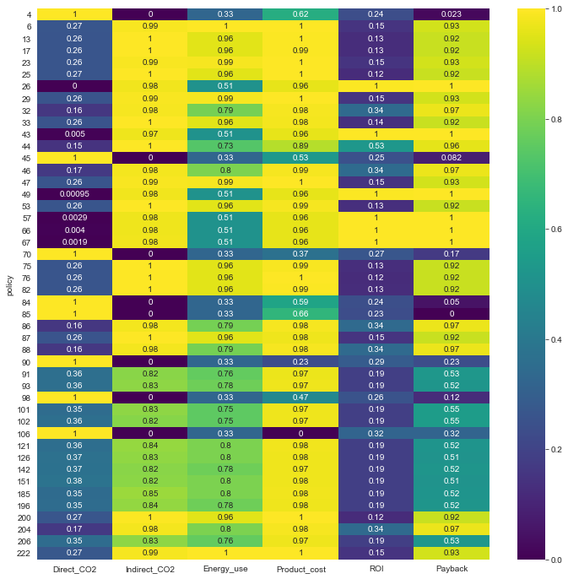

**Figure G1 | Heatmap with the regret scores of candidate policy options (normalised btw. 0-1)[79]**

# APPENDIX H – Common issues when replicating MORDM results

Microsoft Excel was chosen in this study as the working environment for model building, and Jupyter Notebook as the default [Integrated Development Environment (IDE) for programming in Python.](https://en.wikipedia.org/wiki/Integrated_development_environment) Using MS Excel allowed the easy inventorisation of the industry under study, as well as the handy creation of system relationships which are needed in the Model specification stage. Two Excel models are provided: the “Glass model” for exploring technologies and adjusting manually input parameters, and the “Glass MORDM” for observing the input parameters used for MORDM. The software requirements for replicating the code which is provided through Github is the installation of Anaconda 32 bit and Python 3.7. In the command window named “Anaconda prompt” (which is included in the installation folder of Anaconda), the user needs to install the following libraries: mpld3, jpype using conda, and platypus-opt, ipyparallel, and ema-workbench, numpy, seaborn, pandas using pip. Two examples are provided below, and more elaborate installation guides can be retrieved online.



For ensuring that the Glass model and the workbench communicate smoothly, the user needs to define “Named ranges” in Excel for the parameters of his/her interest. This can be done by selecting the cell which contains the value to be transferred to the workbench, and then by selecting the area under the tools bar which contains the name of the cell. Re-name it without using spaces, and ensure that the respective parameter in the workbench has the same name. If the optimisation does not run, make sure that the named range defined previously is not shared by two different cells. For validation, click on “Data” ribbon in Excel > click on “Manage names” option > find the name in the menu and look for duplicates > select the one which is placed in an unexpected reference and click “Delete”. It is also a matter of referring to the correct Excel sheet, as defined in the Model specification stage[80].

The user needs to perform the following actions for being able to run the code and call the Glass MORDM model. The dialog boxes which appear on the start-up of Excel prevent the model function to be called for each candidate evaluation, therefore it is necessary to deactivate macros (e.g. VBA, PowerPivot, Solver etc.) and disable the option of updating links in MS Excel. For deactivating macros, the user can click on the “File” drop menu of MS Excel > click on“Options” > click on “Add ons” > For all options in the “Management” drop menu click on them one by one (e.g. “Add on Excel OCM”) and click Go > Uncheck all the options > Save. For disabling the auto-update of links, the user can click on the “Data” ribbon in MS Excel > click on “Links” option > select all the links from the menu > click on “Remove”. Make sure that the Excel file remains closed when running the optimisation in the workbench. If the problem persists, the user can start the “Task Manager” on his/her computer > click on “Processes” ribbon > Find the “EXCEL” process and click on “End Process”. If the issues remain the same, copy the code in an empty notebook or convert it into a python file and import it in other IDE’s such as Spyder or Pycharm. “Do-nothing” principle also applies; restart the computer or give it some time to rest.

1. The proposed strategies are generalised and they are not representative for a Dutch container glass company.
2. Joost Lavèn, O-I Netherlands Schiedam B.V., Personal communication.
3. Oscar Verheijen, Celsian Glass and Solar B.V., Personal communication.
4. Sven-Roger Kahl, Ardagh Glass Dongen B.V., Personal communication.
5. Own calculations; see Glass_model.xlsx.
6. Retrieved from: <https://www.klimaatakkoord.nl/documenten/publicaties/2019/06/28/klimaatakkoord>
7. Retrieved from: <https://www.government.nl/topics/climate-change/climate-policy>
8. The main piece of legislation regulating emissions from industrial installations is the Industrial Emissions Directive (IED; 2010/75/EU), which lays down specific minimum requirements for certain industrial activities.
9. Author J. H. Kwakkel, retrieved from: <https://waterprogramming.wordpress.com/author/jhkwakkel/>
10. Standard conditions refer to temperature level Troom = 25oC of environment and to isobaric conditions at p=1 bar. The cp values presented in Table 4 consist of the average of all glass types for the temperature window between the ambient and the furnace temperatures (see Chapter 4.3).
11. Retrieved from Engineering Toolbox: <https://www.engineeringtoolbox.com/methane-d_980.html>
12. Division of tonnes of molten glass by the inverse of internal cullet rate (i.e. pack-to-melt ratio).
13. Lower limits are 1500oC for furnace temperature and 1100oC melting point for a cullet-only batch. In reality, the maximum furnace temperature is mainly related to glass quality demands.
14. Net calorific value (approx. 31.669 MJ/m3 Groningen Natural gas) is appropriate for predicting the temperature reached within the flame. As a result, the enthalpy of exhaust gases will consist of sensible heat terms only.
15. Sven-Roger Kahl, Ardagh Glass Dongen B.V., Personal communication.
16. Joost Lavèn, O-I Netherlands Schiedam B.V., Personal communication.
17. Sven-Roger Kahl, Ardagh Glass Dongen B.V., Personal communication.
18. Regenerative furnace; Natural gas to total fuel input ratio 92%, indirect emissions factor 0.5kg/kWh. Formulas applied from Madivate (1998); normalised for 1tn of packed glass.
19. A 300tpd end-fired furnace; natural gas to fuel ratio 92%, boosting 8%, regenerator efficiency 70%; cullet 78%.
20. Conversion losses are taken into account (assum. 40% efficiency of electricity generation) (Blok & Nieuwlaar, 2016).
21. As stated by the interviewed companies and according to the criteria described in Chapter 4.3.
22. Assumed £1 = €1.4073 (June 30th, 2015) for converting from values expressed in British pounds.
23. Cost price for conventional H2 production via Steam Methane Reforming (SMR). Burners’ costs are not included.
24. Without considering CO2 capturing. See Chapter 5.7 for the full-capture system.
25. Fuel savings for cullet preheaters are 6% less compared to batch/cullet preheaters (Baukal, 2013).
26. For a 300tn/day CG furnace (end fired) with heat extracted after Electro-static Precipitator (Ricardo AEA, 2013).
27. Approx. 20% compared to oxy/fuel; approx. 30% compared to air/fuel furnace.
28. Includes the additional decrease of 10% compared to oxy-combustion without air preheating.
29. All costs are for CO2 capture alone, including CO2 purification and compression (PB & DNV GL, 2015b).
30. Sven-Roger Kahl, Ardagh Glass Dongen B.V., Personal communication; Oscar Verheijen, Celsian Glass and Solar B.V., Personal communication.
31. Retrieved from BDF Industries: <https://www.bdfindustriesgroup.com/products/melting-furnace-rigenerative-recuperative-furnace/>
32. Sven-Roger Kahl, Ardagh Glass Dongen B.V., Personal communication.
33. Much heat is released from the open surface if the batch blankets get too hot, and there is not much heat capacity to keep the process running without isolating or insulating the top (e.g. through adding extra batch materials).
34. Oscar Verheijen, Celsian Glass and Solar B.V., Personal communication.
35. Retrieved from Turboden: <https://www.turboden.com/turboden-orc-technology/1062/the-orc-technology>
36. Oscar Verheijen, Celsian Glass and Solar B.V., Personal communication.
37. Sven-Roger Kahl, Ardagh Glass Dongen B.V., Personal communication.
38. The assessment refers to post-combustion carbon capture. Pre-combustion systems relate to syngas production (see Chapter 5.3.4.c). If more than one furnace will be operated as oxy/fuel in the glass plant, usually a cryogenic installation is built (i.e. oxy-combustion capture). This depends on the local circumstances and it is up to the decision of the oxygen supplier. The glass plant pays for the oxygen and provides the necessary electricity (Kahl, Personal communication).
39. Joost Lavèn, O-I Netherlands Schiedam B.V., Personal communication.
40. The Sankey diagram was originally found at <http://www.sankey-diagrams.com/tag/furnace/>. The values are the product of own calculations (in tonnes of molten glass) and they are analogous to the values of the original diagram.
41. The values are expressed in tonnes of packed glass.
42. Raw material inputs were assumed to be 62.3% silica, 18.4% soda ash, 7.8% limestone, 10.9% dolomite and 0.6% sodium sulphate (i.e. flint glass type).
43. Sven-Roger Kahl, Ardagh Glass Dongen B.V., Personal communication.
44. Joost Lavèn, O-I Netherlands Schiedam B.V., Personal communication.
45. Positive reductions denote that the technology “2” (i.e. where the arrow points at) consumes less energy or emits less CO2 emissions compared to technology “1” (i.e. the back of the arrow). Zero reductions denote that technology “1” over performs technology “2”. The blue boxes are the benchmark specification of each technology aggregate, which enable comparisons between options when the model specifications have been alternated by the user.
46. The bare equipment cost of Technology 9 (i.e. €56.3 mil. for Electric furnace) was removed for better clarity.
47. The ROI of the “as-is” regenerative furnace (i.e. Technology 0) is zero, as the “Net profit (margin)” is the difference between the “Net profit” of each technology compared to the “Net profit” of Technology 0 (Eq. 20). On the contrary, the Payback period of Technology 0 is positive due to the division of its total Capex by its Net profit.
48. The complete list of policy alternatives can be found in the Glass_MORDM.ipynb file at Github.
49. Joost Lavèn, O-I Netherlands Schiedam B.V., Personal communication.
50. Sven-Roger Kahl, Ardagh Glass Dongen B.V., Personal communication.
51. Oscar Verheijen, Celsian Glass and Solar B.V., Personal communication.
52. Sven-Roger Kahl, Ardagh Glass Dongen B.V., Personal communication.
53. The solutions are not sorted by preference or performance over an outcome of interest.
54. Marco van Valburg, Libbey Inc, Personal communication.
55. Joost Lavèn, O-I Netherlands Schiedam B.V., Personal communication.
56. Sven-Roger Kahl, Ardagh Glass Dongen B.V., Personal communication.
57. Oscar Verheijen, Celsian Glass and Solar B.V., Personal communication.
58. Marco van Valburg, Libbey Inc, Personal communication.
59. These melters “…range from limiting the zones of regenerative or oxy/fuel firing or using by-product fuels for regeneration and enriching the air stream with oxygen” (O’Connor, 2015).
60. Sven-Roger Kahl, Ardagh Glass Dongen B.V., Personal communication.
61. Oscar Verheijen, Celsian Glass and Solar B.V., Personal communication.
62. Oscar Verheijen, Celsian Glass and Solar B.V., Personal communication.
63. Marc Marsidi, PBL Netherlands Environmental Assessment Agency, Personal communication.
64. Sven-Roger Kahl, Ardagh Glass Dongen B.V., Personal communication.
65. Many of them are braches of glass companies outside Europe (i.e. mainly USA), which means that joining collab. projects or investing in CO2-reducing technologies require external approval (Lavèn, Personal communication).
66. For analytical comparisons, visit <https://www.makeitfrom.com/material-properties/Annealed-Soda-Lime-Glass>
67. Retrieved from the Ceramic Industry: <https://www.ceramicindustry.com/articles/95243-glass-container-market-expected-to-see-steady-growth-in-europe-through-2020>
68. Sven-Roger Kahl, Ardagh Glass Dongen B.V., Personal communication.
69. Retrieved from Businesswire: <https://www.businesswire.com/news/home/20180514005833/en/Glass-Packaging-Market-Europe---Compatibility-Glass>
70. For hollow glasses, the range of average expected cost pass-through is 30-80% (CE Delft, 2016).
71. Data on glass container collection for recycling (FEVE, 2015).
72. VDI (2015), cited in Anglarill, A.G. (2018). Life cycle assessment of a conventional float glass production and comparison with regenerative alternatives.
73. Sven-Roger Kahl, Ardagh Glass Dongen B.V., Personal communication.
74. Joost Lavèn, O-I Netherlands Schiedam B.V., Personal communication.
75. Retrieved from Glass Service s.r.I.: <https://www.glassservice.it/en/products/booster/49/>
76. Retrieved from website: <https://www.engineeringtoolbox.com/boiler-combustion-efficiency-d_271.html>
77. Sven-Roger Kahl, Ardagh Glass Dongen B.V., Personal communication.
78. Theoretical Energy requirement for 68% cullet, 100% Natural gas. Calculated based on stoichiometry.
79. The technology levers of each policy alternative can be retrieved from the Glass_MORDM.ipynb file at Github.
80. See also Tutorials in: <https://emaworkbench.readthedocs.io/en/latest/basic_tutorial.html#a-simple-model-in-excel>